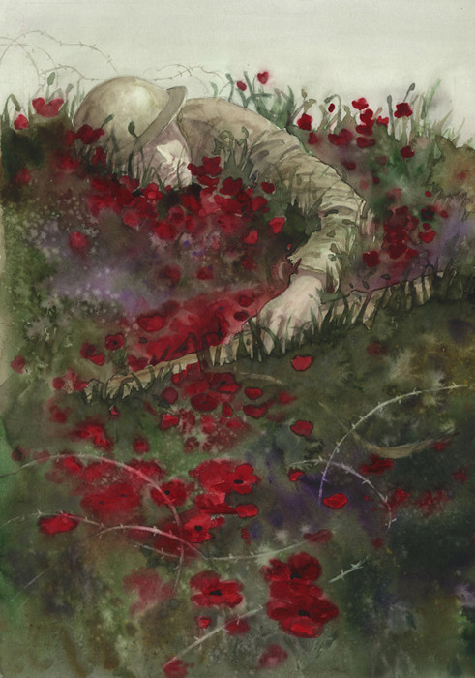

**Short Guided Reading: ‘Remembrance’**

* What can you see in this picture?_____________________________________________________________
* What do you think has happened?___________________________________________________________
* Why is the fallen soldier painted in pale shades of colour?______________________________________________________________
* What do you think the poppies represent? Could they represent more than one thing?_________________________________________________________________________________________________________________________________
* Discuss the contrast between the barbed wire and the poppies.________________________________________________________________________________________________________________________________
* Why is important to remember events from the past?______________________________________________________________
* What can we learn from the events of World War One? What can we apply to our own lives today?_________________________________________________________________________________________________________________________________