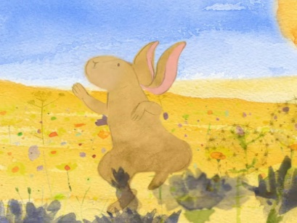 | 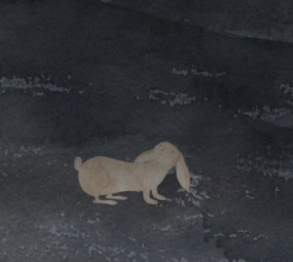
_______________________________________  _______________________________________  _______________________________________  _______________________________________ | _______________________________________  _______________________________________  _______________________________________  _______________________________________
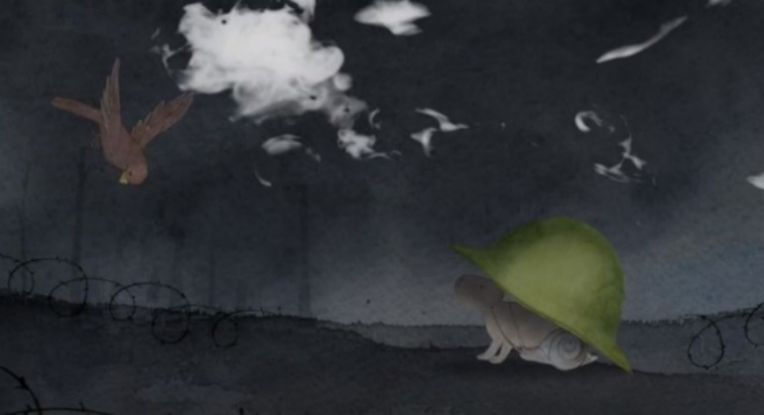 | 
              

