Good Morning Girls and Boys. We hope you had a lovely weekend and managed to get out into your gardens to enjoy the sunshine. We are now into week 2 of the summer term and hope you are enjoying the activities we are setting you.
Here are the activities for the coming week. Remember you can do them in any order and you do not have to do all the activities you can pick and choose the ones you want to do.
Our book we are looking at this week is RUMBLE IN THE JUNGLE, so before you do anything have a look at the eBook on the following website.
https://www.booktrust.org.uk/books-and-reading/have-some-fun/storybooks-and-games/rumble-in-the-jungle/
Have Fun!

Literacy | Activity 1:  Do you remember your activity last week where you had to describe an animal for your helper to guess? Well today I want you, in your exercise book, to write clues about your chosen animal.  Watch What animal am I? You will find the link below  When you have finished watching it have a go at writing your own clues for your chosen animal. Read out the sentences you have written and see if your helper can guess what your animal is.  Activity 2:  Create your own animal jungle on the computer. See link below. If you can print it out and stick into your exercise book. Can you write a list of all the things that are in your jungle? Don’t forget a list is written down the page and remember to use your phonic knowledge to help with the sounding out.  https://www.sheppardsoftware.com/preschool/animals/jungle/animaljunglecreate.htm  Remember to keep practicing your spellings ready for your spelling test on Friday.
Reading | This week we want you to concentrate on learning and reinforcing your knowledge of the long vowel sounds – ay, ee, igh, oo, ou, ow, ue etc. Please see your phonic flash book for the sounds.  Activities you may want to do when looking at the long vowel sounds:  - Play bingo. Choose 4 long vowel sounds and an adult flashes the sound. If you have it cross it off your board. The person with all of them crossed off is the winner.  - Place certain sounds in different places of the room and get an adult to shout the sound you need to move to ie jump to the sound ee, run to the sound ay etc.  - Play guess the object. An adult reads out description of an object of their choice (which has the long vowel sound) you need to guess what it is and write the name of it down using your long vowel knowledge. Example it is yellow and black, it buzzes, it makes honey = BEE. You could draw the object too if you wanted.  - Get an adult to flash you your sounds. How many can you get right in 1 minute? Can you beat your time?  - How many words can you write in a minute with your chosen long vowel sound? Can you beat your score?  - You be the teacher and teach your adult the long vowel sounds that you know.  - See how many sounds you can recall in 1 minute. Start with phase 2 and work your way through.  Username: march20  Password: home  https://new.phonicsplay.co.uk/resources/phase/2/flashcards-time-challenge
Expressive Arts and Design | Activity 1: Often explorers go into the jungle in search of new animals. They have to take binoculars with them so that they can see the animals.  Can you make your own binoculars and go into the garden to see what animals you can find.  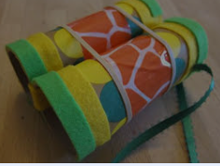  Activity 2: Can you sketch your favourite jungle animal. Then carefully colour it in selecting the correct colours to represent your animal.  Activity 3: Can you make your own jungle habitat out of different materials for your animals to live in. Think carefully about what a jungle has in it.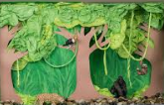
Maths | Don’t forget to complete your doodle maths and any extras that you may have been assigned.  Activity 1:  https://www.memozor.com/memory-games/for-kids/jungle-animals  Can you find the matching pairs of animals? This game is brilliant for your memory. See if you can beat your parents.  Activity 2:  We would like you to really look carefully at being able to form your numbers neatly and correctly.  Can you practice writing your numbers accurately from 1-10 and then 11-20. Make sure you practice writing them the correct way around. You could make your own number poster to 20 to remind you how to write your numbers the correct way around  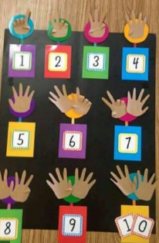  If there are any numbers you find tricky writing can you write them using different resources such as chalk, paint, water. Can you make them out of playdough?  https://www.youtube.com/watch?v=0mP501l5gGo  Watch the video link can you write the numbers as the computer does it too.  Can you make your own number formation book to remind you of how brilliantly you can write your numbers?  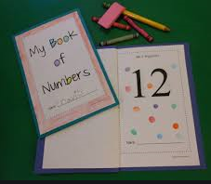
Communication and Language/PSED | Activity:  For this activity we would like you to complete a survey with your family/friends. Can you ask your family and friends what their favourite animal is from the story ‘Rumble in the Jungle’ and create a pictogram?  We have made a template for you which can be found under ‘documents’ at the bottom of the page, or you may want to create your own.  This is a perfect opportunity for you to use different technologies to contact your family/friends. With help from a grown up, you may make a phone call, help a grown up send a text or use a video calling app to complete your survey.  Colour in a square each time a member of your family or friend chooses a particular animal.
Physical Development | Activity 1:  Don’t forget to join in with Joe Wicks morning workout at 9am on YouTube.  Activity 2:  Yoga: Enjoy going on a jungle safari with Jamie.  https://www.youtube.com/watch?v=C4CaR0syf1g  Activity 3:  We would like you to learn the ‘African Animals’ poem which is attached at the bottom of the page. There are actions too to help your remember the words. If you would like to, you could ask a grown up to video you performing the poem and actions and send it into us at school on the following email: snaith.primary2020@gmail.com
Understanding the World (Technology) | Activity 1:  Why not observe the penguins, tigers, koala bears and pandas at Edinburgh zoo through their live cameras? See if you can spot them. Here is the link to the website:  https://www.edinburghzoo.org.uk/webcams/panda-cam/  Activity 2:  Get creative and design your own ‘Rumble in the Jungle’. Use the animals from the story to create a picture. Can you use all of the tools correctly to create and edit your design?  Select ‘Make a picture’ and then click ‘Draw your own’. See what you can come up with.  https://www.booktrust.org.uk/books-and-reading/have-some-fun/storybooks-and-games/jungle-picture-maker/

