Type of Animal | 
Type of Animal | 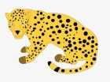
Type of Animal | 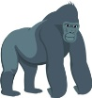
Type of Animal | 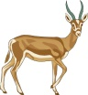
Type of Animal | 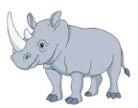
Type of Animal | 
Type of Animal | 
Type of Animal | 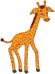
Type of Animal | 
Type of Animal | 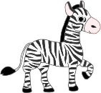
Type of Animal | 
Type of Animal | 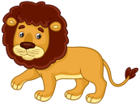
Type of Animal | 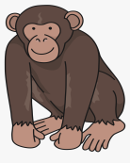
Type of Animal |  | 1 | 2 | 3 | 4 | 5 | 6 | 7 | 8 | 9
Number of People

