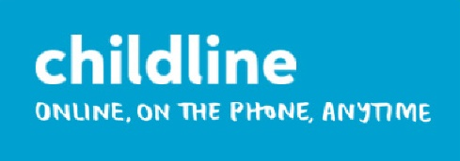

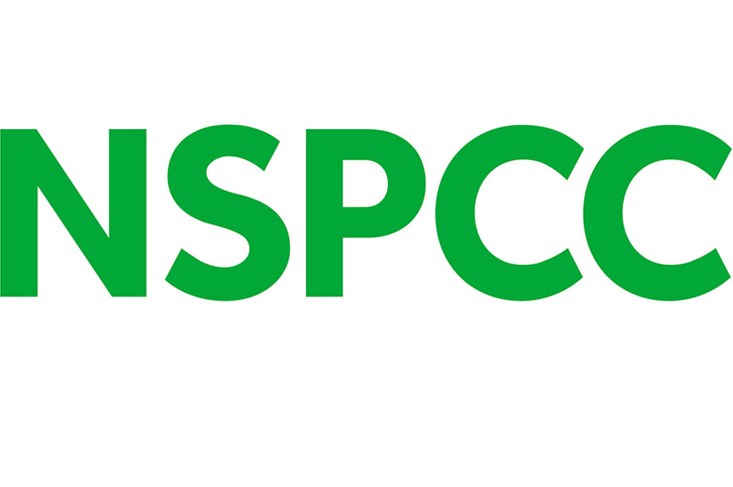
Secondary schools
Talk Relationships - Training, lessons plans and a dedicated helpline to support secondary school teachers to confidently deliver inclusive sex and relationships education and a Whole school Approach framework.
It’s not ok - It's Not OK helps children and young people recognise concerning behaviour and identify characteristics of positive relationships. The lesson plans, films and accompanying activities cover what behaviour to look out for and how to respond to it.
AGENDA - AGENDA is a free online toolkit to help explore ideas around equality and diversity with children and young people.

SEND/ASL/ALN
Speak Out Stay Safe - The SEND/ASN/ALN programme provides support and resources to help you deliver messages to your pupils about what abuse is and which trusted adults they can turn to for help. We provide access to resources including session plans, films and printable props all of which use our friendly speech bubble mascot called Buddy.
Love life - Helping young people explore topics such as emotions, relationships and identity. The films and supporting resources are aimed at young people aged 11 to 25 to help them learn strategies for staying safe as they grow up and gain independence.
Primary Schools
Speak Out Stay Safe - Our assemblies and workshops for under 7’s (KS1) and over 7’s (KS2) aim to equip a generation of children with the knowledge and skills they need to stay safe from abuse and neglect. Available as a BSL version. Sign up here - nspcc.org.uk/services/speak-out-stay-safe
AGENDA toolkit - Primary Agenda are free online toolkits to help explore ideas around equality and diversity with children and young people.
Further resources and support on:
- Harmful Sexual Behaviour in schools
- Online training packages for schools
- Online safety
- Parents/carers guides and support
- Audit toolkit
- Parent workshops/keeping children safe online
Visit our website for further information - https://learning.nspcc.org.uk/

Childline - A free confidential space where children can talk about anything on the phone or online.

Early years and Key stage 1
PANTS - Download our free Talk PANTS resources, teaching children the Underwear Rule to help keep them safe from abuse. Available in MAKATON version too!

Report Remove
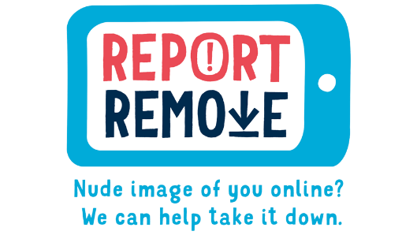Online tool to help young people under 18 to remove nude or sexual images of themselves from the internet: https://learning.nspcc.org.uk/research-resources/report-remove
The NSPCC provide a range of free safeguarding resources for schools. From lesson plans to resources to share with parents/carers, staff training and child facing workshops. This includes SEND guidance and resources. Click HERE for more information.

Resources for schools
EVERY CHILDHOOD IS WORTH FIGHTING FOR

