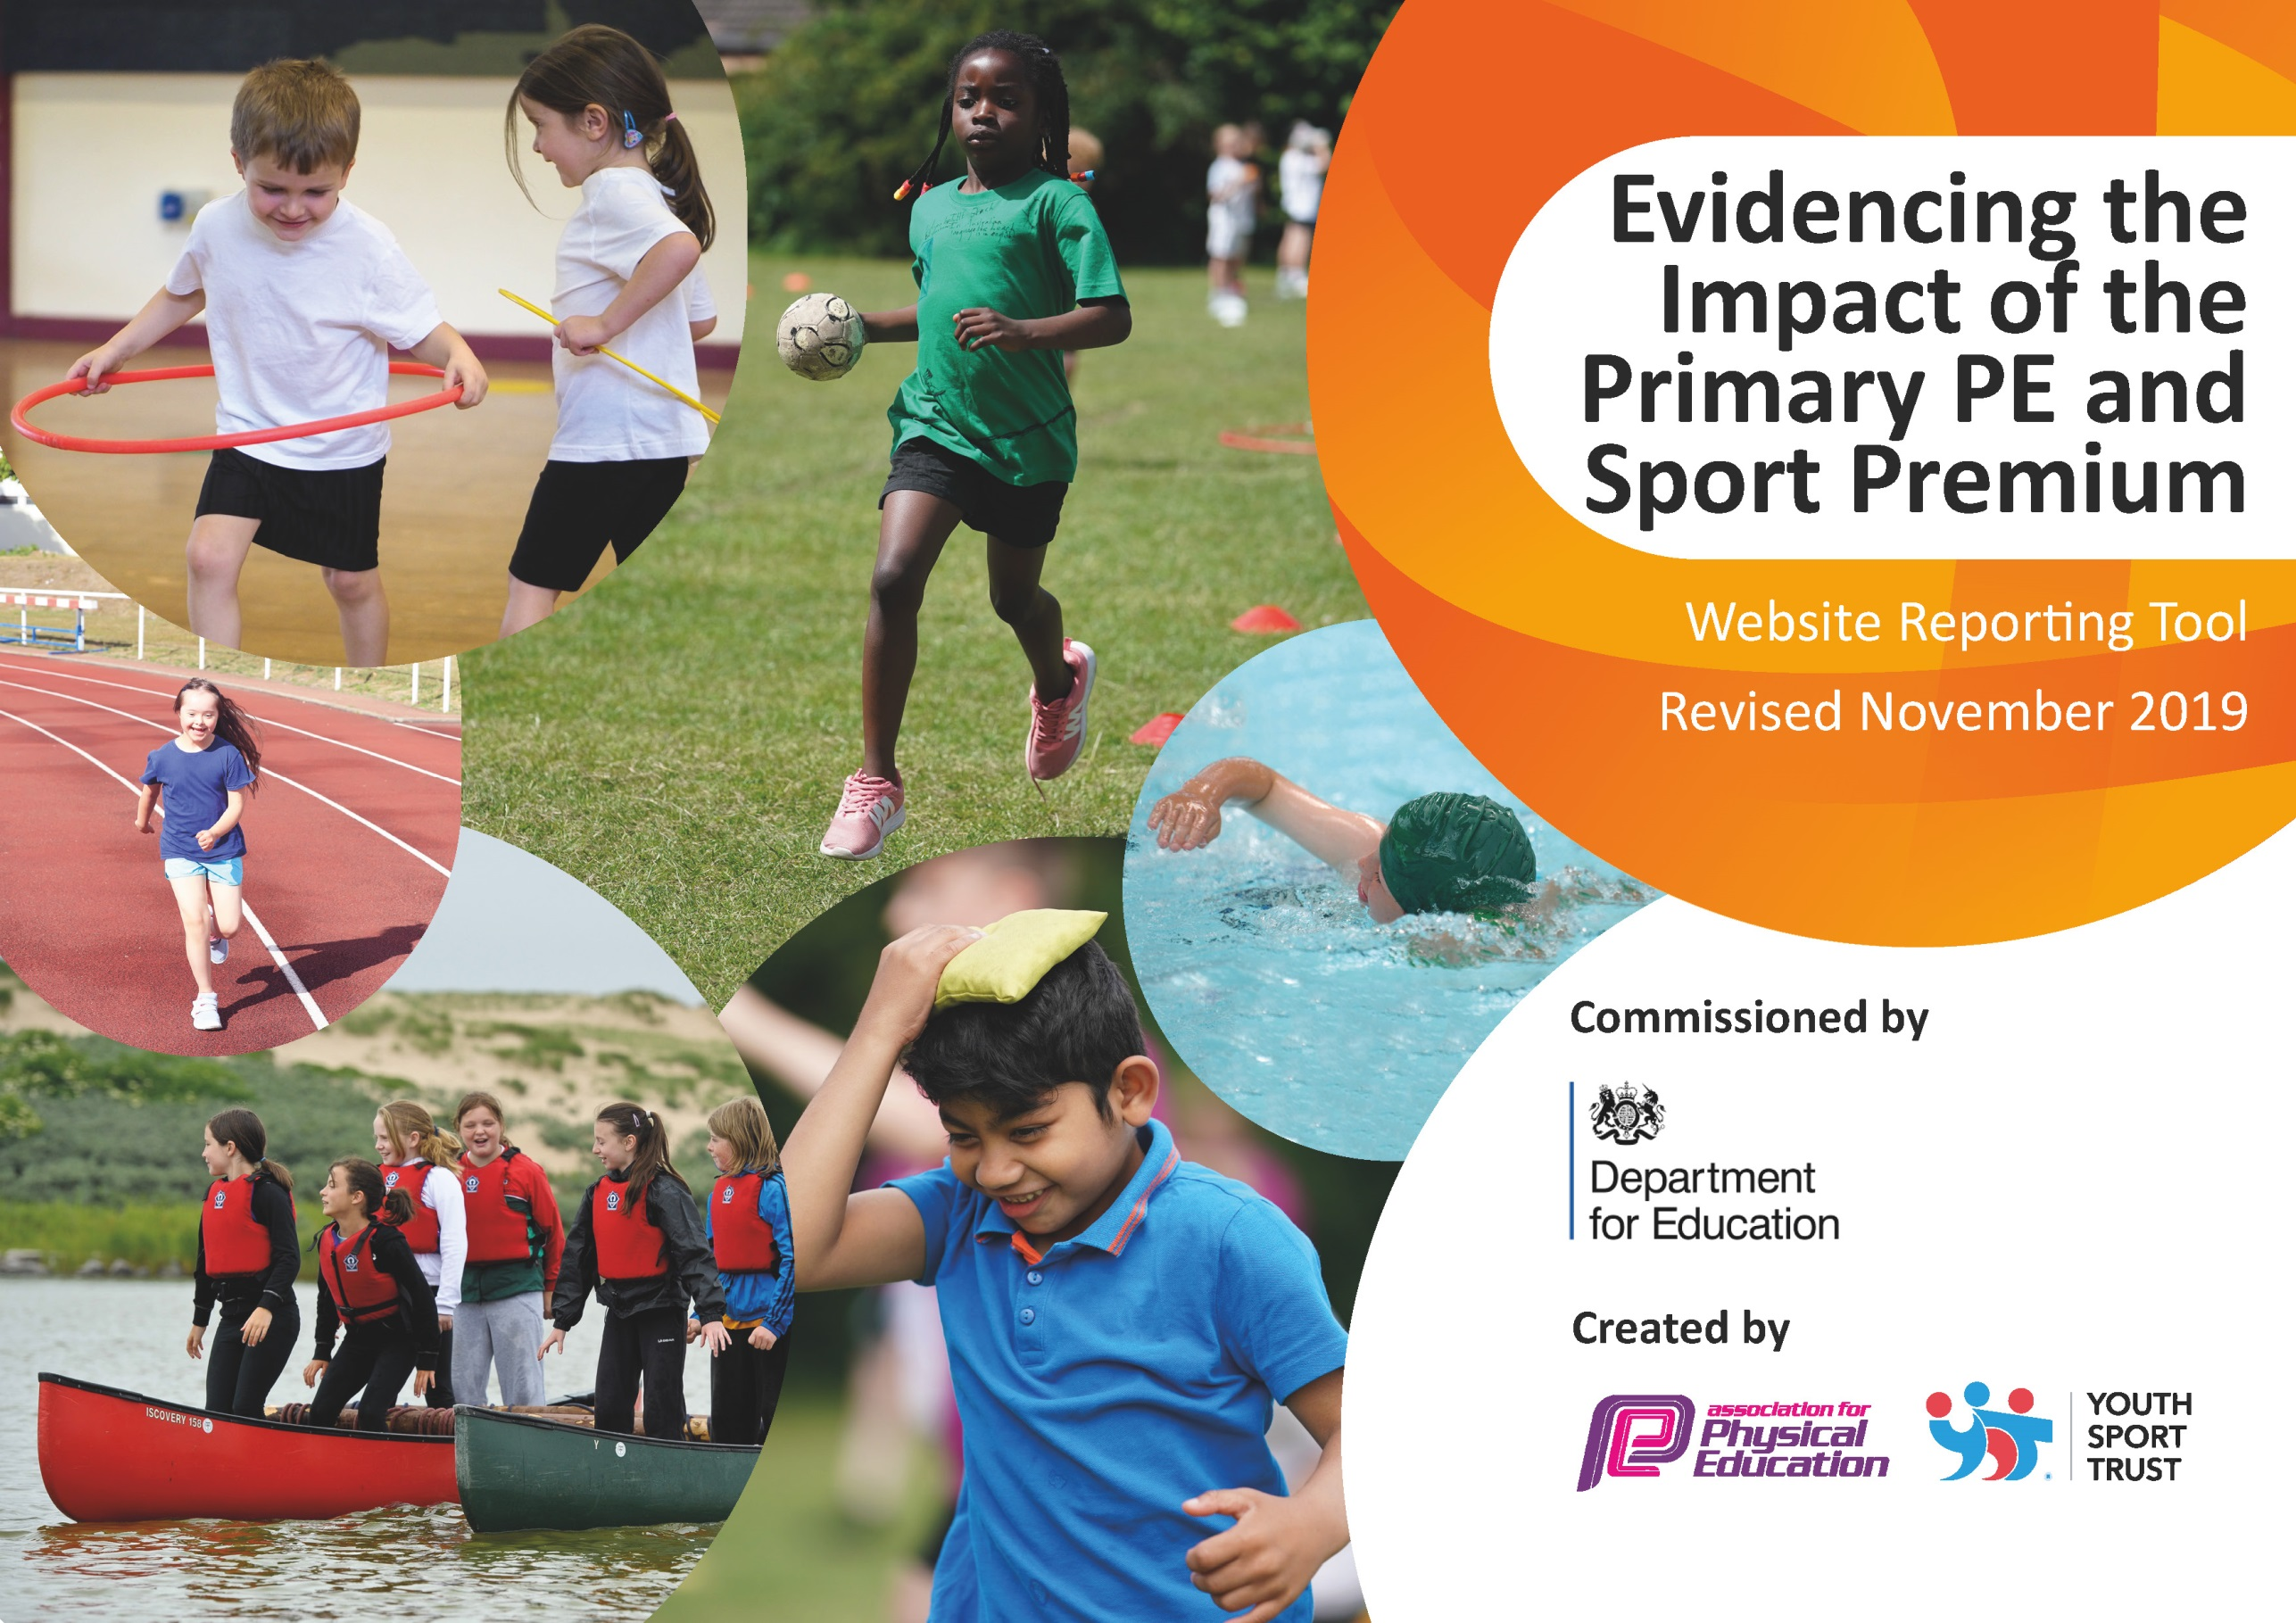
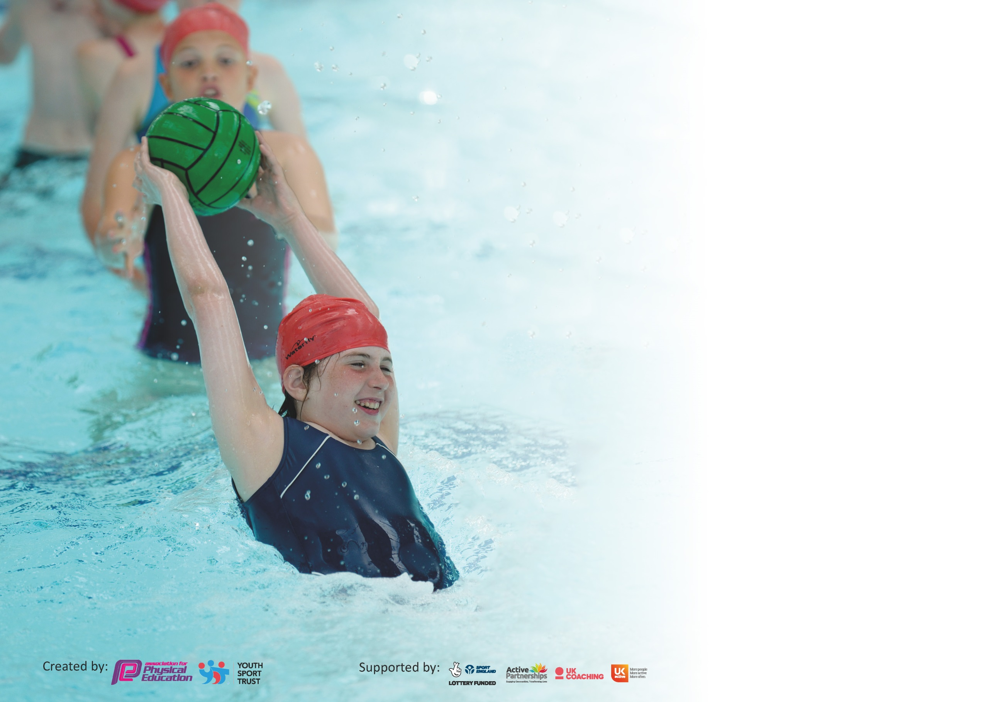

It is important that your grant is used effectively and based on school need. The Education Inspection Framework (Ofsted 2019 p64) makes clear there will be a focus on ‘whether leaders and those responsible for governors all understand their respective roles and perform these in a way that enhances the effectiveness of the school’.

Under the Quality of Education criteria (p41) inspectors consider the extent to which schools can articulate their curriculum (INTENT), construct their curriculum (IMPLEMENTATION) and demonstrate the outcomes which result (IMPACT).

To assist schools with common transferable language this template has been developed to utilise the same three headings which should make your plans easily transferable between working documents.

Schools must use the funding to make additional and sustainable improvements to the quality of Physical Education, School Sport and Physical Activity (PESSPA) they offer. This means that you should
use the Primary PE and Sport Premium to:

- Develop or add to the PESSPA activities that your school already offer
- Build capacity and capability within the school to ensure that improvements made now will benefit pupils joining the school in future years

Please visit gov.uk for the revised DfE guidance including the 5 key indicators across which schools should demonstrate an improvement. This document will help you to review your provision and to report your spend. DfE encourages schools to use this template as an effective way of meeting the reporting requirements of the Primary PE and Sport Premium.

We recommend you start by reflecting on the impact of current provision and reviewing the previous spend.

Schools are required to publish details of how they spend this funding as well as on the impact it has on pupils’ PE and sport participation and attainment by the end of the summer term or by 31st July 2020 at the latest.

We recommend regularly updating the table and publishing it on your website throughout the year. This evidences your ongoing self-evaluation of how you are using the funding to secure maximum, sustainable impact. Final copy must be posted on your website by the end of the academic year and no later than the 31st July 2020. To see an example of how to complete the table please click HERE.

Support for review and reflection - considering the 5 key indicators from DfE, what development needs are a priority for your setting and your pupils now and why? Use the space below to reflect on previous spend and key achievements and areas for development.

Key achievements to date until July 2021 | Areas for further improvement and baseline evidence of need:
Increased daily physical activity in school through weekly mile.  Attended all cluster competitions. (Covid 19)  Widespread participation in cluster competitions in KS2. (Covid 19)  100% of KS2 children with SEN participate in SEN games competitions.  Staff training in increasing participation and enthusiasm for multi-skill games  PE - Progression Curriculum Map | To increase Physical Activity – purchase a class set of pedometers.  To develop staff’s knowledge of how to deliver active math’s and physical English lessons.

Meeting national curriculum requirements for swimming and water safety.
What percentage of your current Year 6 cohort swim competently, confidently and proficiently over a distance of at least 25 metres?  N.B. Even though your pupils may swim in another year please report on their attainment on leaving  primary school at the end of the summer term 2020. | 100%
What percentage of your current Year 6 cohort use a range of strokes effectively [for example, front crawl, backstroke and breaststroke]? | 100%
What percentage of your current Year 6 cohort perform safe self-rescue in different water-based situations? | 100%
Schools can choose to use the Primary PE and Sport Premium to provide additional provision for swimming but this must be for activity over and above the national curriculum requirements. Have you used it in this way? | Yes – catch up for Year 5/6

Action Plan and Budget Tracking
Capture your intended annual spend against the 5 key indicators. Clarify the success criteria and evidence of impact that you intend to measure to evaluate for pupils today and for the future.

Academic Year: 2020/21 | Total fund allocated: £19,030 and roll over from the previous year due to COVID was of £3,730  Total of £22,760 | Date Updated: 22.9.2020
Key indicator 1: The engagement of all pupils in regular physical activity – Chief Medical Officer guidelines recommend that primary school pupils undertake at least 30 minutes of physical activity a day in school |  |  |  | Percentage of total allocation:
 |  |  |  | %
Intent | Implementation |  | Impact
Your school focus should be clear what you want the pupils to know and be able to do and about  what they need to learn and to  consolidate through practice: | Make sure your actions to achieve are linked to your intentions: | Funding allocated: | Evidence of impact: what do pupils now know and what can they now do? What has changed? | Sustainability and suggested next steps:
To ensure Children continue to do 30  minutes of physical activity each day. The physical and mental  benefits aim to support not only  the health of a child but also  support their capacity to learn. | Active 30 minutes activities undertaken in each year group each day this may include activities in lessons such as Super Movers etc. provision for organised playtime sports and dedicated PE time. |  | Children demonstrate positive mental attitudes which includes good behaviours and engagement in learning (evidence staff evaluation).
All pupils will have the opportunity to participate in high quality PE lessons.  Including in a safe environment with appropriate and good quality equipment.  Staff running games. | Delivery of high quality provision is supported by  - Sports coach  - Purchase of PE equipment to maintain high quality resources  - Grounds maintenance and markings / sports day markings  - PE equipment inspection  - Hall floor maintenance | £1,800+on costs  £3,000  £900  £120  £250 | Timetable provision  Monitoring of pupil progress through school tracking programme
Lunchtimes and after school (COVID restricted) activities will have a focus of Healthy Lifestyles.  After school sports provision facilitated by school staff and some external providers to enable children to take part in sporting activities to promote healthy lifestyles including mental well-being.  Girls Football – Leeds Wildcats  Chance To Shine Cricket  Tennis Goole Tennis Club | KS1 children to have opportunity at lunchtimes sporting activities/clubs supervised by staff trained to facilitate this. (normally without COVID restrictions this would be facilitated by KS2 Sports Leaders)  Team Games  Multi sports  KS2  Football  Dodge ball  Bench Ball  Netball  Rugby  Orienteering  Curling  Archery  Golf  Kwik Cricket  Cross Country  (Pending COVID RESTRICTIONS) | £2,841 (staffing)  £1200 | Fully attendance achieved through club registers  Positive feedback from pupils and parents  More confident and motivated children | Continuation of provision  To ensure there is something for everyone  Continuation of extra curricula clubs  Continued use of outdoors.
Children to access swimming lessons in the Summer Term.  To accelerate progress children will have a block of 5 weeks intensive sessions – each of 2 hours. | Swimming Lessons delivered to year four.  Catch up if restrictions allow Year 5/6 | £1,500  £1,200 | Percentage of children of attaining expected standard increase from previous years to ensure that by the end of year 6 the school can attain an aspirational 100%.
To improve provision at  playtimes and lunchtimes.  ensuring all children have  access to resources which  will support them in their  physical development.  Having access to more ‘active’  play will help to ensure the  children are achieving their  daily ‘active 30.’ | Purchasing of equipment following survey from School Council  This may include:  Tennis/volleyball nets  Bats  Rebounder  Balls – airflow  - Netballs  - Basketballs  - Plastic balls  - Cricket balls  - Plastic bats  - Hoops  - Netball posts  - Tennis nets  - Cricket bats  Each class to have own equipment to look after! | £2,500 | Children are more engaged at  playtimes and lunchtimes  through active play, ensuring  they are active and are  taking part in more physical  activities.  The access to these resources  encourages children to use their  imagination and be creative in  play.
Key indicator 2: The profile of PESSPA being raised across the school as a tool for whole school improvement |  |  |  | Percentage of total allocation:
 |  |  |  | %
Intent | Implementation |  | Impact
Your school focus should be clear what you want the pupils to know and be able to do and about  what they need to learn and to  consolidate through practice: | Make sure your actions to achieve are linked to your intentions: | Funding allocated: | Evidence of impact: what do pupils now know and what can they now do? What has changed? | Sustainability and suggested next steps:
To uphold the Gold Award, therefore giving the children and staff the  recognition they deserve for all their improving sport at Snaith Primary.  To continue to develop leadership of sport.  To attend training opportunities through SSCo. | Monitoring and reporting on the  standards and achievement in PE  and sport.  Deputy Subject Lead to work alongside Lead to monitor the quality of sport provision.  Continued upskilling of staff and pupils when possible  Games taster sessions for Staff after Staff survey to find out which area they’d like. | £120 (cost of cover)  Part of SLA | Award successfully upheld. | To seek to attain Platinum in subsequent years.  Succession planning for leadership.
To further develop healthy lifestyles and food choices, alongside mental health and wellbeing. | Hold whole school Challenge initiatives to promote Health and Fitness and pupil participation. Cross curricular links to Science and PSHCE  Link to Pedometer  Like partnership challenge e.g. Plank Challenge | £4500  SSCO Funding  £2000  £250 | Displays in school  - Sporting achievements (including celebrating children’s achievements outside school)  - Leader boards for fitness and fun  - To celebrate Sports Days  Children show healthy attitude to sport  Children show positive attitude to competition (pupil surveys)  Children show team spirit and sportsmanship (staff and visitor feedback)

Key indicator 3: Increased confidence, knowledge and skills of all staff in teaching PE and sport |  |  |  | Percentage of total allocation:
 |  |  |  | %
Intent | Implementation |  | Impact
Your school focus should be clear | Make sure your actions to | Funding | Evidence of impact: what do | Sustainability and suggested
what you want the pupils to know | achieve are linked to your | allocated: | pupils now know and what | next steps:
and be able to do and about | intentions: |  | can they now do? What has
what they need to learn and to |  |  | changed?
consolidate through practice:
Increase confidence, knowledge and skills of cross-curricular teaching of PE.  Use of Sports specialist teaching plus SSCO courses  Review of our curriculum map with staff and its implementation with staff collaborating and coaching each other to show high quality delivery.  Staff meetings and feedback from Sports subject coordinator. | Teaching the awareness of Healthy Life Styles  KS1 staff to be trained in Multi-skills / Playground Games by Owen Donovan.  Specialist PE teacher to work alongside class teachers | SSCO | Confident and inspirational teaching of all aspects of sport and PE across school and when taking part in cluster and county events.  The school’s tracking system for PE shows progression with more able children –FLIC ( monitored by subject leader)  More able children are up-skilled  and can share their expertise with  their peers - Young Leaders.  Children who need more support will be given a modified activity to complete, ensuring they are still feeling confident at their level. | Continuation to be a high profile and well led aspect of the school.  Staff will be upskilled through their work with Owen Donovan and Specialist sport teacher.(see indicator4)
Key indicator 4: Broader experience of a range of sports and activities offered to all pupils |  |  |  | Percentage of total allocation:
 |  |  |  | %
Intent | Implementation |  | Impact
Your school focus should be clear | Make sure your actions to | Funding | Evidence of impact: what do | Sustainability and suggested
what you want the pupils to know | achieve are linked to your | allocated: | pupils now know and what | next steps:
and be able to do and about | intentions: |  | can they now do? What has
what they need to learn and to |  |  | changed?
consolidate through practice:
 | The promotion of greater awareness of a Healthy Lifestyle  Awareness of mental health and well being |  | Children can understand and talk confidently about their knowledge of what a healthy lifestyle means and how being positive makes you feel better. | Continuation to be a high profile and well monitored aspect of the school including displays for promotion.  Timetabled clubs
Children have access to working with inspirational/ professionals within different disciplines of sport leading to high quality delivery of skills and knowledge and staff enhancing their skills through engagement with professionals.  Yorkshire Cricket Club ‘Assembly’ Competitions. | Sports coaches to be invited into school to support teaching staff and enhance the children’s skills in that particular sport. | Part of SSCo funding. Additional cost £150 (£300 allocation for opportunities arising) | Key note speakers and links with coaches and professionals to share  - Skills  - Knowledge  - Life experiences  Chance To Shine Cricket  Tag Rugby | Teaching staff to be in attendance to develop their skills to continue delivery if high quality sessions.

Key indicator 5: Increased participation in competitive sport |  |  |  | Percentage of total allocation:
 |  |  |  | %
Intent | Implementation |  | Impact
Your school focus should be clear | Make sure your actions to | Funding | Evidence of impact: what do | Sustainability and suggested
what you want the pupils to know | achieve are linked to your | allocated: | pupils now know and what | next steps:
and be able to do and about | intentions: |  | can they now do? What has
what they need to learn and to |  |  | changed?
consolidate through practice:
To attend the majority of the SSCo events for all A, B and C teams.  Giving all children the opportunity to take  part in out of school sporting events at their own level, ensures we are being fair and allowing all children whatever their ability to enjoy sport. | Good quality equipment and suitable storage  Host intra-school competitions – KS1  Host inter-school competitions.  School Sport Development Officer to  organise and attend events through the cluster and SSCo events. | £1,200 (bursary for organising events)  £1,500 (attendance of SSCo meetings)  SLE Sports Premium £3,900 Estimated Transportation costs £2,500 | School Sports events including the SSP calendar  All children have the opportunity at school level as part of the selection process.  Registers of evidence to show  A,B and C team selections across a  range of physical activities.  Children are confident to take part in competition (evident through selection logs/ registers). | Ensure the full participation in the annual calendar of events.

Signed off by
Head Teacher: | Helen Calpin
Date: | November 2020
Subject Leader: | Jean Richardson
Date: | November 2020

