Reading Spine

Updated March 2024

Our Reading Spine

The Purpose of the reading spine is to ensure that all children have exposure to high quality texts, which are of a higher level than those books that they would usually read to develop their reading skills. The aim is for every child to experience the pleasure and challenge of great literature and develop their love for story.
Each year group has a selection of quality core texts that can be enjoyed with the children through a teacher led ‘read aloud’ programme which can also be supplemented by other texts.
The Reading Spine has been carefully selected to ensure that the children have a range of core texts that are progressive over time but more importantly, allow the children to be immersed in story language and when read with expression, the stories will come alive for the children which will allow them to build their imaginations, supporting them as learners.
“A child who is read to will have an inner kingdom of unicorns, talking spiders and a knife that cuts into other worlds” Pie Corbett.

In the Foundation Stage and Year One, the core texts are picture books, with which the children should build a strong acquaintance. Year Two is a transitional year where the core texts include a range of picture books and chapter books, which will then be supplemented through guided, shared and independent reading. For all Key Stage Two classes, the core texts are novels with the addition of a core picture book, which again allows teachers to supplement the children’s reading through guided, shared and independent reading. At Snaith Primary School, we also value the importance of high-quality non-fiction texts (which are usually related to the curriculum focus being studied) and poetry (which the children will have the opportunity to enjoy, perform and discuss).

In Key Stage Two, some of the texts are linked with the curriculum focus which is a two-year rolling programme. Therefore, the Reading Spine for Lower Key Stage Two and also for Upper Key Stage Two, is a two-year rolling programme.
2023-24: LKS2 - Year 4, UKS2 – Year 6
2024-25: LKS2 – Year 3, UKS2 – Year 5

Each classroom has their own ‘Reading Spine Book Box’ which contains a copy of each text on their respective year group list.
In the Foundation Stage and Key Stage 1, children will have access to each book as a physical copy and / or shown on a screen.
In Key Stage 2, wherever possible, children are to have access to class sets to enable all children to follow the text when being read to.
Ideally, all children are to have access to quality read aloud sessions at least three times per week.

All classrooms have a ‘We are Reading’ sign on or near their door, which displays the title and author of the text that is currently being enjoyed by the class during the ‘read-aloud’ programme.

Our ‘Reading Spine’ is to be reviewed on an annual basis through discussion and consultation with teachers and pupils, whilst paying attention to texts that have been recently published and may be suitable.

March 2024

Nursery Reading Spine
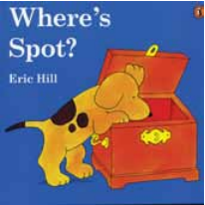 | 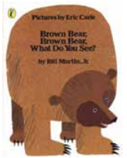 | 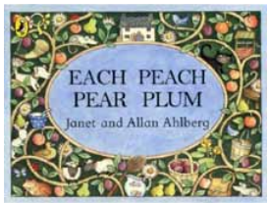
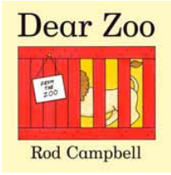 | 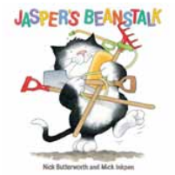 | 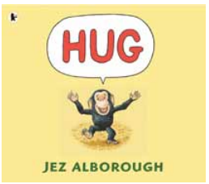
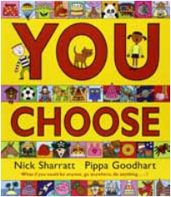 | 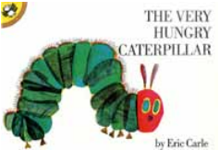 | 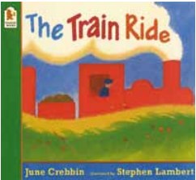
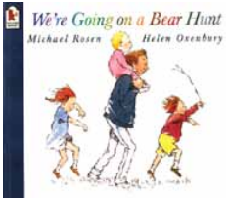 | 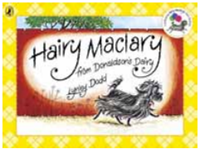 | 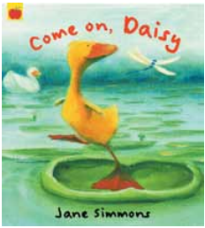

Reception Reading Spine
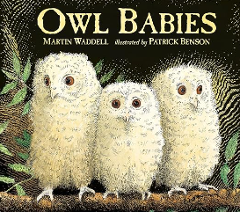 | 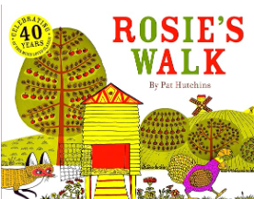 | 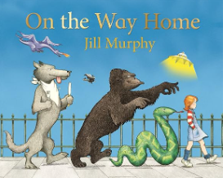
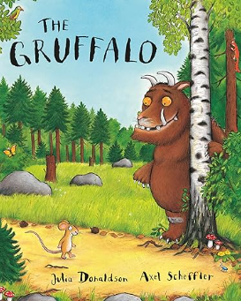 | 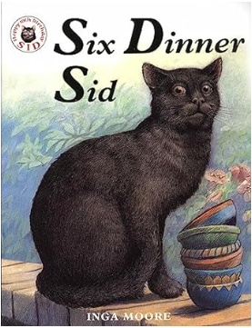 | 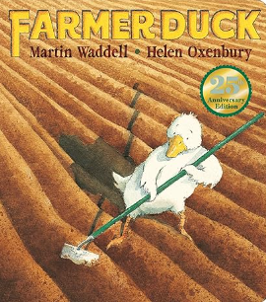
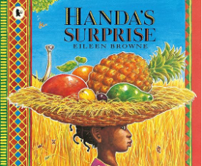 | 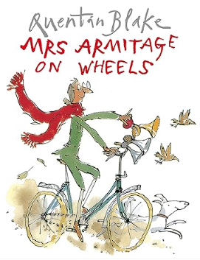 | 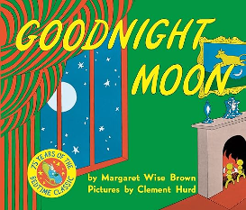
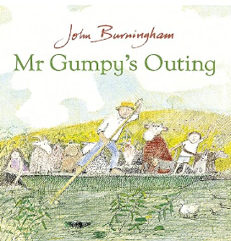 | 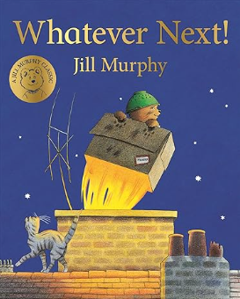 | 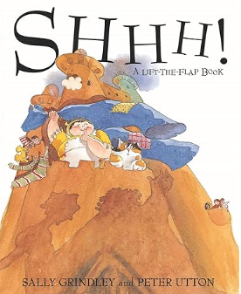

Year 1 Reading Spine
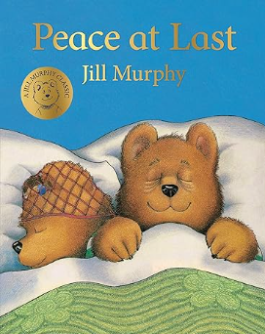 | 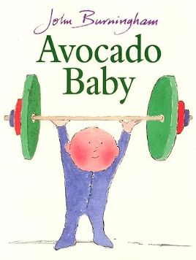 | 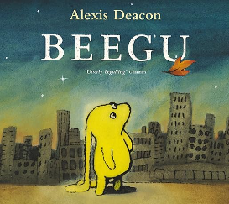
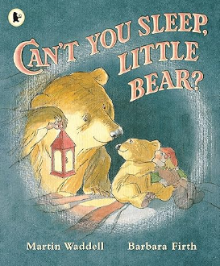 | 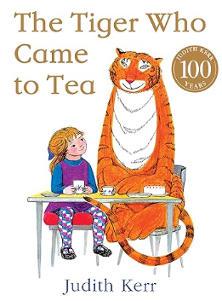 | 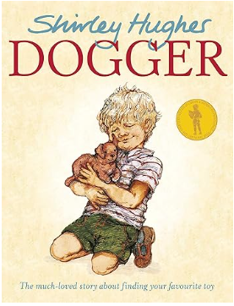
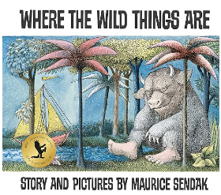 | 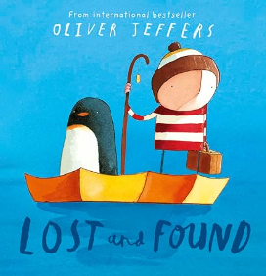 | 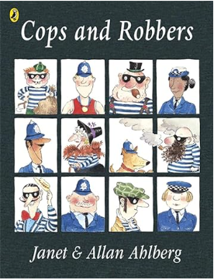
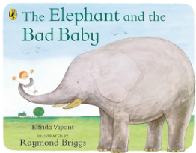 | 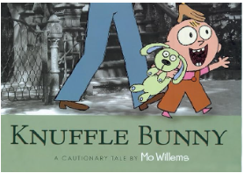 | 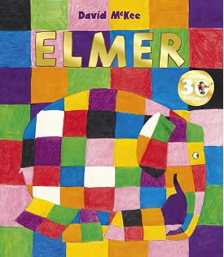

Year 2 Reading Spine
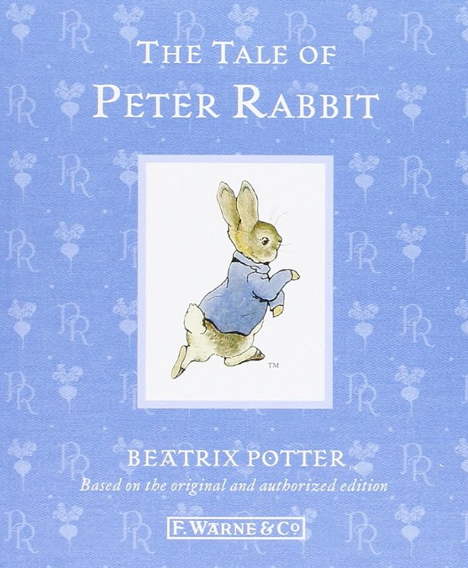 |  | 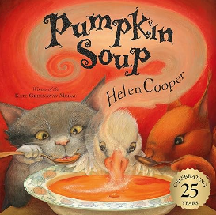 |  | 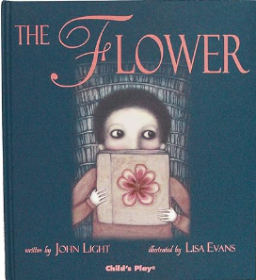
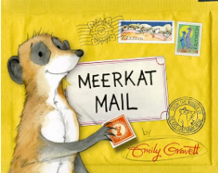 |  | 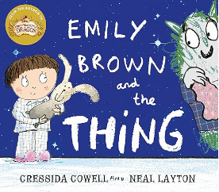 |  | 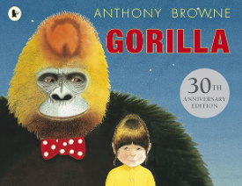
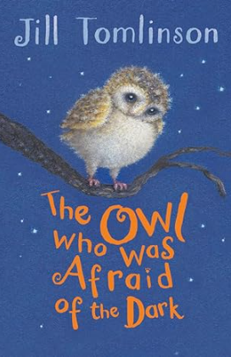 | 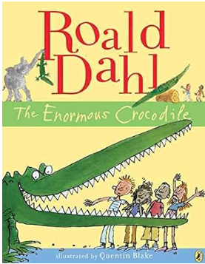 |  | 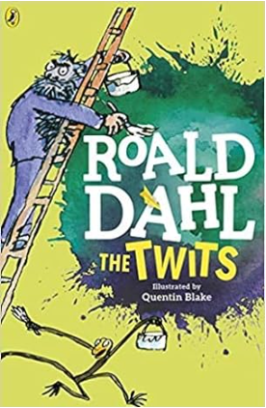 |  | 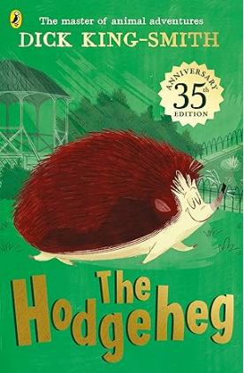
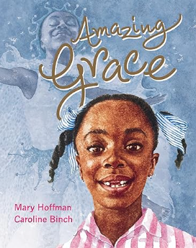 | 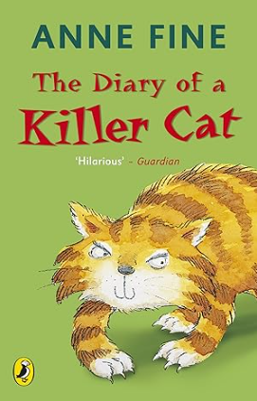 |  | 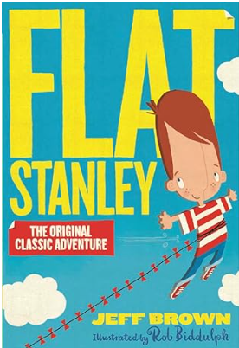 |  | 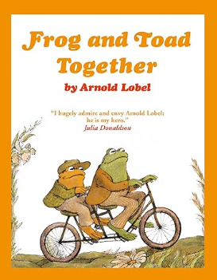
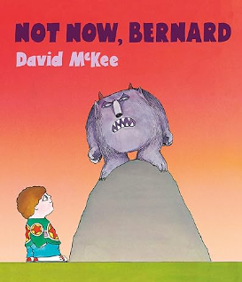 | 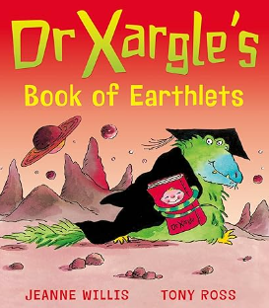 |  | 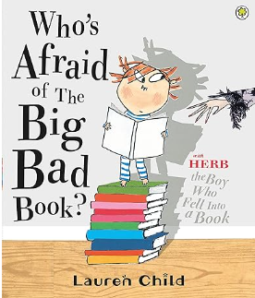 |  | 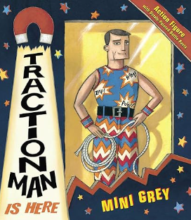

Year 3 Reading Spine
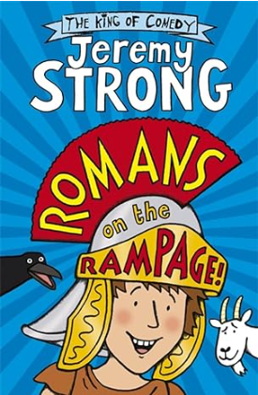 | 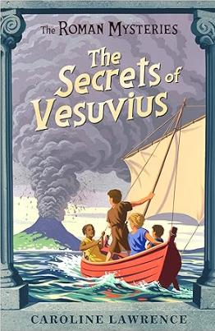
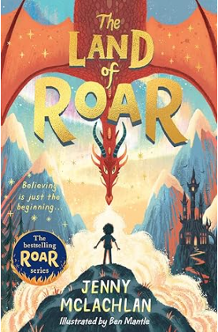 | 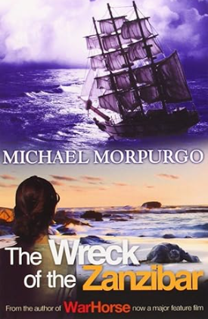
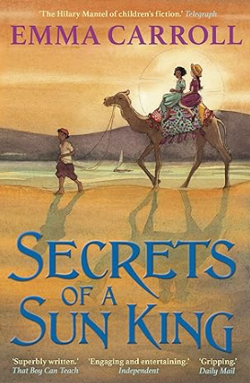 | 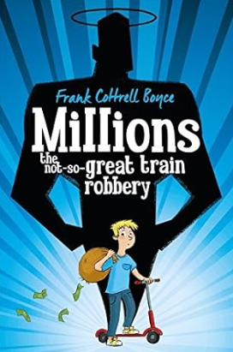
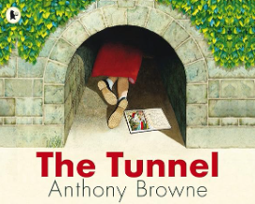

Year 4 Reading Spine
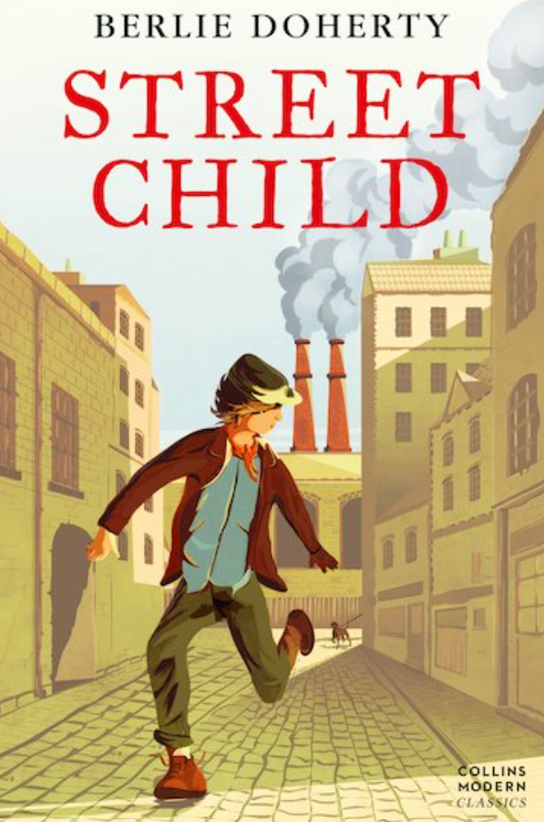 | 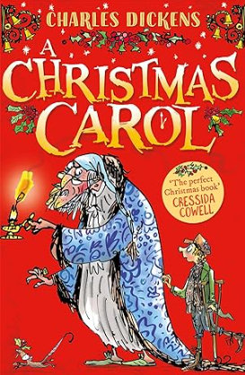
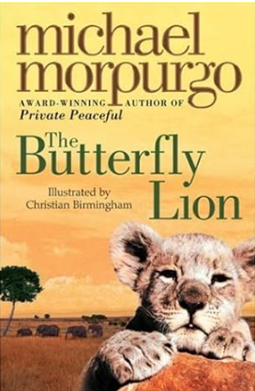 | 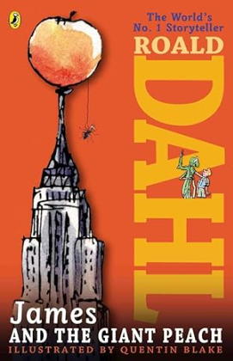
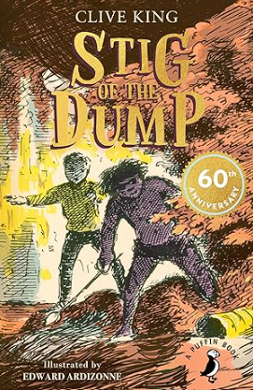 | 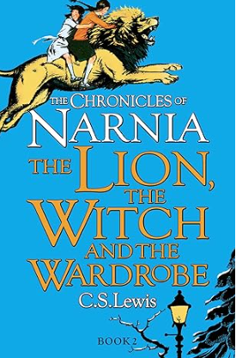
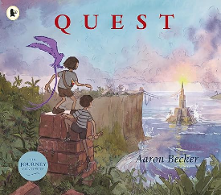

Year 5 Reading Spine
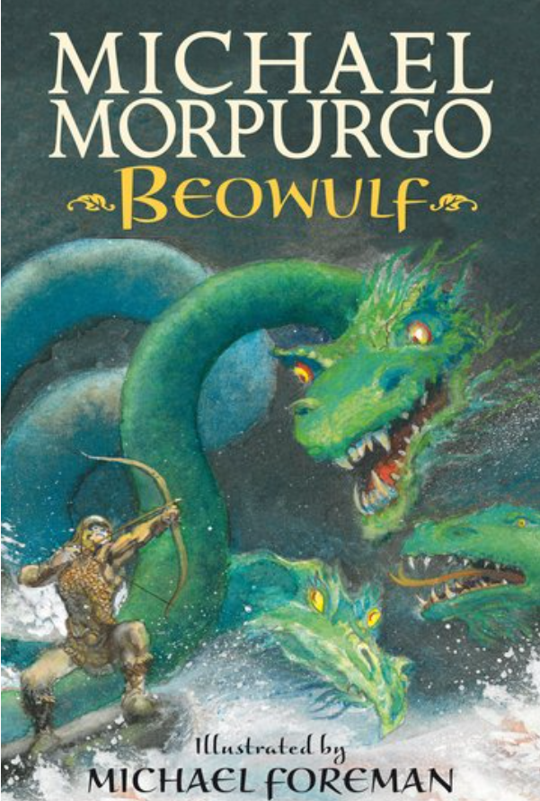 | 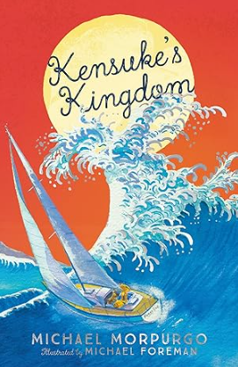
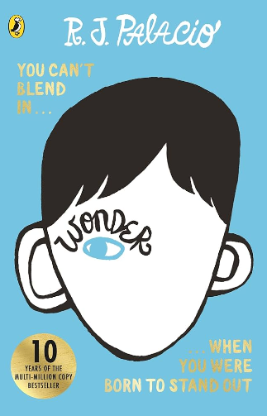 | 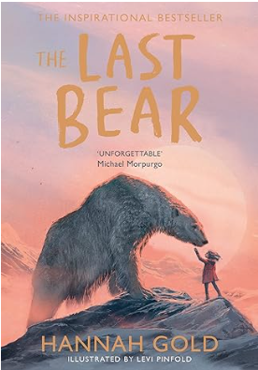
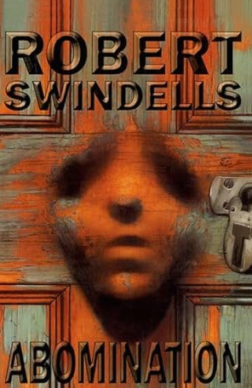 | 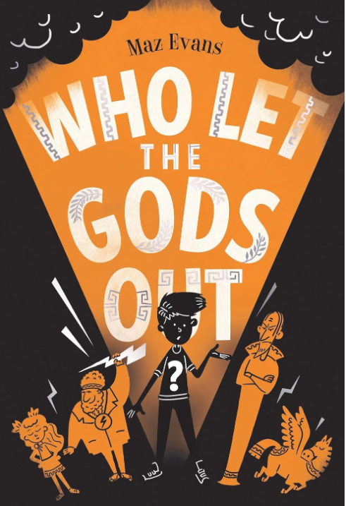
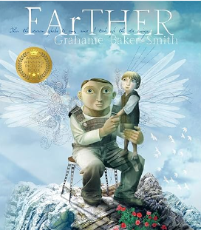

Year 6 Reading Spine
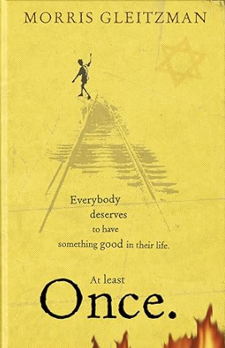 | 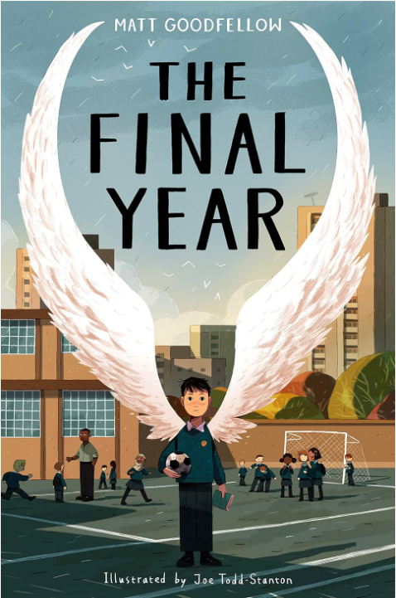
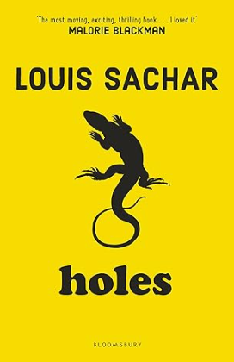 | 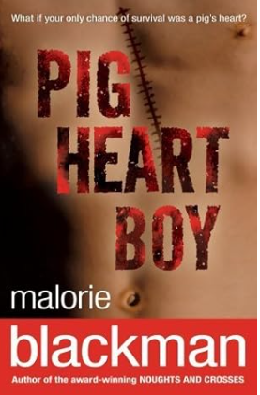
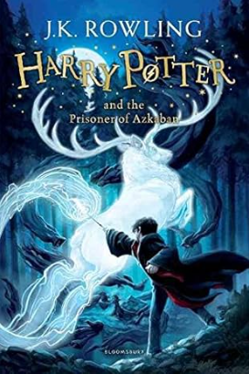 | 

