Snaith Primary School

Religious Education

Year A and Year B
RE as a Multi-disciplinary Subject
Each focus is covered and colour co-ordinated in each of the units throughout the year.
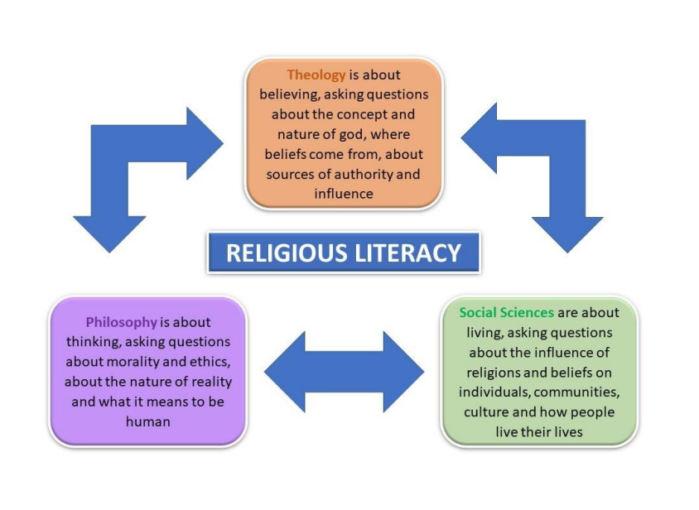
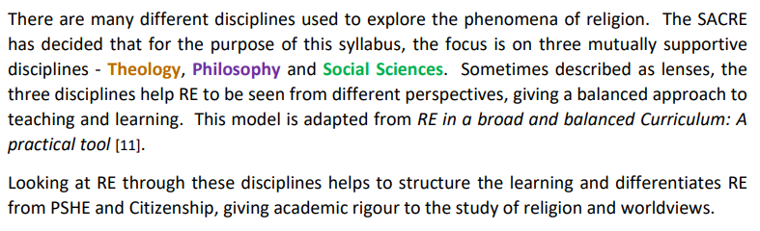

RE Key Stages 1 & 2
Year A

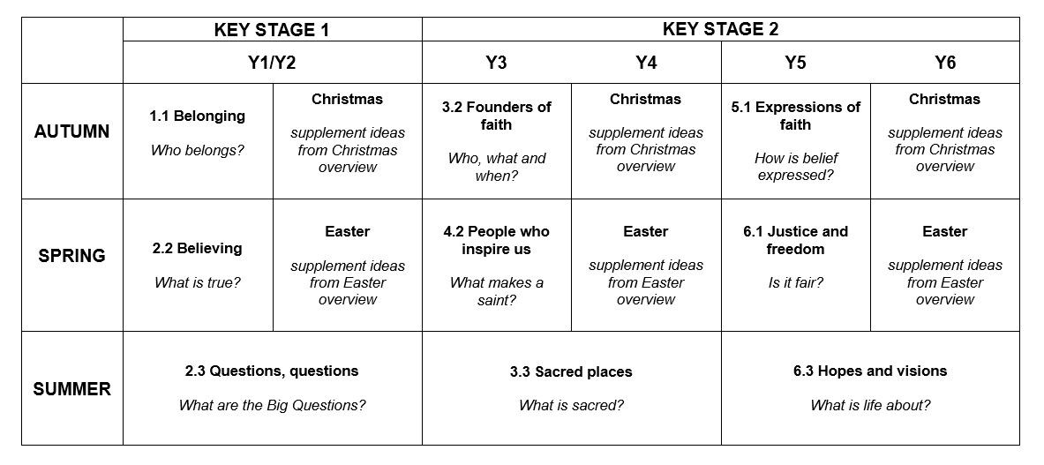

Key Stages 1 & 2
Year B

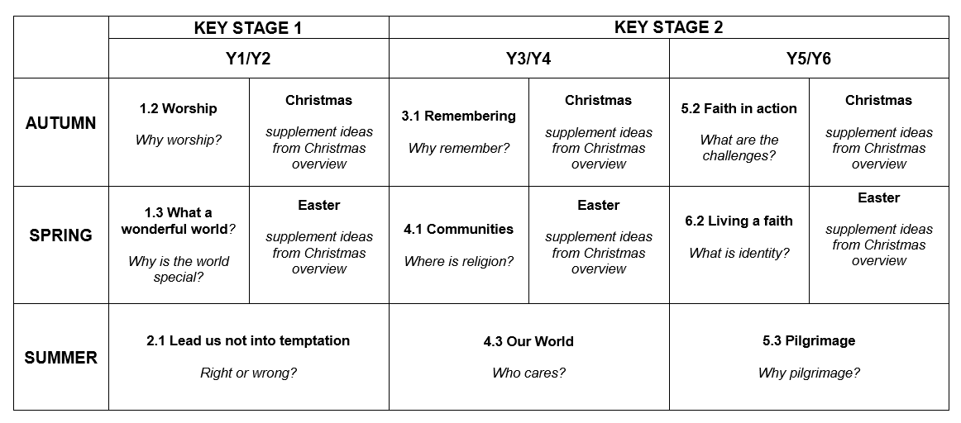

Year A

Autumn Term
Unit 5.1: Expressions
Key Question: How is belief expressed?
About this unit
Through the lens of Social Science, pupils investigate religious expression in all its diversity, considering different ways of expressing belief through range of creative media and in their actions. They explore the meaning of symbols and activities expressing belief.

By the end of this unit, pupils will recognise different forms of spiritual and religious expression within and between religions and denominations. Also see the KS2 Christmas2 unit which may follow.

Our Rainbow Threads
Concepts
People of God, gospel, worship, spiritual, community
Vocabulary
expression, spiritual, environment, identity, individual, symbol

Exploring | Learning Outcomes  By the end of KS2 pupils should be able to
How do believers worship? | describe some different ways people communicate with their god  consider the meaning of different forms of religious worship and how they are expressions of belief
How do people express their beliefs? | identify symbols and artefacts which are important for at least two different faiths  explain how artefacts and symbols express the beliefs of faith members  recognise different forms of religious and spiritual expression
Prior knowledge
The unit builds on Unit 1.2 Worship and Unit 3.3 What is sacred? Recall visits made to places of worship and conversations with faith members, and the personal use of symbols to express faith

Identify learning questions: How is faith expressed?
What are some expressions of faith?
How can the arts express beliefs and ideas?
How do faith members creatively express their beliefs?
Where do people worship?
How are places of worship expressions of belief?
Is worship only one expression of faith?
When and where do faith members worship in silence?
What are common forms of expression in religious worship from different faiths? How might a believer feel a sense of belonging when participating in worship?

Enquiry: consider
- Religious expression in all its diversity
- How religious building are expressions of faith in their shape and design
- Different styles of music as expressions of faith, including singing in ‘gospel’ style
- Different art forms expressing beliefs, including islamic art, iconostasis, murtis, buddhist thankas • beliefs represented through the arts
- Expressions of worship within different faiths and denominations talking to a faith member about personal religious expression and how it promotes a sense of belonging
- How people of faith express their spirituality
- The inspiration and spiritual impact of nature

Mastery Thinking Questions
Question a faith member about how they express their religious beliefs Discuss what might be described as ‘secular worship’ Are gifts of money better than gifts of time or attention?

Reflect on learning
Reflect on a collection of symbols and artefacts; what do they say about the person who uses them?
Reflect on the feelings that different forms of religious expression create, such as joy, hope, unity, belonging, peace

Progression exemplars

Identify the importance of symbolism in the expression of beliefs
Describe different forms of worship and spiritual expression and explain where they might take place

This contributes to the following End of Key Stage statements:
• Demonstrate understanding of how people express their identity and their spirituality through symbols and actions

Curriculum Links

Jigsaw:
- Being Me in My World
- Celebrating difference

Autumn 2
Unit: Christmas
About this unit
This is a supplementary unit designed to help teachers ensure progression when exploring the festival of Christmas across Key Stage 2. It continues to explore the concepts of Incarnation, God and Messiah. Revisit different gospel accounts of the nativity story and consider the different perspectives of the key characters. Check what Old Testament prophecies say about the coming of the Messiah.

The focus for Year 5 is Peace and for Year 6 the focus is on diverse and global celebrations. It may be useful to consider festivals of light from other faith festivals alongside Christmas.

Concepts
incarnation, People of God, Kingdom of God, Messiah, secular Vocabulary
gospel, Prince of Peace, prophecy

Exploring | Learning Outcomes  By the end of KS2 pupils should be able to
How do the lives of faith founders influence believers? | identify key events in the lives of faith founders and their impact on those around them  explain the relevance of different faith founders for their followers today
What is the value of participating in a religious festival or ritual? | compare the experience of participating in a religious festival or celebration around the world  reflect and share how religious celebrations and rituals have an impact on the community
Prior knowledge
This unit builds on learning about Winter festivals in Years 3 and 4

Identify learning questions What is peace?
Did Jesus bring peace?
What is the message of Christmas for Christians?
Is Christmas only for Christians?
What does Christmas mean in society today?
What do the different gospel writers say about what happened at Christmas? How does this link with Old Testament prophesy?

Enquiry: consider
Year 5
- Different titles for Jesus - Prince of Peace, Messiah, Light of the World
- Listening to Handel's Messiah and link to Isaiah’s prophecy
- A series of images and symbols expressing peace and harmony in art and literature
- How the message of Christmas is celebrated around the world
- Festivals of peace celebrated throughout the year

Year 6
- How Luke’s account of the Christmas story is different from Matthew’s other stories which have developed from the gospels - The Fourth Wise Man, Papa Panov, Baboushka
- Contrasting the mood of secular/religious Christmas images, icons, poems and music
- Similarities between key aspects of festivals celebrated by different faiths

Mastery Thinking Questions
Explore the statement “Everyone has the right to enjoy peace… Declaration on the Right to Peace, UN General Assembly 2016.
Was Jesus the Messiah?
As a community of enquiry, debate: Is Christmas only for Christians?

Reflect on learning
Reflect on the relevance of different Jesus for his followers today
Reflect on the impact that Christmas celebrations and rituals have on communities

6.1 Justice and Freedom
Key Question: Is it fair?
About this unit
This unit provides opportunities for pupils to use a Philosophical lens to explore and explain the concepts of justice and freedom; to consider how justice is significant in stories from religions and in secular life; to consider, through the lens of Theology, what religions teach about forgiveness and how reconciliation may take place. This unit has strong links with citizenship, British values and personal and spiritual development.

By the end of this unit pupils should be able to explain what freedom and justice, forgiveness and reconciliation mean; they show how this is demonstrated in the lives of people of different faiths and worldviews. Also see the KS2 Christmas2 unit which may follow.

Our Rainbow Thread
Concepts
People of God, Kingdom of God, God, justice and freedom, authority, universal
Vocabulary
forgiveness, reconciliation, harmony, moral, ethical, parable

Exploring | Learning Outcomes  By the end of KS2 pupils should be able to
What is the meaning of justice and freedom? | explain what freedom means to people of faith  show understanding of the beliefs and feelings of faith members who have experienced injustice  explain their hopes and dreams for a just world
Why should people be good? | identify the responses of different religions to ethical questions
What do religions teach about forgiveness and reconciliation? | identify the impact of a religious teaching such as forgiveness on a believer’s actions  describe the ways in which people of faith have demonstrated forgiveness and reconciliation  identify the impact that reconciliation has on community harmony
Prior knowledge
Recall learning about making choices in Unit 2.1 Lead us not into temptation
Identify learning questions: Is it fair?
What does it mean to be fair? Is justice the same as fairness?
Can one person make a difference to issues of social justice and global inequality?
What does freedom mean to people of different faiths and to those with no faith?
What would the world be like without forgiveness? Is it easy to forgive?
What do different religions teach about forgiveness? What might a Humanist say about forgiveness?
What is meant by reconciliation; how can people be reconciled?
How do people respect and relate to each other; what motivates that respect?

Enquiry: consider
- How it feels to be treated differently
- The meaning of freedom to individuals and to different faith communities
- Issues of personal, social and global injustice, looking at examples of how people of faith work to address issues such as those raised by the holocaust (Shoah)
- What happens when people of faith are treated unjustly
- Joseph and his brothers (examples of justice, freedom, forgiveness and reconciliation)
- Jesus’ teaching about justice and forgiveness: sermon on the mount; parables of the good Samaritan and the unforgiving servant, Jesus healing the leper, Jesus speaking about the unfairly treated - women, children and non-Jews
- How following god can bring freedom and justice, according to Christian teaching
- How the teaching of forgiveness is central in two or more faiths
- The practice of restorative justice in school
- The ways in which a person of faith has demonstrated forgiveness and reconciliation and why
- The reconciliatory work of Corrymeela in Northern Ireland
- How seeds grow and what flowers of peace might look like; design a seed packet for ‘seeds of peace’ showing what they would look like when grown

Mastery Thinking Questions
Does making a moral choice mean the same as an ethical choice?
Is the teaching of Jesus relevant for people today?
Are we always free to act the way we would like to?
Is personal freedom limited sometimes by the need to live in harmony with others?
Explore stories from different faiths about freedom of action and their relevance for people today Does harmony and reconciliation sometimes involve compromise? What might that look like?

Reflect on learning
What does freedom mean to me and my life?
What does it take to make a just society?
Why do peacemakers act as they do? Do we Give Peace a Chance?
Reflect upon how forgiveness and reconciliation can change the lives of both victim and perpetrator and change whole communities

Progression exemplars

Explain their hopes and dreams for a just community and a just world
Discuss barriers to reconciliation and harmony and the power of forgiveness

This contributes to the following End of Key Stage statements:
- Express understanding of the key concepts underpinning different faiths, linking sources of authority to belief
- Articulate the responses of different religious and non-religious worldviews to ethical questions, including ideas about what is right and wrong and what is just and fair

Curriculum Links

Jigsaw:
- Dreams and Goals
- Healthy Me

Spring Term 2
Unit Easter

About this unit
This is a supplementary unit designed to help teachers ensure progression when exploring the festival of Easter across upper Key Stage 2. It continues to explore and develop the concepts of salvation and gospel. The focus for Year 5 is on the resurrection and for Year 6, the message of Easter for today.

It may be useful to consider Spring festivals from other faiths alongside Easter.

Concepts salvation, gospel Vocabulary
Ash Wednesday, Lent, fasting, sacrifice, resurrection, Ascension, Pentecost, repentance, forgiveness of sins, redemption, Good News

Exploring | Learning Outcomes  By the end of KS2 pupils should be able to
How do the lives of faith founders influence believers? | identify key events in the lives of faith founders and their impact on those around them  explain the relevance of different faith founders for their followers today
What is the value of participating in a religious festival or ritual? | compare the experience of participating in a religious festival or celebration around the world  reflect and share how religious celebrations and rituals have an impact on the community
Prior knowledge
This unit builds on learning about Spring festivals in Lower KS2

Identify Learning questions
What does Jesus’ death and resurrection mean to Christians?
How do Christians use Lent to prepare for Easter?
What is repentance?
How does the Jewish festival of Pesach fit with the story of Easter? How do Christians celebrate the resurrection?

Enquiry: consider
Year 5
- the symbolism of Ash Wednesday
- Lenten actions: fasting, making sacrifices, spending more time with God, an act of service
- how Jews prepare homes for Passover (link with story of Moses)
- how Jesus, as a Jewish boy, travelled to Jerusalem to celebrate Pesach with his parents
- the resurrection and its impact on Jesus’ disciples

Year 6
- the Easter story from different perspectives and the dilemmas of the three Marys, the disciples, Pontius Pilate and Barabbas
- what happened next - focussing on Ascension and Pentecost
- how the events of Easter translated into the founding of Christianity
- hot-seating St Paul after his experience on the road to Damascus

Mastery Thinking Questions
Consider the ‘ultimate sacrifice’ that Jesus made
What do Christians mean by the ‘forgiveness of sins’? What is ‘redemption’?
What is the impact of the message of salvation for the world today?
Jesus said, “I am the Way, the Truth and the Life.” How is this reflected at Easter?

Reflect on learning
During Lent, is it better to give something up, or give something away?
Create feelings graphs reflecting the hopes/fears, highs/lows of people in the Easter story What is the most important to Christians – Christmas or Easter?

Progression exemplars

How did the disciples react to the resurrection of Jesus?
Explain the message of Easter for Christians and for the world today

This contributes to the following End of Key Stage statements:
- Make connections between the beliefs that underpin different celebrations, forms of worship, pilgrimages and rituals
- Describe and show understanding of links between different sacred texts and how those faith teachings influence communities and society today

Summer Term
Unit: Hopes and visions
Key Question: What is life about?
About this unit
This unit provides opportunities for pupils to consider the significance and impact of some key teachings, and the ways in which they have shaped believers’ responses to ultimate questions. Philosophy for Children (P4C) strategies are helpful in enabling pupils to identify differences between ultimate and nonultimate questions.

By the end of this unit, pupils should have investigated different ideas about god and humanity; they ask ultimate questions from different perspectives. When discussing the end of life, be sensitive to pupils who may have recently experienced bereavement.

Our Rainbow Thread
Concepts
God, creation, faith, peace, truth
Vocabulary
purpose, meaning of life, mission, ambition, hope

Exploring | Learning Outcomes  By the end of KS2 pupils should be able to
What is an ultimate question? | identify what makes some questions ultimate  offer answers to an ultimate question from different faith perspectives
Who is god? | explain how people of different faiths describe what god is like  identify what different sacred writings say about the attributes of god
Prior knowledge
This unit builds on work from Unit 5.2 Faith in action about key religious teachings and follows on directly from Unit 6.2 Living a faith; pupils should be encouraged to debate challenging questions whilst being respectful of the responses of others

Identify learning questions: What is life about?
What do people say life is about? What is the purpose of our existence? Who or what is God?
What do different people believe about the purpose of life? What is similar, what is different?
What do religious and non-religious communities teach about how people should live their lives? Is there something beyond this life?
Where does the soul go when you die?
Who am I? Who and what influences me?
What are my hopes for the world?

Enquiry: consider
- A Community of Enquiry to explore the key question
- Who or what most influences our lives; what lessons of life do we learn from others or from our own experience?
- How faith influences young lives and life choices
- Different beliefs concerning the point of life and what’s to come
- What young people of different faiths and no faith say about themselves and their beliefs; are there similarities?
- Exploring reports of visions of life after death
- The Christian message of hope for the world through the resurrection of Jesus
- The purpose of life according to different worldviews, including Sanatana Dharma
- Clips from a film such as Soul and talking about what it means to ’have soul’

Mastery Thinking Questions
Compare different ideas about the meaning of life and death from different religious and other perspectives What is the hope religions offer about life after death?

Reflect on learning
Identify what makes some questions ultimate; reflect on big questions in life
Share hopes and dreams and aspirations for the future and for the world

Progression exemplars

Debate differing faith views about the purpose of life; compare different possible answers and contrast with a secular view
Explain and give examples of how people of different faiths respond to the question ‘Who is god?’

This contributes to the following End of Key Stage statements:
• Offer some answers to challenging questions from different religious and non-religious perspectives

Curriculum Links

Jigsaw:
- Relationships
- Changing Me

Year B

Autumn Term
Unit: 5.2: Faith in action
Key Question: What are the challenges
About this unit
This unit is an opportunity to use the lens of Theology to explore in greater depth the impact of the teaching of faith founders and other religious figures and the influence they had - and continue to have - today. In addition, contrast the ideas and influence of significant people who hold non-religious worldviews. There are elements of personal development covered in this unit.

By the end of this unit pupils should know something of the challenges posed by choosing to live a life of faith. Also see the KS2 Easter2 unit which may follow.

Our Rainbow Thread
Concepts
People of God, holy, belief, ethics & morality
Vocabulary
teaching and key concepts for each religion, vocation, inspiration, influence

Exploring | Learning Outcomes  By the end of KS2 pupils should be able to
What do key religious figures teach? | explain the significance of the key teachings of faith founders for faith members  describe the teachings of key religious figures, identifying some similarities and differences  reflect on the teachings of key religious figures and how these teachings impact on society
How do the lives of faith founders influence believers? | identify key events in the lives of faith founders and their impact on those around them  explain the relevance of different faith founders for their followers today
Prior knowledge
This unit follows on from 5.1 Expressions to build upon Unit 3.2 Founders of faith

Identify learning questions: What are the challenges?
Who do we listen to? Where do we get our beliefs from? Who and what helps to shape them?
How can we discriminate between good and bad influencers?
What are the different key beliefs that stem from the teachings of faith founders?
How do faith-based charities exemplify faith teachings?
What is vocation? Where does it come from? Do you have to be religious to have a vocation?

Enquiry: consider
Investigate key beliefs from different religions and other worldviews in some depth; find out where they come from and their relevance for today in the practice of faith members. Explore similarities and differences between religious concepts such as:
- Prayer
- Goodness
- The Fruits of the Spirit for Christians
- Five Pillars of Islam
- Service to others
- The concept of unity in the Baha’i Faith
- The Eightfold Path for Buddhists
- Tawid and ummah for Muslims
- The Communion of Saints for Christians
- The concept of Covenant for Judaism and Christianity
- Atman and karma for Sanatanis
- The Khalsa and sangat
- Think for yourself, act for everyone

Mastery Thinking Questions
Investigate the meaning of dharma for Sanatanis, Sikhs and Buddhists
Consider the impact of faith on the actions of faith members from three different faith communities Explore the influence that the media has on beliefs and the practice of religion today

Reflect on learning
How do beliefs influence actions, and how do actions influence beliefs?
What inspires and influences my life?
How does it show in the way I live and what I do?

Progression exemplars

Identify the origins and make connections between different faith teachings Give a considered response to the challenges of following a faith

This contributes to the following End of Key Stage statements:
- Express understanding of the key concepts underpinning different faiths, linking sources of authority to belief
- Describe and show understanding of links between different sacred texts and how those faith teachings influence communities and society today

Curriculum Links

Jigsaw:
- Being Me in My World
- Celebrating difference

Autumn 2
Unit: Christmas
About this unit
This is a supplementary unit designed to help teachers ensure progression when exploring the festival of Christmas across Key Stage 2. It continues to explore the concepts of Incarnation, God and Messiah. Revisit different gospel accounts of the nativity story and consider the different perspectives of the key characters. Check what Old Testament prophecies say about the coming of the Messiah.

The focus for Year 5 is Peace and for Year 6 the focus is on diverse and global celebrations. It may be useful to consider festivals of light from other faith festivals alongside Christmas.

Concepts
incarnation, People of God, Kingdom of God, Messiah, secular Vocabulary
gospel, Prince of Peace, prophecy

Exploring | Learning Outcomes  By the end of KS2 pupils should be able to
How do the lives of faith founders influence believers? | identify key events in the lives of faith founders and their impact on those around them  explain the relevance of different faith founders for their followers today
What is the value of participating in a religious festival or ritual? | compare the experience of participating in a religious festival or celebration around the world  reflect and share how religious celebrations and rituals have an impact on the community
Prior knowledge
This unit builds on learning about Winter festivals in Years 3 and 4

Identify learning questions
What is peace?
Did Jesus bring peace?
What is the message of Christmas for Christians?
Is Christmas only for Christians?
What does Christmas mean in society today?
What do the different gospel writers say about what happened at Christmas? How does this link with Old Testament prophesy?

Enquiry: consider
Year 5
- Different titles for Jesus - Prince of Peace, Messiah, Light of the World
- Listening to Handel's Messiah and link to Isaiah’s prophecy
- A series of images and symbols expressing peace and harmony in art and literature
- How the message of Christmas is celebrated around the world
- Festivals of peace celebrated throughout the year

Year 6
- how Luke’s account of the Christmas story is different from Matthew’s other stories which have developed from the gospels - The Fourth Wise Man, Papa Panov, Baboushka
- contrasting the mood of secular/religious Christmas images, icons, poems and music
- similarities between key aspects of festivals celebrated by different faiths

Mastery Thinking Questions
Explore the statement “Everyone has the right to enjoy peace… Declaration on the Right to Peace, UN General Assembly 2016.
Was Jesus the Messiah?
As a community of enquiry, debate: Is Christmas only for Christians?

Reflect on learning
Reflect on the relevance of different Jesus for his followers today
Reflect on the impact that Christmas celebrations and rituals have on communities

Spring Term
Unit 6.2 Living a Faith
Key Question: What is identity?
About this unit
This unit takes a Social Science perspective to explore the concept of religious identity through the way people live and practise their beliefs. There is a focus on how rites of passage (may include death and bereavement) give shape to a person’s identity. Consider the ways in which these milestones impact on families and the wider community.

By the end of this unit, pupils should have a view about who and what influences someone to be who they are and what may shape their identity. When discussing the end of life, be sensitive to pupils who may have recently experienced bereavement. Also see the KS2 Easter2 unit which may follow.

Our Rainbow Thread
Concepts
Kingdom of God, identity, spiritual, worship, belonging, religion
Vocabulary
belonging, rites of passage – confirmation, Bar/Bat Mitzvah, ritual, celebrations, expression

Exploring | Learning Outcomes  By the end of KS2 pupils should be able to
Which religious rituals show identity and belonging for different traditions? | suggest how the milestones of life give a sense of identity and belonging for faith members
What is the value of participating in a religious festival or ritual? | compare the experience of participating in a religious festival or celebration around the world  reflect and share how religious celebrations and rituals have an impact on the community
Prior knowledge
Recall work from Units 3.3 Sacred Places and 4.1 Communities on the journey of life and identity
Identify learning questions: What is identity?
What contributes to a sense of identity and belonging?
Does having a faith shape a person’s identity? Can a person be spiritual without being religious? Are names and titles important?
How can life be described as a journey?
How do people of faith mark transitions in life? How do non-religious people mark these transitions? Is it appropriate to call these transitions ‘milestones’?
How do rites of passage demonstrate identity and belonging for a person of faith? What if there were no traditions to mark stages in life?

Enquiry: consider
- What is meant by the term identity? Can religion shape identity?
- The different names and titles given to jesus in the new testament; what do they say about jesus’ identity?
- How siddhartha gautama got the title ‘buddha’
- The steps taken by buddhist boys towards becoming a monk
- The metaphor ‘life as a journey’ and where the milestones may occur
- How, as a jewish boy aged 12, jesus was taken to the temple by his parents for his bar mitzvah
- A film clip of a bar or bat mitzvah or read extracts from bar mitzvah boy by jack rosenthal; what does this ceremony have to do with identity?
- Who and what influences someone to be who they are; what shapes identity?
- How coming together as a community contributes to a sense of identity and belonging
- How the rites of passage for three different faiths are similar

Mastery Thinking Questions
Consider what a person says about themselves when they say “I am a… (Christian/Muslim/Sikh)” Explore the challenges in meeting new responsibilities at a new stage in life What are the challenges on a faith journey?

Reflect on learning
Think about the importance of celebrating the milestones of life and the ways they may engender a sense of identity and belonging
How does marking life’s milestones help people make the transition to the next stage?

Progression exemplars

Explain and give reasons about how personal milestones engender a sense of identity
Discuss and give examples of how participating in rites of passage have an impact on religious communities

This contributes to the following End of Key Stage statements:
- Make connections between the beliefs that underpin different celebrations, forms of worship, pilgrimages and rituals
- Demonstrate understanding of how people express their identity and their spirituality through symbols and actions
Curriculum Links

Jigsaw:
- Dreams and Goals
- Healthy Me

Spring 2
Unit Easter

About this unit
This is a supplementary unit designed to help teachers ensure progression when exploring the festival of Easter across upper Key Stage 2. It continues to explore and develop the concepts of salvation and gospel. The focus for Year 5 is on the resurrection and for Year 6, the message of Easter for today.

It may be useful to consider Spring festivals from other faiths alongside Easter.

Concepts salvation, gospel Vocabulary
Ash Wednesday, Lent, fasting, sacrifice, resurrection, Ascension, Pentecost, repentance, forgiveness of sins, redemption, Good News

Exploring | Learning Outcomes  By the end of KS2 pupils should be able to
How do the lives of faith founders influence believers? | identify key events in the lives of faith founders and their impact on those around them  explain the relevance of different faith founders for their followers today
What is the value of participating in a religious festival or ritual? | compare the experience of participating in a religious festival or celebration around the world  reflect and share how religious celebrations and rituals have an impact on the community
Prior knowledge
This unit builds on learning about Spring festivals in Lower KS2

Identify learning questions
What does Jesus’ death and resurrection mean to Christians?
How do Christians use Lent to prepare for Easter?
What is repentance?
How does the Jewish festival of Pesach fit with the story of Easter? How do Christians celebrate the resurrection?

Enquiry: consider
Year 5
- The symbolism of Ash Wednesday
- Lenten actions: fasting, making sacrifices, spending more time with God, an act of service
- How Jews prepare homes for Passover (link with story of Moses)
- How Jesus, as a Jewish boy, travelled to Jerusalem to celebrate Pesach with his parents
- The resurrection and its impact on Jesus’ disciples

Year 6
- The Easter story from different perspectives and the dilemmas of the three Marys, the disciples, Pontius Pilate and Barabbas
- What happened next - focussing on Ascension and Pentecost
- How the events of Easter translated into the founding of Christianity
- Hot-seating St Paul after his experience on the road to Damascus
Mastery Thinking Questions
Consider the ‘ultimate sacrifice’ that Jesus made
What do Christians mean by the ‘forgiveness of sins’? What is ‘redemption’?
What is the impact of the message of salvation for the world today?
Jesus said, “I am the Way, the Truth and the Life.” How is this reflected at Easter?

Reflect on learning
During Lent, is it better to give something up, or give something away?
Create feelings graphs reflecting the hopes/fears, highs/lows of people in the Easter story What is the most important to Christians – Christmas or Easter?
Progression exemplars

How did the disciples react to the resurrection of Jesus?
Explain the message of Easter for Christians and for the world today

This contributes to the following End of Key Stage statements:
- Make connections between the beliefs that underpin different celebrations, forms of worship, pilgrimages and rituals
- Describe and show understanding of links between different sacred texts and how those faith teachings influence communities and society today

Summer Term
Unit 5.3: Pilgrimage
Key Question: Why pilgrimage?
About this unit
This is a stand-alone unit building on an understanding of ‘journey’ to investigate the impact of pilgrimage on participants, exploring local, national and global pilgrimage sites for different faiths. It is important where possible to visit a local sacred place which may be a place of pilgrimage for some – church, cathedral, cemetery, memorial, garden, tree, monument, quiet space.

By the end of this unit pupils will understand the purpose of making pilgrimage, what happens during pilgrimage and its impact.

Our Rainbow Thread
Concepts
holy, sacred, ritual Vocabulary
festivals, rituals, journeys, sacred, pilgrim

Exploring | Learning Outcomes  By the end of KS2 pupils should be able to
What is the value of participating in a religious festival or ritual? | compare the experience of participating in a religious festival or celebration around the world  reflect and share how religious celebrations and rituals have an impact on the community
What makes a place sacred? | show understanding of what is sacred for believers in religious places  describe the uses of sacred places, symbols and artefacts by believers and the community  explain how activities at local places of worship create a sense of community
Why do people of faith make a pilgrimage? | compare key places of pilgrimage and identify why a faith member might go there  describe and show understanding of actions carried out by a pilgrim before, during and after pilgrimage  suggest ideas about the meaning of pilgrimage to a believer and the impact on their life
Prior knowledge
It builds upon Unit 5.1 Expressions looking at pilgrimage as a different expression of faith. Recall other forms of religious expression

Identify learning questions: Why pilgrimage?
What is pilgrimage? Who goes and why?
How is a pilgrim different from a tourist?
Where are the sacred sites of pilgrimage for different faiths? Why are they sacred?
How does a pilgrim prepare for the journey? What might they take with them?
What does a pilgrim do on their pilgrimage?
What might they leave at the site and what might they bring away with them?
How might a pilgrim feel at different stages of their journey?
What does pilgrimage mean to a believer? What might be the lasting impact on their life?

Enquiry: consider
- Significant places in the local community, such as war memorials, memorial seats, parks, trees
- A virtual or real visit a local sacred site to find out why it is sacred
- World pilgrimage sites on a map and on the web; consider how to get there
- Important places of pilgrimage for several faiths; why are they holy?
- A guided visualisation of a pilgrim’s journey
- Talking with someone who has been on pilgrimage to find out the impact pilgrimage made on them
- Artefacts used by the pilgrim, their purpose and meaning
- Rituals performed at sites of pilgrimage and before, during and after a pilgrimage; discover how those actions link to faith beliefs
- Participating in a prayer walk, or making a pilgrimage to a labyrinth
- John bunyan’s pilgrims’ progress and other stories of life-changing journeys; discuss the meaning of
Christian’s story and consider the motivation and inspiration it brings to christian believers

Mastery Thinking Questions
Make an imaginary blog, tweet or video diary as a pilgrim; journal thoughts and impressions along the journey and assess the impact at the finish
Suggest reasons why some people think of life as a pilgrimage or journey
Identify other stories of life-changing journeys and discuss their meaning

Reflect on learning
Reflect on why a pilgrimage is different from any ordinary journey
Reflect on feelings experienced by pilgrims and the impact of pilgrimage on their life
Consider the words of the hymn To Be A Pilgrim or One More Step and put them into modern form - what do they say today?
Progression exemplars

Identify and explain why people may participate in a pilgrimage
Describe and show understanding of actions carried out by a pilgrim

This contributes to the following End of Key Stage statements:
- Make connections between the beliefs that underpin different celebrations, forms of worship, pilgrimages and rituals
- Show understanding of the challenges of commitment to a community of faith or belief, suggesting why belonging to a community may be valuable

Curriculum Links

Jigsaw:
- Relationships
- Changing Me

