Snaith Primary School

Religious Education
Year A and Year B



RE as a Multi-disciplinary Subject
Each focus is covered and colour co-ordinated in each of the units throughout the year.
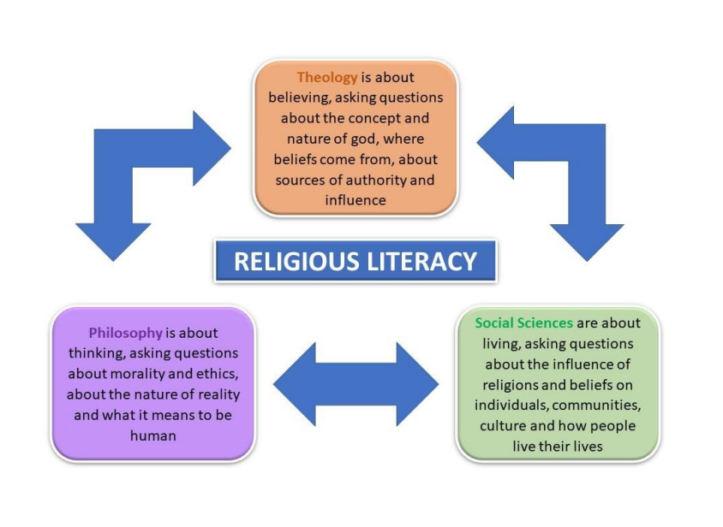
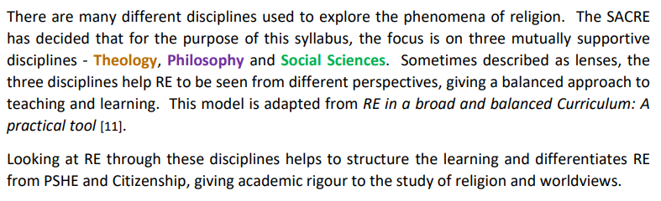

RE Key Stages 1 & 2
Year A

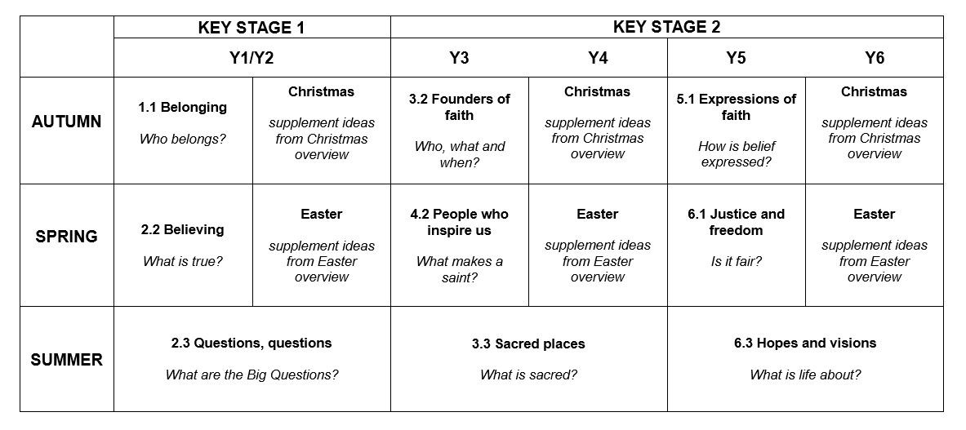

Religious Education: Key Stages 1 & 2
Year B

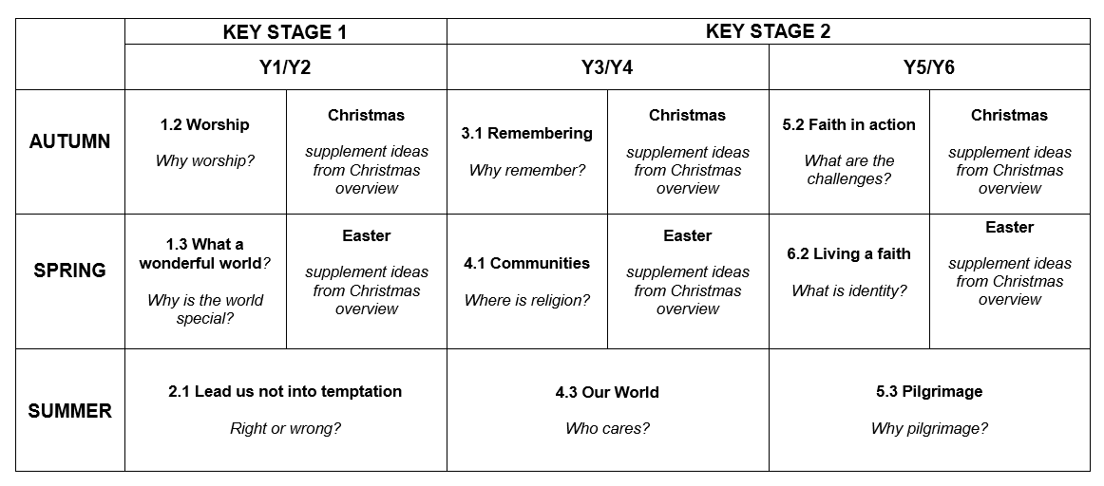

Year A

Autumn Term
3.2 Founders of faith
Key Question: Who, what and when?
About this unit
Investigate the lives of two key figures who may be described as founders of their faiths, such as Jesus, St Paul, Mohammad (pbuh), Guru Nanak, Baha’u’llah, the Buddha and Abraham. Through a Theological lens, consider some key beliefs and how faith members follow the teachings of those founders.

By the end of this unit, pupils know the key events in the lives of at least two key religious figures; they should be able to talk about some key teachings. Also see the KS2 Easter1 unit which may follow.

Our Rainbow Threads
Concepts
gospel, authority, faith Vocabulary
founder, leader, teaching, values

Exploring | Learning Outcomes  By the end of KS2 pupils should be able to
How do the lives of faith founders influence believers? | identify key events in the lives of faith founders and their impact on those around them  explain the relevance of different faith founders for their followers today
What do key religious figures teach? | explain the significance of the key teachings of faith founders for faith members  describe the teachings of key religious figures, identifying some similarities and differences  reflect on the teachings of key religious figures and how these teachings impact on society
Prior knowledge
Recollection of some facts about key figures from different faiths
Identify learning questions: Who, what and when?
What makes a good leader?
Who are the key religious figures for Christianity and other faiths?
What did they teach their followers to believe and to do? Where do we find these teachings?
What did those figures do in their lives? How did people respond to their deeds and words?
How does a person’s faith influence the way they live?
How do the teachings of a faith founder impact on wider society?

Enquiry: consider
- The characteristics of a good leader
- What it means to be the ‘founder’ or leader of a group or a team
- The founders of christianity and other faiths and the ways they inspired people to follow them • the life of jesus and his teaching
- Making links between the teaching of jesus and other leaders of faith
- The impact of faith teachings on the world today
- The ways in which art depicts founders of faith

Mastery Thinking Questions
What is the relevance of Jesus for people today?
Explore the meaning of a parable Jesus taught
Which religions other than Christianity recognise Jesus as an important teacher? What aspects of living a faith might be the hardest and why?
Reflect on learning
Share thoughts and feelings when hearing the teaching in a story from a holy book
Express thoughts about whether the teachings of faith founders can change lives for the better and guide followers

Progression exemplars

Recognise key events in the lives of some faith founders and the impact they made Describe and make links between the teachings of different faith founders

This contributes to the following End of Key Stage statements:
• Express understanding of the key concepts underpinning different faiths, linking sources of authority to belief

Curriculum Links

Jigsaw:
- Being Me in My World
- Celebrating differences

Autumn Term 2
Unit: Christmas
Key Question: What are the special symbols of the Christmas story?

About this unit
This is a supplementary unit designed to help teachers ensure progression when exploring the festival of Christmas across Key Stage 2. It gives opportunity to explore and develop the concepts of Incarnation, God and Gospel.
The focus for Year 3 is on Mary, mother of Jesus and for Year 4 the focus is on the symbolism of light.

It may be useful to consider festivals of light from other faiths alongside Christmas.

Concepts
incarnation, God, gospel Vocabulary
nativity, festival, celebration, Messiah, annunciation, Epiphany, wise men

Exploring | Learning Outcomes  By the end of KS2 pupils should be able to
What is the significance of religious festivals and rituals? | identify the stories celebrated at festivals from different faiths  explain the meaning behind the celebration of festivals and rituals from different faiths
How do people express their beliefs? | identify symbols and artefacts which are important for at least two different faiths  explain how artefacts and symbols express the beliefs of faith members  recognise different forms of religious and spiritual expression
Prior knowledge
This unit builds on learning about festivals of light in KS1

Identify learning questions
Year 3
Why is Mary such an important part of the Christmas story?
What do the gospel writers say about Mary’s actions and feelings up to the time of Jesus’ birth?
What is the story of Epiphany?
When and how is Epiphany celebrated? Is it the same in all countries?

Year 4
Why is light an important symbol?
Why is light an important symbol of Christmas?
Why is Jesus the ‘light of the world’ for Christians? How is light used in festivals?

Enquiry: consider
Year 3
- Looking afresh at the whole Christmas story, including the Annunciation, recognising that the events took place over time
- Different artistic depictions of Mary as the mother of Jesus, and Mary with the Angel Gabriel
- Focusing on the Dalit Madonna, a painting by Jyoti Sahi
- Completing the unit of work on the Dalit Madonna (reinhull)
- What happened at Epiphany when Mary shows Jesus as a precious ‘gift’ to the world.
Year 4
- The way light is used to express feelings (‘a beaming smile’, ‘she lights up the room’, ‘he’s a guiding light’, ‘then I saw the light’)
- Artwork such as Holman Hunt’s The Light of the World - who is depicted? - what do you see? – what did the artist want to convey?
- Old Testament prophecy that the Messiah would come ‘as light’
- The use of light in the celebration of Christmas (Christingles, Advent candles, tree lights)
- Planning a celebration of light

Mastery Thinking Questions
How do Christians see Jesus as a ‘gift’ to the world?
What is meant by Jesus as ‘the light of the world’? What does this mean for Christians today? Jesus is called The Son of God; how does this link to ‘Incarnation’?

Reflect on learning
Reflect on how Mary reacts to the news the angel gave her
Think about why the wise men made such long journeys to see Jesus
Consider how artists over the centuries have depicted the incarnation of Jesus

Progression exemplars

Talk about the nativity story from Mary’s point of view and from the perspective of one of the wise men Explain how and why Christians believe Jesus to be the ‘Light of the World’

This contributes to the following End of Key Stage statements:
- Make connections between the beliefs that underpin different celebrations, forms of worship, pilgrimages and rituals
- Describe and show understanding of links between different sacred texts and how those faith teachings influence communities and society today

Spring Term
4.2 People who inspire us
Key Question: What makes a saint

About this unit
This unit explores the concept of commitment through a Social Sciences lens and provides opportunity to explore lives of people who have been inspired by religion to perform heroic deeds or dedicate their lives to a cause. There are opportunities to start with local saints and heroes, linking with aspects of history and citizenship.

By the end of this unit pupils will recognise how religion has motivated people to dedicate themselves to worthwhile causes and the actions they have taken. Also see the KS2 Easter1 unit which may follow.

Our Rainbow Threads
Concepts
commitment, spiritual, belief, right and wrong Vocabulary
saint, inspiration, sacrifice, a ‘cause’, altruism, justice and freedom

Exploring | Learning Outcomes  By the end of KS2 pupils should be able to
How is commitment demonstrated in the lives and work of significant people of faith? | explain why significant people of faith acted according to their commitments  explain how people are inspired by actions of significant people of faith
What motivates faith believers to get involved in different causes? | explain the values that motivate people of faith to respond to a cause  give reasons why people may choose to make sacrifices to improve the lives of others
Prior knowledge
This unit builds on prior learning in Unit 2.1 Lead us not into Temptation. Recall the names and actions of saints and talk about what makes a saint or a hero

Identify learning questions: What makes a saint?
What is a saint? How does a person become one?
Where are saints’ names found in the local community?
Who might be the saints and heroes of the local community?
How are local or national saints remembered? Why?
Are all saints Christian? What title is given to the ‘saints’ of other faiths?
What inspires some people to commit their lives to an altruistic cause?
What can we learn about commitment from the lives of significant people of faith?
Do you have to be religious to commit to a cause?
What impact may a person’s actions have on the lives of others?
Enquiry: consider
- People of faith who have shown great commitment to a cause
- Whether these people might be saints, or are they heroes? Is there a difference?
- The life and work of a (local) saint; consider why they were made a saint; what are the key characteristics of a saint?
- Local newspapers for ‘acts of faith’ demonstrating commitment to the community
- The actions of a historical christian and a modern-day hero
- The life-changing events of significant people of faith and their impact
- Significant people who demonstrate commitment to a cause actions to relieve poverty by different faith groups
- Whether the gurus are saints?

Mastery Thinking Question
Consider what influences and inspires people to commit to a cause
Express thoughts about the actions of some people that change lives for the better and influence others Do you have to be religious to commit to a cause?

Reflect on learning
Reflect on the heroes and ‘saints’ at a local community, national and global level, including people in the modern world; suggest someone who deserves a ‘heart of gold’ award
Consider the significance of a local saint or person who has worked hard for the local community; what were their motives and what long-term impact have they had?
Choose a poem, prayer, song, teaching or quote of a significant person of faith - share thoughts about its teaching; what impact did their teaching have in their lifetime and what impact might their teachings have now?
Who or what inspires us, why?

Progression exemplars

Explain what prompts people to commit an ethical cause
Explain and give reasons why a person of faith devoted themselves to a cause Give examples of altruistic actions in the community

This contributes to the following End of Key Stage statements:
- Demonstrate understanding of how people express their identity and their spirituality through symbols and actions
- Articulate the responses of different religious and non-religious worldviews to ethical questions, including ideas about what is right and wrong and what is just and fair

Curriculum Links

Jigsaw:
- Dreams and Goals
Healthy Me

Spring 2: Easter
Key Question: What is the significance of the cross for Christians at Easter?

About this unit
This is a supplementary unit designed to help teachers ensure progression when exploring the festival of
Easter across lower Key Stage 2. It gives opportunity to explore and develop the concepts of Salvation and Gospel. The focus for Year 3 is on how Christians remember the events of Holy Week, and in Year 4 the different ways in which the cross conveys the importance and message of Easter.

It may be useful to consider Spring festivals from other faiths alongside Easter.

Concepts salvation, gospel Vocabulary
Holy Week, Last Supper, Holy Communion, Maundy Thursday, Good Friday, crucifixion

Exploring | Learning Outcomes  By the end of KS2 pupils should be able to
What is the significance of religious festivals and rituals? | identify the stories celebrated at festivals from different faiths  explain the meaning behind the celebration of festivals and rituals from different faiths
How do people express their beliefs? | identify symbols and artefacts which are important for at least two different faiths  explain how artefacts and symbols express the beliefs of faith members  recognise different forms of religious and spiritual expression
Prior knowledge
This unit builds on learning about Spring festivals in KS1

Identify learning questions
Who was at the Last Supper? Why were they there?
What is the symbolism of the bread and wine?
What did Jesus say to his disciples?
What happened in the Garden of Gethsemane?
What is meant by betrayal and denial?
What is the ‘good news’ of Easter for everyone?

Enquiry: consider Year 3
- Looking afresh at the events of Palm Sunday at the beginning of Holy Week
- Artwork depicting the Last Supper and the events in the Garden of Gethsemane
- The significance of bread and wine
- The symbols and actions Christians use to remember the Last Supper
- The feelings of the disciples at the Last Supper
- The actions of Peter and Judas following the Last Supper
Year 4
- The key events associated with Holy Week from Palm Sunday to Good Friday
- How Christians remember and relive the events of Holy Week
- The symbolic meaning of the Easter ritual of the washing of feet on Maundy Thursday
- The contrast of Jesus’ entry into Jerusalem on Palm Sunday and his actions on Maundy Thursday • the events of Good Friday
- Artwork depicting Mary the mother of Jesus at the crucifixion
- Different styles of crosses from around the world and what they mean

Mastery Thinking Questions
How does the crucifixion offer ‘salvation’ for Christians?
Why is the festival of Easter an important celebration for Christians?
How do you think Mary, the mother of Jesus, felt when he was crucified? How do Christians see Jesus as a saviour to the world?

Reflect on learning
Reflect on the symbolism of Jesus washing the disciples’ feet Why is Friday called ‘Good’ Friday?
Contrast the sadness of Good Friday with the joy of Palm Sunday How does Christian music communicate feelings at Eastertime?

Progression exemplars

Describe the events of Holy Week and how Christians remember them today
Explain the meaning of the cross for Christians and how it conveys the Easter message

This contributes to the following End of Key Stage statements:
- Make connections between the beliefs that underpin different celebrations, forms of worship, pilgrimages and rituals
- Describe and show understanding of links between different sacred texts and how those faith teachings influence communities and society today

Summer Term
Unit 3.2 Sacred places
Key Question: What is sacred?

About this unit
Build on work in Unit 1.2 Worship and provide opportunities to observe worship in more than one faith, focusing on its significance for faith members. Make links with a local place of worship and contrast with a place of worship from a different faith. Consider the ways people celebrate milestones of life such as marriage in a sacred place. Find out how tradition and ceremony is part of the life of a religious community. By the end of this unit, pupils will understand what makes a place sacred and to whom; how the place is used to mark the milestones of life.
Our Rainbow Thread
Concepts
sacred, holy, belief, worship Vocabulary
sacred places, ceremony, symbols, artefacts, milestones of life – marriage

Exploring | Learning Outcomes  By the end of KS2 pupils should be able to
What makes a place sacred? | show understanding of what is sacred for believers in religious places  describe the uses of sacred places, symbols and artefacts by believers and the community  explain how activities at local places of worship create a sense of community
Which religious rituals show identity and belonging for different traditions? | suggest how the milestones of life give a sense of identity and belonging for faith members
How do people express their beliefs? | identify symbols and artefacts which are important for at least two different faiths  explain how artefacts and symbols express the beliefs of faith members  recognise different forms of religious and spiritual expression
Prior knowledge
Recollection of previous visits to sacred places and ways of showing respect; recall the ritual of baptism in Unit 1.1 Belonging as a first milestone
Identify learning questions: What is sacred?
What does the word ‘sacred’ mean?
What makes a place sacred? How is it used?
How can a place be a form of religious or spiritual expression?
Why are some places special enough to merit a long journey?
Why are some buildings considered sacred? What happens there?
How do faith members show respect when they are in a sacred place?
What rituals are part of worship?
What symbols or artefacts can be found in a sacred building or space and what meaning do they have?
How do symbols and artefacts in rites of passage represent belief?
Why do people choose to mark milestones in their life in a sacred place?

Enquiry: consider
- Sacred places and why people go there
- Visiting a local sacred place or place of worship; find out what happens there
- Visiting a contrasting worship space for a different faith or access a virtual tour online
- Photos / video clips of people involved in routines and rituals, secular and non-secular (such as new zealand’s all-blacks rugby team performing the haka)
- The symbols of rites of passage for two different faiths; explore similarities and differences
- Talking to religious leaders to find out about their role in rituals and the symbols they wear or use
- Observing and identifying ritual within a ceremony
- How shared religious rituals mark life’s milestones and give a sense of identity and belonging

Mastery Thinking Questions
Discuss why religions may build places of worship when they believe God is everywhere
Explore how activities in a place of worship build a sense of community
Compare religious rituals and rites of passage from different faiths; consider how they express the beliefs of faith members

Reflect on learning
Reflect on feelings of faith members when in a sacred space
Record personal responses when visiting special places
Express thoughts about the importance of rituals for faith members
Think about the difference it makes to celebrate milestones of life in a sacred place
Progression exemplars

Discover the milestones in life for different religions and respond to the ways in which they offer a sense of identity and belonging
Recognise what makes a place sacred and recognise reasons why

This contributes to the following End of Key Stage statements:
• Make connections between the beliefs that underpin different celebrations, forms of worship, pilgrimages and rituals

Curriculum Links

Jigsaw:
- Relationships
- Changing Me

Year B

Autumn Term
Unit 3.1 Founders of faith
Key Question: Who, what and when?

About this unit
This unit builds on work from Unit 1.2 Worship and provides opportunity to use a Social Science lens to explore remembrance in the context of some important religious and secular festivals; include Remembrance Day and festivals which remember or commemorate people or events in the past. Use the lens of theology to interpret the stories behind religious festivals. Explore actions and rituals associated with festivals, celebrations and times of remembering. Consider how symbols and artefacts may be used to express what is remembered.

By the end of this unit, pupils should have a good understanding of the purpose and value of religious and community celebrations. Note that rituals linked to remembrance and commemoration may need to be handled sensitively. Also see the KS2 Christmas 1 unit which may follow.

Our Rainbow Thread
Concepts
belonging, ritual, peace, universal Vocabulary
festival, celebration, remembrance

Exploring | Learning Outcomes  By the end of KS2 pupils should be able to
What is the value of participating in a religious festival or ritual? | compare the experience of participating in a religious festival or celebration around the world  reflect and share how religious celebrations and rituals have an impact on the community
What is the significance of religious festivals and rituals? | identify the stories celebrated at festivals  explain the meaning behind the celebration of festivals and rituals of different faiths
Prior knowledge
Recall times of celebration to remember key events

Identify learning questions: Why remember?
What does (religious festival/observance) remember?
Why do people celebrate religious and cultural events?
What happens at a named religious celebration or festival?
Who takes part in a festival and why?
What actions or rituals are performed at a celebration or remembrance?
What do different religious celebrations or remembrances have in common?
How might a believer feel a sense of belonging when participating in a festival or a ritual?
How do faith members use symbols and artefacts within their celebrations and how might this affect the way they behave or feel?
Are all festivals happy and joyous? When is remembrance a happy time and when is it a sad time?

Enquiry: consider
- Why people often feel that it is important to remember
- A seasonal community festival such as harvest or sukkot and the meaning behind it
- Two religious celebrations from different faiths - readings, singing, food, actions
- The use and meaning of symbols and artefacts in different faiths associated with celebrations or festivals interviewing a faith member about how they celebrate religious celebrations and festivals; explore how they promote a sense of belonging to the community
- Festivals of remembering such as remembrance sunday, pesach, dia de los muertos (day of the dead), all souls day
- A remembrance ceremony and discuss ritual elements such as reflective silence, words and music, the laying of poppy wreaths and crosses, visiting graves

Mastery Thinking Questions
Explore the importance of celebrations and festivals in the life of school and local community
Talk the importance of national commemorations, such as the Festival of Remembrance and the Fifth of November

Reflect on learning
Reflect on the meanings of the stories which underpin festivals of remembering Talk about feelings after participating in a remembrance ceremony
How would we wish to be remembered?
Respond to music linked to both happy and sad occasions
Progression exemplars

Compare the ways in which religious festivals are celebrated in the community and across the world
Explain the link between the rituals associated with celebrations and the stories behind them

This contributes to the following End of Key Stage statements:
- Make connections between the beliefs that underpin different celebrations, forms of worship, pilgrimages and rituals
- Describe and show understanding of links between different sacred texts and how those faith teachings influence communities and society today
Curriculum Links
Jigsaw:
- Being Me in My World
- Celebrating difference

Autumn Term 2
Unit: Christmas
Key Question: What are the special symbols of the Christmas story?

About this unit
This is a supplementary unit designed to help teachers ensure progression when exploring the festival of Christmas across Key Stage 2. It gives opportunity to explore and develop the concepts of Incarnation, God and Gospel.
The focus for Year 3 is on Mary, mother of Jesus and for Year 4 the focus is on the symbolism of light.

It may be useful to consider festivals of light from other faiths alongside Christmas.

Concepts
incarnation, God, gospel Vocabulary
nativity, festival, celebration, Messiah, annunciation, Epiphany, wise men

Exploring | Learning Outcomes  By the end of KS2 pupils should be able to
What is the significance of religious festivals and rituals? | identify the stories celebrated at festivals from different faiths  explain the meaning behind the celebration of festivals and rituals from different faiths
How do people express their beliefs? | identify symbols and artefacts which are important for at least two different faiths  explain how artefacts and symbols express the beliefs of faith members  recognise different forms of religious and spiritual expression
Prior knowledge
This unit builds on learning about festivals of light in KS1

Identify learning questions
Year 3
Why is Mary such an important part of the Christmas story?
What do the gospel writers say about Mary’s actions and feelings up to the time of Jesus’ birth?
What is the story of Epiphany?
When and how is Epiphany celebrated? Is it the same in all countries?

Year 4
Why is light an important symbol?
Why is light an important symbol of Christmas?
Why is Jesus the ‘light of the world’ for Christians? How is light used in festivals?

Enquiry: consider
Year 3
- Looking afresh at the whole Christmas story, including the Annunciation, recognising that the events took place over time
- Different artistic depictions of Mary as the mother of Jesus, and Mary with the Angel Gabriel
- Focusing on the Dalit Madonna, a painting by Jyoti Sahi
- Completing the unit of work on the Dalit Madonna (reinhull)
- What happened at Epiphany when Mary shows Jesus as a precious ‘gift’ to the world.
Year 4
- The way light is used to express feelings (‘a beaming smile’, ‘she lights up the room’, ‘he’s a guiding light’, ‘then I saw the light’)
- Artwork such as Holman Hunt’s The Light of the World - who is depicted? - what do you see? – what did the artist want to convey?
- Old Testament prophecy that the Messiah would come ‘as light’
- The use of light in the celebration of Christmas (Christingles, Advent candles, tree lights)
- Planning a celebration of light

Mastery Thinking Questions
How do Christians see Jesus as a ‘gift’ to the world?
What is meant by Jesus as ‘the light of the world’? What does this mean for Christians today? Jesus is called The Son of God; how does this link to ‘Incarnation’?

Reflect on learning
Reflect on how Mary reacts to the news the angel gave her
Think about why the wise men made such long journeys to see Jesus
Consider how artists over the centuries have depicted the incarnation of Jesus

Progression exemplars

Talk about the nativity story from Mary’s point of view and from the perspective of one of the wise men Explain how and why Christians believe Jesus to be the ‘Light of the World’

This contributes to the following End of Key Stage statements:
- Make connections between the beliefs that underpin different celebrations, forms of worship, pilgrimages and rituals
- Describe and show understanding of links between different sacred texts and how those faith teachings influence communities and society today

Spring Term
Unit 4.1: Communities
Key Question: Where is religion?
About this unit
This unit is considered mainly through the lens of Social Science and provides opportunity for pupils to find out more about their locality and their local community, to explore the diversity of religion found within, and to study a religious community in depth. It will be helpful to meet with different people, and members of different faiths, to investigate the impact of their beliefs and values on community life. It may be appropriate to make links to learning about local history and geography. Questions should be asked about living in a multicultural society.

By the end of this unit pupils should know about the religions and other worldviews represented in the locality; they have a knowledge of at least one religion in depth and its contribution to their community. Also see the KS2 Christmas1 unit which may follow.

Our Rainbow Thread
Concepts
People of God, religion, community, spiritual, unity
Vocabulary
religion, identity, values, multicultural, diversity

Exploring | Learning Outcomes  By the end of KS2 pupils should be able to
How do religious values provide rules for living? | give examples of beliefs and values from different faiths  describe the impact of religious beliefs, values and rules on the life of a believer
Prior knowledge
This unit builds upon work covered in Unit 1.1 Belonging and Unit 3.2 Founders of faith; make links to previous learning about British values

Identify learning questions: Where is religion?
What is meant by ‘community’?
Where is there evidence of religion in the locality?
How diverse is the local community?
Why do people belong to different groups?
What are the responsibilities of belonging? Are there rules and values to keep?
Does belonging to a group, including a religion, give people a sense of identity?
How might a member of a religious group make a difference within the wider community? How might this be different for a non-religious person?
What impact does religion have on communities?

Enquiry: consider
- The local community and what happens there – celebrations, events, processions, activities; can we tell which have a religious context?
- Using an ordnance survey map and/or google maps to explore the local area and identify the diversity of religion and culture
- The symbols and logos seen in the community and what they represent
- Ways in which members of the community gain a sense of identity, belonging and unity
- Similarities and differences between the beliefs of different religions in the community
- Inviting people, including faith members, to talk about where their values come from • investigating one or two religions in some depth
Mastery Thinking Questions
What is the contribution of religions to the community? Does religion make a difference?
Consider the key values from at least two different faiths and how these influence a believer’s way of life Investigate where non-religious people get their values

Reflect on learning
How does a set of religious or non-religious beliefs provide a code for living?
What freedom of choice does a believer have?
What may unite different religious communities?

Progression exemplars

Explain what makes a community
Describe the contribution of a religious group to their community

This contributes to the following End of Key Stage statements:
• Consider and apply ideas about ways in which diverse communities can live together for the wellbeing of all, responding thoughtfully to ideas about community, values and respect
Jigsaw:
- Dreams and Goals
- Healthy Me

Spring 2: Easter
Key Question: What is the significance of the cross for Christians at Easter?

About this unit
This is a supplementary unit designed to help teachers ensure progression when exploring the festival of
Easter across lower Key Stage 2. It gives opportunity to explore and develop the concepts of Salvation and Gospel. The focus for Year 3 is on how Christians remember the events of Holy Week, and in Year 4 the different ways in which the cross conveys the importance and message of Easter.

It may be useful to consider Spring festivals from other faiths alongside Easter.

Concepts salvation, gospel Vocabulary
Holy Week, Last Supper, Holy Communion, Maundy Thursday, Good Friday, crucifixion

Exploring | Learning Outcomes  By the end of KS2 pupils should be able to
What is the significance of religious festivals and rituals? | identify the stories celebrated at festivals from different faiths  explain the meaning behind the celebration of festivals and rituals from different faiths
How do people express their beliefs? | identify symbols and artefacts which are important for at least two different faiths  explain how artefacts and symbols express the beliefs of faith members  recognise different forms of religious and spiritual expression
Prior knowledge
This unit builds on learning about Spring festivals in KS1

Identify learning questions
Who was at the Last Supper? Why were they there?
What is the symbolism of the bread and wine?
What did Jesus say to his disciples?
What happened in the Garden of Gethsemane?
What is meant by betrayal and denial?
What is the ‘good news’ of Easter for everyone?

Enquiry: consider Year 3
- Looking afresh at the events of Palm Sunday at the beginning of Holy Week
- Artwork depicting the Last Supper and the events in the Garden of Gethsemane
- The significance of bread and wine
- The symbols and actions Christians use to remember the Last Supper
- The feelings of the disciples at the Last Supper
- The actions of Peter and Judas following the Last Supper
Year 4
- The key events associated with Holy Week from Palm Sunday to Good Friday
- How Christians remember and relive the events of Holy Week
- The symbolic meaning of the Easter ritual of the washing of feet on Maundy Thursday
- The contrast of Jesus’ entry into Jerusalem on Palm Sunday and his actions on Maundy Thursday • the events of Good Friday
- Artwork depicting Mary the mother of Jesus at the crucifixion
- Different styles of crosses from around the world and what they mean

Mastery Thinking Questions
How does the crucifixion offer ‘salvation’ for Christians?
Why is the festival of Easter an important celebration for Christians?
How do you think Mary, the mother of Jesus, felt when he was crucified? How do Christians see Jesus as a saviour to the world?

Reflect on learning
Reflect on the symbolism of Jesus washing the disciples’ feet Why is Friday called ‘Good’ Friday?
Contrast the sadness of Good Friday with the joy of Palm Sunday How does Christian music communicate feelings at Eastertime?

Progression exemplars

Describe the events of Holy Week and how Christians remember them today
Explain the meaning of the cross for Christians and how it conveys the Easter message

This contributes to the following End of Key Stage statements:
- Make connections between the beliefs that underpin different celebrations, forms of worship, pilgrimages and rituals
- Describe and show understanding of links between different sacred texts and how those faith teachings influence communities and society today

Summer Term
Unit 4.3 Our world
Key Question: Who cares
About this unit
The unit builds upon understanding and appreciation of the natural world. It focuses on the uniqueness of the Earth as Our World that everyone has a duty to respect and conserve. It explores through the lens of philosophy how various faiths explain some of life’s big and difficult-to-answer questions about god, creation and man’s responsibilities towards the Earth.

By the end of this unit pupils will understand some of the global challenges for mankind in caring for the world and be able to explain the concept of stewardship for different faiths.

Our Rainbow Thread
Concepts
creation, worldview Vocabulary
stewardship, khalifah, environment, ecology, habitat, Climate Action, Eco Warriors, Friends of the Earth, Extinction Rebellion, Greenpeace, Eco Schools, Eco Churches

Exploring | Learning Outcomes  By the end of KS2 pupils should be able to
What is an ultimate question? | identify what makes some questions ultimate  offer answers to an ultimate question from different faith perspectives
How did the universe begin? | compare different beliefs about how the universe began making reference to sacred texts
Why is it important to look after the Earth? | compare religious teachings to see how faith members should care for the Earth  show understanding of stewardship and suggest actions everyone can take
Who is god? | explain how people of different faiths describe what god is like identify what different sacred writings say about the attributes of god
Prior knowledge
This unit builds upon work covered in Unit 1.3 What a wonderful world
Identify learning questions: Who cares?
Where did the Earth come from? Is it sacred? What do different faiths say about sacredness of life? How do faith members interpret creation stories?
Who is god? How do different religions describe god?
How does belief in a Creator God influence believers’ lives?
What is meant by stewardship of the Earth?
What do holy books say about care for animals and showing respect for the world? How can we better care for the world?

Enquiry: consider
- pupils’ concepts of ‘creation’ and ‘stewardship’; where do these ideas come from?
- images of Earth from space and images of other planets and galaxies
- how small, big, simple or complex creation can be
- the environment; express responses to creation; explore images of patterns/colours in nature
- creation stories from different faiths, identifying similarities and differences
- the writers’ inspiration for songs and psalms of creation attributes of god in statement of faith, such as Sikh Mool Mantar, Christian Apostles’ Creed, Muslim Shahada, Jewish Shema
- non-religious/other viewpoints about creation such as aboriginal dreamtime stories
- scientific views on how Earth was created
- a ‘stewardship walk’ around the school environment looking out for places that need more careful stewardship; in what ways could they be improved?
- local and national environmental projects and the impact that they are having; what influences people involved in such projects?
- pupils’ own impact on the environment; what more can we do to care for the world around us?

Mastery Thinking Questions
Consider ways creation is celebrated in society What duty do we all have to look after the Earth?
Investigate man's dependence on Earth's resources, considering the responsibility and challenge for us all How do humans treat Earth? What impact is this having?

Reflect on learning
Identify something in the natural world which gives a sense of awe and wonder; appreciate different aspects of creation; marvel at the adaptation of living things to their habitats – accident or design? Discuss the concept of man’s responsibility to share the world’s resources
Reflect on stories, songs and psalms of creation
Consider the shape of the individual ‘footprint’ pupils hope to leave on the Earth

Progression exemplars

Reflect and present ideas about the origin of the universe
Offer reasons why it is important to look after the earth
Describe what different religions say about the attributes of god

This contributes to the following End of Key Stage statements:
- Express understanding of the key concepts underpinning different faiths, linking sources of authority to belief
- Offer some answers to ultimate questions from different religious and non-religious perspectives
Curriculum Links

Jigsaw:
- Relationships
- Changing Me

