Snaith Primary School

Religious Education
Year A and Year B

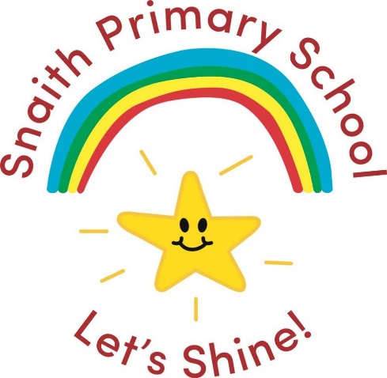

RE as a Multi-disciplinary Subject
Each focus is covered and colour co-ordinated in each of the units throughout the year.
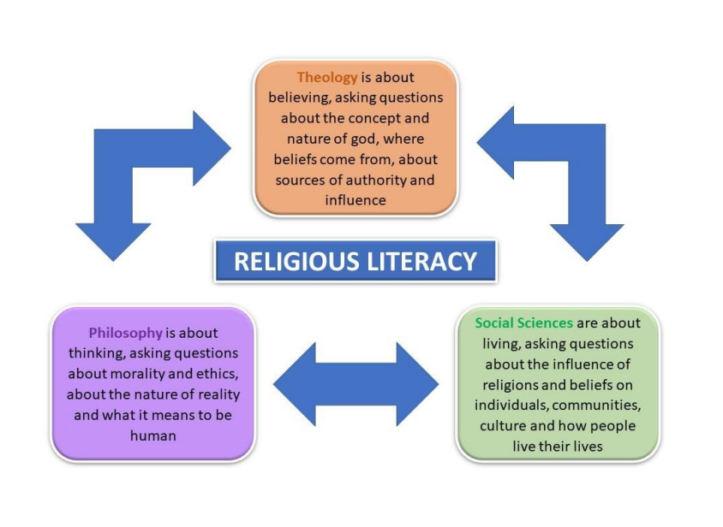
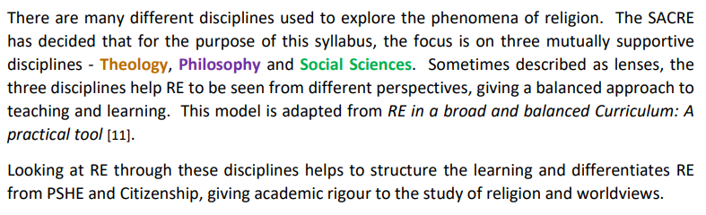

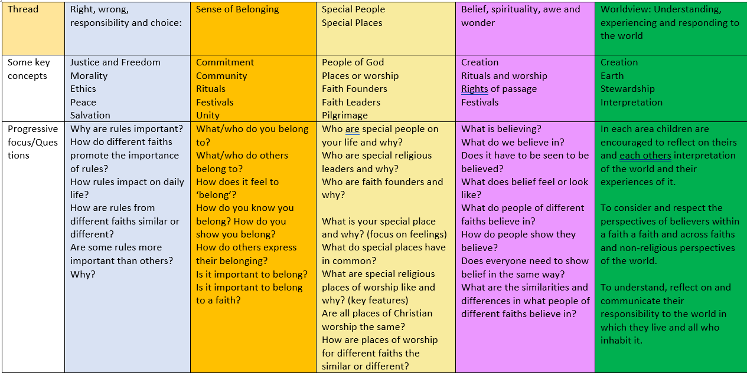
Our Rainbow Threads

RE Key Stages 1 & 2
Year A

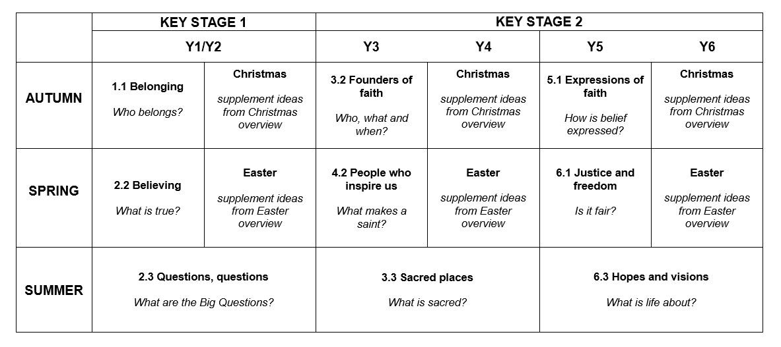

Within each year group the units have been sequenced to build on children’s knowledge and understanding of religion with links between each unit.
Religious Education: Key Stages 1 & 2
Year B

Within each year group the units have been sequenced to build on children’s knowledge and understanding of religion with links between each unit.
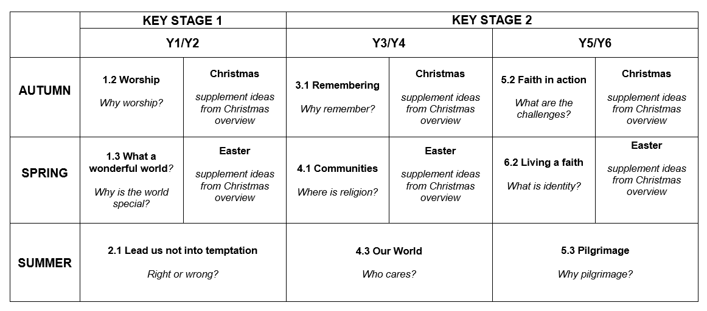

Year A

Autumn Term 1:
Unit 1.1: Belonging
Key Question: Who belongs?

About this unit
This unit builds on and extends children’s learning from the EYFS about the uniqueness of the individual, focusing on what it means to belong and enquire how a faith member has a sense of belonging to their faith. Present different kinds of family through story, persona dolls, puppets and explore what it means to belong to a faith family, becoming a member and keeping the rules. Make use of stories from sacred texts and think about what believers can learn from them.

By the end of the unit, pupils should be able to associate some symbols and artefacts with naming and marriage ceremonies, connect sacred texts to the appropriate faith and explain how belonging to a faith starts with a naming ceremony and is lived out in daily life. Also see the Christmas unit which may follow.

Our Rainbow Learning Threads
Concepts
belonging, commitment, faith, community, ritual, worldview
Vocabulary
religion, life values, rules, naming ceremonies, promises

Exploring | Learning Outcomes  By the end of KS1 pupils should be able to
Why are symbols and artefacts important to some people? | Reflect on what is special to themselves and others  Identify connections to religion and belief in the community  Identify precious things for people of faith
How does a person of faith live their life? | Explain how a person shows religion in their life  Talk about the lives of children from two different faith communities
What are the religious rituals and ceremonies connected with important times in life? | Say why religious people celebrate an important life event  Think about what matters most in a religious ceremony, including symbols and artefacts  Say why people of faith make promises
Identify learning questions: Who belongs?
How do we show belonging? How do we know if someone belongs to a club or group?
Can anyone belong to every club or group? (ask for reasons)
What does it mean to belong to a religion? How does a child in a faith family show belonging? What do they wear/do to show they belong?
How do they become a member of their faith?
What do Christian symbols and artefacts tell us about what people believe?
What is a promise? What promises might a faith member make?
Is it ever right to break a promise?
Do we need rules?
Where do faith members find their rules for living?

Enquiry: consider
- Personal relationships among family, friends and in school life
- What makes a family, exploring different models, including marriage
- Belonging to a faith family
- Looking at the pattern of a faith life and what it means to believe and belong • shared values
- Rules for family, school, friendship and faith groups
- The importance of keeping promises when making a commitment
- Items faith members might wear/own to show their faith and learn about their meaning; explore why faith members might find it important to wear particular items at certain times
- Video clips showing how people mark important times in life - baptism, naming ceremonies and welcoming a baby, wedding
- Stories from sacred texts that contain ‘golden’ rules for living
- Rules for living within the bible and other sacred texts and identify links between religious rules and rules in school

Mastery Thinking Questions
Interview a faith member about how the impact of belonging to their faith guides their life and determines how they treat others

Reflect on learning
Respond and express feelings about belonging to groups at school, home and elsewhere Talk about how belonging to a faith gives members a sense of identity

Progression exemplars

Recall some of the symbols, artefacts and rules associated with belonging to a faith group
Recognise some similarities between faith groups
Talk about what it means to belong and understand the importance of a promise

This contributes to the following End of Key Stage statements:
- Describe what happens at festivals, ceremonies and rituals and talk about the beliefs behind them
- Tell of the ways people express identity in belonging to a faith group, and show how they are similar to another faith group
Curriculum Links
Belonging over time: The contributions made by those in the local community during WW2. School plays an active part in how we commemorate this.
Belonging to our local heritage and history.

Jigsaw:
- Being Me in My World
Rights, responsibilities and choices
Being special and keeping each other safe
- Celebrating difference
What makes us unique
Celebrate similarities and differences
How to help and ask for help.

Autumn Term 2:
Christmas
About this unit
This is a supplementary unit designed to help teachers ensure progression when exploring the festival of Christmas across Key Stage 1.

It may be useful to consider festivals of light from other faiths alongside Christmas.

Concepts
incarnation, gospel
Vocabulary
Advent, nativity, festival, celebration

Exploring | Learning Outcomes  By the end of KS1 pupils should be able to
Which festivals are important to faith members? | Name some religious festivals and say how faith members celebrate them  Describe and explain some traditions linked to religious festivals
What stories are told at different religious festivals? | Suggest reasons why festivals are important  Talk about how stories are celebrated at different religious festivals
Prior knowledge
This unit builds on learning about festivals of light in the Foundation Stage

Identify learning questions
What signs tell us that Christmas is coming? How do we feel?
How do Christian families prepare for Christmas?
What do our senses tell us?
What customs are associated with various parts of the Christmas story?
Why is the Christmas story ‘good news’ for Christians?
What is the ‘good news’ of Christmas for everyone? What does ‘incarnation’ mean?

Enquiry: consider
Year 1
- The story of the nativity
- What happens at Christmas (sending cards, buying presents)
- Using the senses to explore Christmas
  - Sights (advent calendars and candles, Christingles, tree decorations, wreaths)
  - Sounds (bells, Christmas music)
  - Tastes (different types of food)
  - Touch (wrapped presents)
  - Smells (incense and spices, food)
- How Christian and non-Christian families prepare for Christmas both at home and at church
- Traditional festive celebrations
Year 2
- The shepherds hearing the news from the angels
- The wise men (magi) and their gifts: gold for Jesus as king, frankincense for Jesus as one who comes as a priest from god to mankind, myrrh as a foretelling of Jesus’ death
• what would be a suitable gift for Jesus

Mastery Thinking Questions
Why is the festival of Christmas an important celebration for Christians? Is it important to others as well?

Reflect on learning
How would the shepherds have felt when they heard the news of Jesus’ birth? How would the wise men have felt when they heard the news of Jesus’ birth?

Progression exemplars
Recognise and recall the Nativity story and know why it’s important to Christians
Talk about how Christians celebrate the festival of Christmas

This contributes to the following End of Key Stage statements:
- Describe what happens at festivals, ceremonies and rituals and talk about the beliefs behind them
- Retell and suggest meanings for some religious and moral stories and say how they influence people today

Spring Term 1:
Unit: 2.2 Believing
Key Question: What is true?
About this unit
This unit builds on children’s learning in Unit 1.1 Belonging, taking a theological focus, about how beliefs are expressed. Introduce key figures from Old and New Testaments, alongside stories from other religious traditions; focus on key beliefs demonstrated in the stories and the commitments that stem from those beliefs.

By the end of the unit, pupils should be able to associate core beliefs with key figures and artefacts from two religions. There are opportunities to talk about British Values. Also see the KS1 Easter unit which may follow.

Our Rainbow Learning Threads
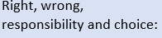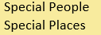
Concepts
God, sacred, holy, belief, religion
Vocabulary
named characters and artefacts from chosen faiths, prayer

Links to Christmas, festivals and the Christian beliefs
Passover 5th April-13th April
Easter 9th April

10 commandments story
Old testament: Book of Exodus (Holy Bible)
Judaism: The First 5 books of Moses- Judaism (Tora)
Who is Moses? Who is Jesus?
Foods associated: eggs

Exploring | Learning Outcomes  By the end of KS1 pupils should be able to
What do people of faith believe? | Name some beliefs of two different faiths  Recognise beliefs that are the same for different faiths
What are the different ways in which people of faith express their beliefs? | Describe how religious people may express their beliefs in action  Consider a prayer or text that expresses belief
Prior knowledge
Links to the prior learning in 1.1 Belonging exploring the importance of the church and synagogue.
Identify learning questions: What is true?
What is ‘belief’? What do I believe in?
Do others believe the same as me?
Why should we respect the beliefs of others?
What do Christians believe?
What do members of a different faith believe?
Do people who don’t follow a religion have their own beliefs?

Enquiry: consider
- Optical illusions – is seeing believing? Do we all see in the same way?
- Artefacts linked to Christianity and another faith; can we work out what a faith member believes?
- Asking a local faith member to show something that represents their beliefs. What are they committed to?
- A simple version of the Lord’s Prayer and talk about what a believer might pray for (Godly Play)
- A simple form of The Apostles’ Creed and a belief statement from another faith to identify what members believe
- Commitments made by significant people of faith underpinned by their beliefs, for example St Francis of Assisi, St Hilda, St Cuthbert, Mother Theresa (her prayer, ‘Make Us Worthy, Lord’)
- Commitments made by contemporary people of faith, such as Mo Farrah (to athletics), Malala
Yousafzai (to girls’ education), Cat Stevens/Yusuf Islam (to music), Sachin Tendulkar (to cricket), Zac Goldsmith (to the environment), Dalai Lama (to peace and kindness), Jaspreet Kaur (to human rights)
- Commitments made by contemporary people devoting themselves to a cause, such as Greta Thunberg, Captain Sir Tom Moore, Marcus Rashford
- How faiths and faith-based charities may work individually/together to help care for the world

Mastery Thinking Questions
What are the similarities and differences in the beliefs of people of different faiths particularly prayer?
Why may a piece of sacred writing be important to a believer?
it important for everyone to believe in something?

Reflect on learning
Reflect on why Jesus is inspirational to Christians today
Why is a key figure inspirational to members of another faith?
Where do faith members get their beliefs and values? Where do mine come from?
How do faith members show their beliefs through commitment; how do I show my beliefs and commitment?

Demonstrate new understanding
Explain what is meant by making a commitment
Make links between key beliefs of two faiths; explain the beliefs represented by their symbols and artefacts
Identify belief and commitment in faith stories
Describe the ways religious beliefs have helped a famous person commit their life to a cause or career

Progression exemplars

Recall and name key beliefs from different religions
Recognise similarities and differences between the key beliefs for different faiths Suggest two examples of religious beliefs that lead into action

This contributes to the following End of Key Stage statements:
• Recall different beliefs and practices, naming key words, key figures and core beliefs
Curriculum Links
This is a stand-alone unit
Jigsaw
- Dreams and Goals
Setting and achieving simple goals
Feelings of tribulation and triumph
- Healthy Me
Keeping healthy-hygiene-staying safe
Healthy and less healthy choices
Associated feelings

Spring Term 2:
Unit: Easter

About this unit
This is a supplementary unit designed to help teachers ensure progression when exploring the festival of Easter across Key Stage 1.

It may be useful to consider Spring festivals from other faiths alongside Easter.

Our Rainbow Learning Threads
Concepts salvation, gospel Vocabulary
festival, celebration, Lent, Holy Week, Shrove Tuesday, Ash Wednesday, Good Friday, Easter Day

Exploring | Learning Outcomes  By the end of KS1 pupils should be able to
Which festivals are important to faith members? | Name some religious festivals and say how faith members celebrate them  Describe and explain some traditions linked to religious festivals
What stories are told at different religious festivals? | Suggest reasons why festivals are important  Talk about how are stories celebrated at different religious festivals
Prior knowledge
This unit builds on learning in the Foundation Stage

Identify learning questions
What signs tell us that Easter is coming and how do they make us feel?
What are the big surprises of Easter?
How do Christians prepare for Easter?
What traditions are associated with the Easter story?
Why were people so excited to welcome Jesus on Palm Sunday?
What is the meaning of ‘salvation’?

Enquiry: consider
Year 1
- A simple version of the Easter story, focusing on Holy Week and Jesus coming back to life
- Using the senses to explore artefacts and symbols associated with Eastertime
  - Shrove Tuesday (pancakes)
  - Ash Wednesday (ash crosses)
  - Lent (giving things up)
  - Mothering Sunday (cards and gifts for Mum)
  - Palm Sunday (palm crosses)
  - Good Friday (hot cross buns)
  - Easter Day (chocolate eggs)
Year 2
- Sequencing events in the Easter story
- How the Easter story is depicted in different art forms
- Listening to the Palm Sunday story at the beginning of Holy Week
- Telling the donkey’s story, based on book Dave the Donkey by Andrew McDonough

Mastery Thinking Questions
Why is the festival of Easter an important celebration for Christians; is it important to others as well? How do you think Mary, the mother of Jesus, felt when he rode into Jerusalem?

Reflect on learning
Why were people so happy when Jesus arrived in Jerusalem? How did they celebrate?
When Jesus came back to life, it was a big surprise to his friends; how would they have reacted?

Demonstrate new understanding
Design or hold a palm celebration including songs (We Have a King Who Rides a Donkey) and palms Create artwork to show what happened on Palm Sunday
Decorate hard-boiled eggs to celebrate
Creatively retell aspects of the Easter story to others (drama, puppets, pictures) Create an Easter garden and explain what the different parts represent

Progression exemplars

Recognise and recall the Easter story and know why it’s important to Christians
Talk about how Christians celebrate the festival of Easter

This contributes to the following End of Key Stage statements:
- Describe what happens at festivals, ceremonies and rituals and talk about the beliefs behind them
- Retell and suggest meanings for some religious and moral stories and say how they influence people today

Summer Term
Unit 2.3: Questions, questions???
Key Questions: What are the BIG questions?

About this unit
This unit encourages children to develop and explore their own Big Questions about how the world and other things came about. Consider some of the answers faith members may offer and celebrate the idea that people may think differently and that it’s OK to disagree. Pupils ask what matters to them - questions of meaning, purpose and truth. Use strategies such as Philosophy for Children (P4C), Godly Play and guided visualisations to help children raise their own questions and offer possible answers.

By the end of this unit, pupils should be able to ask and respond to ultimate questions, and know the answers that different religions and other worldviews offer.

Our Rainbow Learning Threads
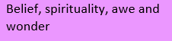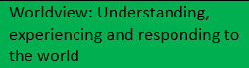
Concepts
God, creation Vocabulary
universe, cycle of life
Exploring | Learning Outcomes  By the end of KS1 pupils should be able to
What are life’s big questions? | Understand that some questions have no simple answers  Ask and talk about big questions and suggest some answers  Know that religions may offer different answers to the same question
Who is god to people of faith? | Identify names for god in different faiths  Express what believers say god is like
Prior knowledge
Recap learning from Year 1 where pupils found out about creation stories from different religions and traditions, attempting to explain how the world began

Identify learning questions: What are the Big Questions?
Who is god?
Where is god?
How was the world created?
Why do bad things happen? (including death, as appropriate)
Pose questions such as: Why don’t some people have enough food/shelter?
Why do earthquakes happen?
Where do religious people look to find some answers to Big Questions?
Where do people without a religion get their answers?

Enquiry: consider
- The biggest question they can think of, thinking especially about questions that no one can answer
- Poems that ask lots of Big Questions
- Ideas about where the world came from
- A non-religious or traditional story about how the world was created
- What we can learn from the ‘Just So’ stories by Rudyard Kipling
- Puzzling questions; provide information about how Christians and members of another faith might answer these questions
- Who Put The Colours In The Rainbow? on YouTube. Discuss answers to the questions from different faith/world perspectives

Mastery Thinking Questions
Ask, think and talk about some Big Questions – truth, creation, God and life
Read religious stories looking for clues; how may faith members answer some Big Questions? Interview faith members about their answers to some Big Questions

Reflect on learning
Is it important to ask Big Questions?
Pupils suggest their own answers to some Big Questions; does this raise new ones? Do we need to be able to answer every question?
How do people think we should care for the world? What can we all do to make a difference?

Progression exemplars
Suggest answers to Big Questions from different religious perspectives
Describe what different religions believe about god

This contributes to the following End of Key Stage statements:
• Consider and make responses to big questions from different worldviews

Curriculum Links
Links PSHE respecting different people’s points of view but this is a stand-alone unit.
Jigsaw
- Relationships
The range of relationships we have
Special relations and what make them special
Healthy and safe relationships
Looking after each other and celebrating friendship
- Changing Me
Life cycles, our bodies and naming parts
Our rights to stay safe
Our bodies are special and private

Year B

Autumn Term
Unit 1.2: Worship
Key Question: Why worship?

About this unit
This unit builds on children’s previous learning around ‘special’ places and objects in EYFS. Take opportunities to visit places of worship, either in real time or virtually; identify their key features; link to cross-curricular studies within the local community.

By the end of the unit, pupils will understand how places of worship are used and this leads directly into learning about the celebration of festivals – Easter, Eid, Holi, Baisakhi, Pesach (also see the Easter unit which may follow).

Our Rainbow Learning Threads
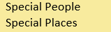
Concepts
gospel, worship, sacred Vocabulary
churches and other places of worship, features of the building, holy days

Exploring | Learning Outcomes  By the end of KS1 pupils should be able to
How and why do people of faith worship? | Describe different ways people may worship  Recognise aspects of worship common to more than one faith  Reflect on the importance of worship in the life of a believer
How is a place of worship used? | Name the parts of two places of worship for different faiths  Describe how the building and its artefacts are used in different ways
What makes a holy book special? | Recognise and name the holy books of different faiths  Retell a story from two different faiths and say what they mean for the believer
Prior knowledge
Be able to talk about their special place, where is it? Why is it special?
Know places that are special to certain groups of people, such as the football/rugby stadium

Identify learning questions: Why worship?
Looking at how people worship in different Christian traditions:
What is worship?
Where can people worship? At home? At a place of worship?
What places of worship are in the community/wider area?
Why is music often important to worship?
What happens in a church? What happens in another place of worship?
Who goes there? Why?
Who looks after the place of worship?
Who leads worship? What do they wear? What do they do? How do they prepare for worship?
What objects do you find in a church? What objects do you find in another place of worship? How are sacred texts treated?

Enquiry: consider
- The idea that a place of worship is special to a group of believer’s different ways people may worship
- Photos illustrating worship in homes and in other places; identify and name objects used
- The use of holy books, prayer and service books
- How religious artefacts are used in places of worship and at home
- Special clothes people might wear in a place of worship
- Stories from different faiths which have similar messages
- Visiting a place of worship and look at how the different parts are used, or make a virtual tour

Mastery Thinking Questions
Listen to religious music, what it might mean to a believer?
Reflect on the style & mood of different types of religious music
What would you ask a worshipper? What do they do in their place of worship and/or at home and why

Reflect on learning
Consider the special atmosphere in a place of worship or another sacred place
Consider what makes a holy book special
Talk about feelings when watching or participating in an act of worship

Progression exemplars

Recall the important features of a place of worship and say how they are used
Say why a local place of worship is important for many people Recognise which holy books are special to different religions

This contributes to the following End of Key Stage statements:
• Talk about what happens in places of worship and describe how symbols and artefacts are used in each, appreciating some similarities and differences
Curriculum Links
Geography: My local town
Specific focus on different Christian places of worship within the local area (CoE church, St Lawrence’s, a chapel, catholic church Carlton)

Jigsaw:
- Being Me in My World
Rights, responsibilities and choices
Being special and keeping each other safe
- Celebrating difference
What makes us unique
Celebrate similarities and differences
How to help and ask for help.

KS1: Christmas

About this unit
This is a supplementary unit designed to help teachers ensure progression when exploring the festival of Christmas across Key Stage 1.

It may be useful to consider festivals of light from other faiths alongside Christmas.

Concepts
incarnation, gospel
Vocabulary
Advent, nativity, festival, celebration

Exploring | Learning Outcomes  By the end of KS1 pupils should be able to
Which festivals are important to faith members? | Name some religious festivals and say how faith members celebrate them  Describe and explain some traditions linked to religious festivals
What stories are told at different religious festivals? | Suggest reasons why festivals are important  Talk about how stories are celebrated at different religious festivals
Prior knowledge
This unit builds on learning about festivals of light in the Foundation Stage

Identify learning questions
What signs tell us that Christmas is coming? How do we feel?
How do Christian families prepare for Christmas?
What do our senses tell us?
What customs are associated with various parts of the Christmas story?
Why is the Christmas story ‘good news’ for Christians?
What is the ‘good news’ of Christmas for everyone?
What does ‘incarnation’ mean?

Enquiry: consider
Year 1
- The story of the nativity
- What happens at Christmas (sending cards, buying presents)
- Using the senses to explore Christmas
  - sights (Advent calendars and candles, Christingles, tree decorations, wreaths)
  - sounds (bells, Christmas music)
  - tastes (different types of food)
  - touch (wrapped presents)
  - smells (incense and spices, food)
- How Christian and non-Christian families prepare for Christmas both at home and at church
- Traditional festive celebrations
Year 2
- the shepherds hearing the news from the angels
- the wise men (Magi) and their gifts: gold for Jesus as king, frankincense for Jesus as one who comes as a priest from God to mankind, myrrh as a foretelling of Jesus’ death • what would be a suitable gift for Jesus

Mastery Thinking Questions
Why is the festival of Christmas an important celebration for Christians?
Is it important to others as well?

Reflect on learning
How would the shepherds have felt when they heard the news of Jesus’ birth?
How would the wise men have felt when they heard the news of Jesus’ birth?

Demonstrate new understanding
Retell the nativity story simply, through drama, puppets, storyboarding
Dramatise the story and freeze-frame key moments
Use hot-seating to try to understand the feelings of different characters in the story What did the shepherds / wise men think/say/do?
Create a class display of the sights and sounds of Christmas

Understanding Christianity
Unit 1.3 Incarnation

Progression exemplars

Recognise and recall the Nativity story and know why it’s important to Christians Talk about how Christians celebrate the festival of Christmas

This contributes to the following End of Key Stage statements:
- Describe what happens at festivals, ceremonies and rituals and talk about the beliefs behind them
- Retell and suggest meanings for some religious and moral stories and say how they influence people today

Spring Term
Unit 1.3: What a wonderful world
Key Question: Why is the world special?

About this unit
This unit builds on children’s previous learning around ‘special’ places in EYFS and provides opportunities for learning outside the classroom. Explore and appreciate the natural world; listen to Jewish/Christian and other worldviews about how the world came into being; discuss traditional and contemporary creation stories and consider ways in which we can all help care for the world.

By the end of the unit, pupils will know that a most religious traditions believe that god made the world and so it is precious, they also believe that the world was created and given to humans to care for. They will be able to explain in simple terms what happened in a creation account and use and show understanding of relevant vocabulary.

Our Rainbow Learning Threads
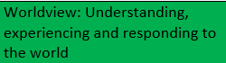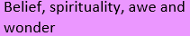
Concepts
creation, God, sacred, peace

Vocabulary
environment, climate, world, universe, precious, care

Ideas
Christian and Hindu creation stories
Holi-Festival of colour and love
Place of worship Hindu temple (Chembakolli New Delhi-linked to comparing places of worship in Snaith 1.1 the synagogue)

Exploring | Learning Outcomes  By the end of KS1 pupils should be able to
Why are creation stories important to faith members? | Recall some creation stories from different traditions identify similarities and differences between creation stories talk about the meaning of two different creation stories
How do different faiths say the world should be cared for? | Say why the world is a special place for faith members talk about ways that everyone can play their part in caring for the world
Prior knowledge
Recall previous learning about special places
Identify learning questions: Why is the world special?
How is the Earth precious; what is wonderful about it; where did it come from?
How do people treat precious things differently?
Where do sacred stories come from?
What do Christians believe about God and creation? What do you think Christians learn from this story?
What stories do other religions tell about the creation of the world? What do these stories teach their followers?
Why should we look after the Earth?

Enquiry: consider
- Listening to Louis Armstrong’s ‘What a wonderful world’; talk about what pupils think makes our world wonderful
- Exploring a natural area, park or nature reserve, let pupils find things they think are wonderful, encourage them to give reasons for their choices
- Making a display/discovery table of wonderful things, say how and why they are wonderful
- Giving time for children to respond in a creative way to what they think is wonderful about the world; encourage them to ask questions and record these for discussion
- Unpacking the concept of creation, looking at familiar objects and considering how they are made, if they have a purpose; what attributes their maker might have
- The Christian / Jewish creation story (UC suggests a guided visualisation for this activity and includes a resource in Unit 2A.1); stimulate responses and encourage pupils to ask questions about it the Hindu or Islamic creation account; encourage pupils to ask questions about it
- Poems, prayers and hymns about creation and the way they describe the world including the ‘Big Bang’ theory if raised by pupils
- Where stories linked to creation may be found, including in artworks, music, dance and drama

Mastery Thinking Questions
Talk about why there are different creation stories
Talk to faith members and find out why the creation story is important to believers What do people with a non-religious worldview believe about how the world began? Look at a piece of art and suggest what the artist is trying to convey Listen to/watch a piece of creation music; what feelings does it arouse?
https://www.youtube.com/watch?v=nxdv2hxg1HQ

Reflect on learning
Reflect on the different ways in which people express their ideas about creation
Look at diversity in the natural world and uniqueness in creation and demonstrate appreciation of this

Progression exemplars

Recall Christian /Jewish beliefs about God and creation stories, adding some details
Retell a creation story using relevant vocabulary and say where the story comes from
Ask their own ‘wondering’ questions about the world Talk about ways of caring for world

This contributes to the following End of Key Stage statements:
- Retell and suggest meanings for some religious and moral stories and say how they influence people today
- Consider and make responses to big questions from different worldviews
Curriculum Links
Science: Plants, life processes and life cycles
Geography: Chembakolli

Jigsaw
- Dreams and Goals
Setting and achieving simple goals
Feelings of tribulation and triumph
- Healthy Me
Keeping healthy-hygiene-staying safe
Healthy and less healthy choices
Associated feelings

Summer Term
2.1: Lead us not into temptation
Key Question: Right or wrong?

About this unit
This unit takes a multidisciplinary approach to exploring the concept of temptation and how people choose between right and wrong. It contributes to personal development and aspects of SMSC and learning how we make personal choices. Stories from different religions illustrate the consequences of making right or wrong choices; pupils should identify similarities and the ways these stories are the basis of rules in society, leading to discussion about how we treat people and the value of the individual.

By the end of the unit, pupils will be able to describe the temptations of Adam and Eve and Jesus. They will be able to explain what temptations there are in their own lives and how they make their own choices, linking to British Values. Also see the Christmas unit which may follow.

Our Rainbow Learning Threads
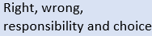
Concepts
gospel, right and wrong
Vocabulary
consequence, good, evil, fairness, moral choices, Adam & Eve, temptation

Exploring | Learning Outcomes  By the end of KS1 pupils should be able to
How do people decide what is right and wrong? | talk about how people make choices  talk to faith members about how they make moral choices
What do faith stories say about the value of each individual? | retell faith stories about the value of each individual  talk sensitively about people of different faiths
What are the special rules and values that religious people follow? | make links between religious rules and values for living
Prior knowledge
Previous link to 10 commandments taught in Year A exploring 2.2 Believing (Jewish faiths)
What a Wonderful World- Creation story (temptation of Adam and Eve)
This also links to jigsaw PSHE ‘Being Me in My World’
Identify learning questions: Right or wrong?
When do we have to make choices; what different choices might we make?
What are our difficult choices?
What are temptations; how do we deal with them?
How do we know what is right and wrong?
What does it mean to be ‘good’?
What is the purpose of rules?
Is it worth doing good things if nobody sees you? How might a faith member respond to this question? Is it ever right to steal or tell lies? What do sacred books say about how to treat others?

Enquiry: consider
- Listening to a faith story such as the Milk and the Jasmine Flower (Sikhi), The Garden of Eden, Jesus’ Temptations, The Good Samaritan
- Re-enacting a faith story about a moral dilemma – link to Talk for Writing
- Holding a community of enquiry (P4C) to raise questions about one of the faith stories
- Hot seating a character from The Good Samaritan and exploring the choices made what faith stories teach faith members about moral choices
- The words of the Christian Lord’s Prayer and the line “Lead us not into temptation….”
- How we can show responsibility and consider the needs of others and the wider community • revisiting the Golden Rule (Unit 1.1) and thinking about how it applies to our treatment of others
- When is it “not fair”?
- What two different faiths say about how we should treat each other and how we can live in communities that are just and fair

Mastery Thinking Questions
What does the word temptation mean?
How do the stories help us to think about making the right choice?
What characteristics do you need to have to resist temptation?
Reflect on learning
How do we feel when we make the right choices?
How do we feel when we realise we have made the wrong choices?
What can we do if we make the wrong choices?
Can we always put things, right?
What would a person of faith do to make things better? What is there always more room in the world for?

Progression exemplars

Respond sensitively to what’s right and what’s wrong
Respond respectfully to people of different faiths and cultures
Recognise differences and similarities between school rules and religious rules

This contributes to the following End of Key Stage statements:
- Express ideas and opinions about moral questions of right and wrong
- Share ideas and examples of co-operation between people who are different
Curriculum Links
This is a stand-alone unit to other subject areas.
Jigsaw:
- Relationships
Strategies to resolve conflict
Acceptable and unacceptable contact
Trust within a relationship
Important of co-operation

