Snaith Primary School Maths Curriculum 2020-21

Rationale
We believe that mathematics is a creative and highly connected subject that is essential to everyday life, science, technology, engineering, finance and most forms of employment. Because of this, we regularly link our maths lessons to our creative curriculum to help the children understand and apply it to real world situations.
Snaith Primary School follow the White Rose Hub maths programme which breaks lessons and topics down into 2 sections: fluency and reasoning and problem solving. Our maths curriculum enables children to build solid foundations and a deep understanding in the fluency section and then they can build on this by applying it to different situations and question types in the reasoning and problem solving section.
The White Rose Hub have specifically set out their maths long term plan using blocks of maths areas which allows the children to really deepen their understanding of the maths topic they are focusing on by spending more time working on one. In addition to this, our maths curriculum clearly shows progression through the year groups in each area of maths and includes a range of stepping stone objectives to build bridges for the children and accelerate progression.
The different areas of maths that have been put into blocks are listed below:
- Number and place value
- Addition and subtraction
- Multiplication and division
- Fractions
- Geometry
- Measurement
- Statistics
- Algebra (Y5/6)
- Ratio & Proportion (Y5/6)
Children with SEND
We recognise that it is extremely important for children with SEND or disadvantaged to have the same opportunities to access the maths curriculum. With this in mind, adjustments will be made. This may include:
- Use of enlarged question sheets
- Use of technology (e.g. iPads, laptops)
- Adapting tasks
- Additional or alternative equipment and/or materials (e.g. trundle wheels, tape measure, numicon, clocks)
- Opportunities for pre-learning and practise
- Varying support from an adult or peer
- Pencil grips
- Larger equipment (e.g. rulers, squared paper, iPads)
- Calculation mats
- Displays

EYFS Nursery
Curriculum Focus- Maths
Number | 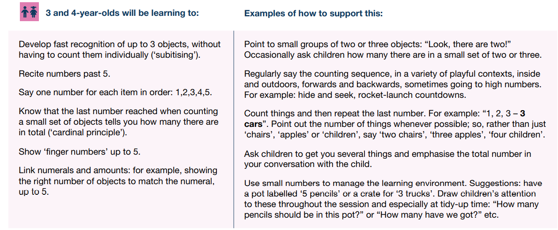
Shape Space and Measure | 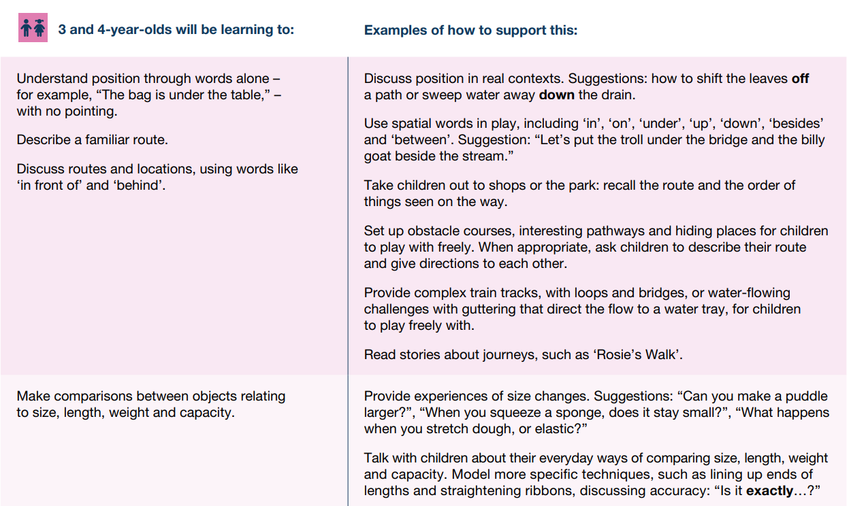
 | 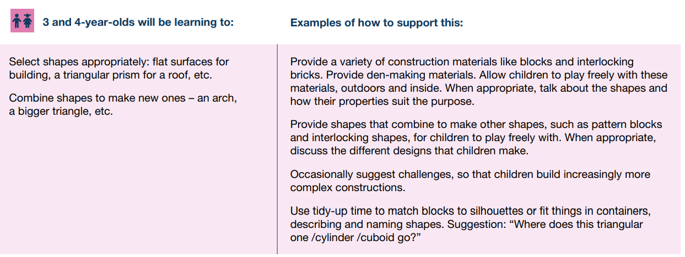
Time | 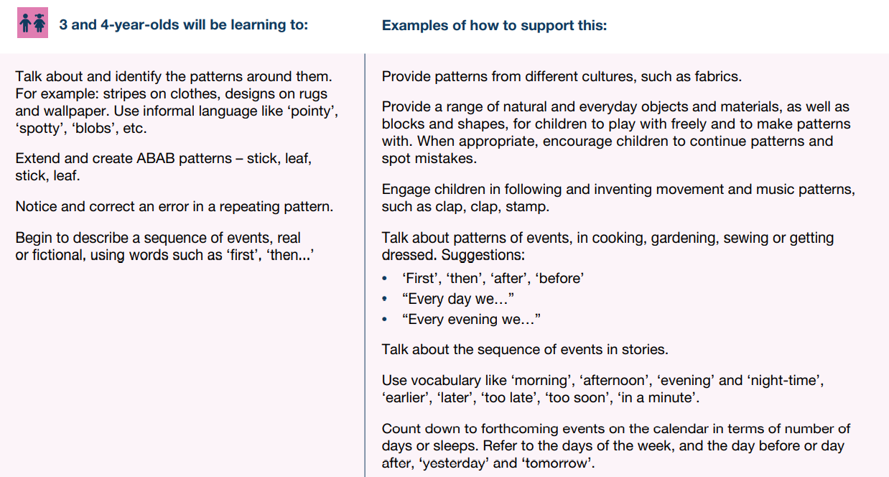

KEY
BOLD text - NC SA objectives purple text – non SA obj blue text - stepping stones red text - wording added
Number and Place Value
 | EYFS Reception | Y1 | Y2
Number and  Place Value KS1 | Count objects, actions and sounds  count objects including saying the numbers in order and matching one number name to each item.  Subitise. Show quantities Eg number of fingers to represent, spots in dice etc.  Link the number symbol (numeral) with its cardinal number value.  Count beyond ten.  Compare numbers.  Understand the ‘one more than/one less than’ relationship between consecutive numbers.  Number ELG  Have a deep understanding of number to 10, including the composition of each number; - Subitise (recognise quantities without counting) up to 5; - Automatically recall (without reference to rhymes, counting or other aids) number bonds up to 5 (including subtraction facts) and some number bonds to 10, including double facts.  Numerical Patterns ELG  Children at the expected level of development will: 12 - Verbally count beyond 20, recognising the pattern of the counting system; - Compare quantities up to 10 in different contexts, recognising when one quantity is greater than, less than or the same as the other quantity; - Explore and represent patterns within numbers up to 10, including evens and odds, double facts and how quantities can be distributed equally. | Count to and across 100, forwards and backwards, beginning with 0 or 1, or from any given number  Count in multiples of two  Count in multiples of fives  Count in multiples of tens | Count in steps of 2, 3, and 5 from 0  Count in tens from any number, forward and backward
Number and  Place Value KS1 |  | Read and write numbers to 100 in digits  Read and write numbers from 1 to 20 in numerals and words | Read and write numbers to at least 100 in digits and in words
Number and  Place Value KS1 |  | Begin to recognise the place value of numbers beyond 20 (tens and ones) | Recognise the place value of each digit in a two-digit number (tens, ones)
Number and  Place Value KS1 |  |  | Understand the connection between the 10 multiplication table and place value
Number and  Place Value KS1 |  | Identify odd and even numbers linked to counting in twos from 0 and 1
Number and  Place Value KS1 |  | Identify and represent numbers using objects and pictorial representations including the number line & Numicon | Identify, represent and estimate numbers using different representations, including the number line & Numicon
Number and  Place Value KS1 |  |  | Partition numbers in different ways (e.g. 23 = 20 + 3 and 23 = 10 + 13)
Number and  Place Value KS1 |  | Given a number, identify one more and one less | Find 1 or 10 more or less than a given number
Number and  Place Value KS1 |  | Use the language of: equal to, more than, less than (fewer), most and least (e.g. comparing amounts) | Compare and order numbers from 0 up to 100; use <, > and = signs
Number and  Place Value KS1 |  |  | Round numbers to at least 100 to the nearest 10
Number and  Place Value KS1 |  | Recognise and create repeating patterns with numbers, objects and shapes | Describe and extend simple sequences involving counting on or back in different steps
Number and  Place Value KS1 |  | Solve problems and practical problems involving all of the above relating to place value | Use place value and number facts to solve problems

Number and Place Value
 | Year 3 | Year 4 | Year 5 | Year 6
Number  and Place Value KS2 | Count from 0 in multiples of 4, 8, in addition to 2, 3, 4, & 10  Count in multiples of 50 and 100 | Count in multiples of 6, 7, 9, 25 and 1000 | Count forwards or backwards in steps of powers of 10 for any given number up to 1 000 000
Number  and Place Value KS2 | Count up and down in tenths | Count backwards through zero to include negative numbers  Count up and down in tenths and hundredths | Count forwards and backwards in decimal steps | Count forwards or backwards in steps of integers, decimals, powers of 10
Number  and Place Value KS2 | Read and write numbers up to 1000 in digits and in words  Recognise the place value of each digit in a three-digit number (hundreds, tens, ones) | Read and write numbers to at least  10 000  Recognise the place value of each digit in a four-digit number | Read and write numbers to at least  1 000 000.  Determine the value of each digit to  1 000 00 | Read, write, order and compare numbers up to 10 000 000  Determine the value of each digit
Number  and Place Value KS2 | Read and write numbers with one decimal place  Identify the value of each digit to one decimal place | Read and write numbers with up to two decimal places  Identify the value of each digit to two decimal places | Read and write numbers with up to 3 decimal places  Identify the value of each digit to three decimal places | Identify the value of each digit to three decimal places
Number  and Place Value KS2 | Partition numbers in different ways e.g. 146 = 100+ 40+6 and 146 = 130+16 | Partition numbers in different ways e.g. 2.3 = 2+0.3 & 1+1.3 | Use partitioning to solve problems  eg 50,000+ ____ + 70 = 50,670 | Use partitioning to solve problems including with decimals  eg. 1.05 + ___ = 1.75
Number  and Place Value KS2 | Identify, represent and estimate numbers using different contexts (including the number line) | Identify, represent and estimate numbers using different representations (including the number line) | Identify represent and estimate numbers using the number line | Identify, represent and estimate numbers using the number line
Number  and Place Value KS2 | Compare and order numbers up to 1000 | Order and compare numbers beyond 1000 | Order and compare numbers to at least 1 000 000
Number  and Place Value KS2 | Compare and order numbers with one decimal place | Order and compare numbers with the same number of decimal places up to two decimal places | Order and compare numbers with different numbers of decimal places up to 3 decimal places Eg 2.15 2.12 2.1 2.2 | Order and compare numbers including integers, decimals and negative numbers
Number  and Place Value KS2 | Find 1, 10 or 100 more or less than a given number | Find 0.1, 1, 10, 100 or 1000 more or less than a given number | Find 0.01, 0.1, 1, 10, 100, 100 and other powers of 10 more or less than a given number | Find 0.001, 0.01, 0.1, 1, 10 and powers of 10 more/less than a given number
Number  and Place Value KS2 | Round numbers to at least 1000 to the nearest 10 or 100 | Round any number to the nearest 10, 100 or 1000  Round decimals (one decimal place) to the nearest whole number | Round any number up to 1 000 000 to the nearest 10, 100, 1000, 10 000 and 100 000  Round decimals with two decimal places to the nearest whole number and to one decimal place | Round any whole number to a required degree of accuracy  Round decimals with three decimal places to the nearest whole number or one or two decimal places
Number  and Place Value KS2 | Find the effect of multiplying a one- or two-digit number by 10 and 100, identify the value of the digits in the answer | Find the effect of dividing a one- or two-digit number by 10 and 100, identifying the value of the digits in the answer | Multiply/divide whole numbers and decimals by 10, 100 and 1000 | Multiply and divide numbers by 10, 100 and 1000 giving answers up to three decimal places
Number  and Place Value KS2 | Describe and extend number sequences involving counting on or back in different steps with whole numbers  (eg if I know 6x table I know 60x table etc) | Describe and extend number sequences involving counting on or back in different steps, including sequences with multiplication and division steps | Describe and extend number sequences including those with multiplication/division steps and where the step size is a decimal or a fraction.  Eg 3 3 ½ 4 4 ½ | Describe and extend number sequences including those with multiplication and division steps, inconsistent steps, alternating steps and those where the step size is a decimal or a fraction  Eg 2 2 ¾ 3 ½ 4 ¼ 5
Number  and Place Value KS2 |  |  | Interpret negative numbers in context, count on and back with positive and negative whole numbers, including through zero | Use negative numbers in context. Calculate intervals across zero.
Number  and Place Value KS2 | Read Roman numerals from I to XII | Read Roman numerals to 100 and know that over time, the numeral system changed to include the concept of zero and place value | Read Roman numerals to 1000 (M); Recognise years written in Roman Numerals to 1000 (M) | Read Roman numerals to 1000 (M); and apply their knowledge to solve problems.
Number  and Place Value KS2 | Solve number problems and practical problems involving place value. | Solve number and practical problems using place value with increasingly large positive numbers | Solve number and practical problems using placing value involving numbers to 3 decimal places | Solve number and practical problems using placing value including decimal numbers and rounding with specified degrees of accuracy.

Addition and Subtraction
 | EYFS | Y1 | Y2
Addition and Subtraction KS1 | Explore the composition of numbers to 10  Automatically recall number bonds for numbers 0–5 and some to 10. |  | Choose an appropriate strategy to solve a calculation based upon the numbers involved (recall a known fact, calculate mentally, use a jotting)
Addition and Subtraction KS1 | ELG  Automatically recall (without reference to rhymes, counting or other aids) number bonds up to 5 (including subtraction facts) and some number bonds to 10 | Read, write and interpret mathematical statements involving addition (+), subtraction (-) and equals (=) signs
Addition and Subtraction KS1 |  | Represent and use number bonds and related subtraction facts within 20 | Recall and use addition and subtraction facts to 20 fluently, and derive and use related facts up to 100  Recall and use number bonds for multiples of 5 totalling 60 (to support telling time to nearest 5 minutes)
Addition and Subtraction KS1 |  |  | Select a mental strategy appropriate for the numbers involved in the calculation
Addition and Subtraction KS1 |  | Add and subtract one-digit and two-digit numbers to 20, including zero (using concrete objects and pictorial representations) | Add and subtract numbers using concrete objects, pictorial representations, and mentally, including:  - a two-digit number and ones - a two-digit number and tens - two two-digit numbers - adding three one-digit numbers
Addition and Subtraction KS1 |  |  | Show that addition of two numbers can be done in any order (commutative) and subtraction of one number from another cannot
Addition and Subtraction KS1 |  |  | Understand subtraction as take away and difference (how many more, how many less/fewer)
Addition and Subtraction KS1 |  | Solve one-step problems that involve addition and subtraction, using concrete objects and pictorial representations, and missing number problems such as 7 =  - 9 | Solve problems with addition and subtraction including with missing numbers: - using concrete objects and pictorial representations, including those involving numbers, quantities and measures - applying their increasing knowledge of mental and written methods
Addition and Subtraction KS1 |  |  | Recognise and use the inverse relationship between addition and subtraction and use this to check calculations and solve missing number problems

Addition and Subtraction
 | Y3 | Y4 | Y5 | Y6
Addition & Subtraction KS2 | Choose an appropriate strategy to solve a calculation based upon the numbers involved (recall a known fact, calculate mentally, use a jotting, written method)  Select a mental strategy appropriate for the numbers in the calculation | Choose an appropriate strategy to solve a calculation based upon the numbers involved (recall a known fact, calculate mentally, use a jotting, written method)  Select a mental strategy appropriate for the numbers in the calculation | Choose an appropriate strategy to solve a calculation based upon the numbers involved (recall a known fact, calculate mentally, use a jotting, written method)  Select a mental strategy appropriate for the numbers in the calculation | Choose an appropriate strategy to solve a calculation based upon the numbers involved (recall a known fact, calculate mentally, use a jotting, written method)  Select a mental strategy appropriate for the numbers in the calculation
Addition & Subtraction KS2 | Understand and use take away and difference for subtraction, deciding on the most efficient method for the numbers involved, irrespective of context
Addition & Subtraction KS2 | Recall/use addition/subtraction facts for 100 (multiples of 5 and 10) | Recall and use addition and subtraction facts for 100  Recall and use +/- facts for multiples of 100 totalling 1000 | Recall and use addition and subtraction facts for 1 and 10 (with decimal numbers to one decimal place) | Recall and use addition and subtraction facts for 1 (with decimals to two decimal places)
Addition & Subtraction KS2 | Derive and use addition and subtraction facts for 100  Derive and use addition and subtraction facts for multiples of 100 totalling 1000 | Derive and use addition and subtraction facts for 1 and 10 (with decimal numbers to one decimal place) | Derive and use addition and subtraction facts for 1 (with decimal numbers to two decimal places) | Perform mental calculations including with mixed operations and large numbers and decimals
Addition & Subtraction KS2 | Add and subtract numbers mentally, including:  - a three-digit number and ones  - a three-digit number and tens  - a three-digit number and hundreds | Add and subtract mentally combinations of two and three digit numbers and decimals to one decimal place | Add and subtract numbers mentally with increasingly large numbers and decimals to two decimal places
Addition & Subtraction KS2 | Add numbers with up to three digits, using a written method that will lead to a formal written method for addition & subtraction | Add numbers with up to 4 digits and decimals with one decimal place using the column written method | Add whole numbers with more than 4 digits and decimals with two decimal places using the column written method | Add several numbers with more than 4 digits (including decimals up to three decimal places) using the column written method
Addition & Subtraction KS2 | Subtract numbers with up to three digits, using a written method that will lead to a formal written method for addition & subtraction | Subtract numbers with up to 4 digits and decimals with one decimal place using the column written method | Subtract whole numbers with more than 4 digits and decimals with two decimal places using the column written method | Subtract whole numbers with more than 4 digits and decimals with three decimal places using the column written method
Addition & Subtraction KS2 | Estimate the answer to a calculation and use inverse operations to check answers | Estimate; use inverse operations to check answers to a calculation | Use rounding to check answers to calculations and determine, in the context of a problem, levels of accuracy | Use estimation to check answers to calculations and determine, in the context of a problem, an appropriate degree of accuracy
Addition & Subtraction KS2 |  |  | Begin to use knowledge of the order of operations to carry out 2 step calculations  e.g. 100 – 7 x 5 = | Use knowledge of the order of operations to carry out 3 step calculations  e.g. 200 – 25 x 3 + 5 =
Addition & Subtraction KS2 | Solve problems, including missing number problems, using number facts, place value, and more complex +/- | Solve addition and subtraction two-step problems in contexts, deciding which operations and methods to use and why (Singapore bar) | Solve addition and subtraction multi-step problems in contexts, deciding which operations and methods to use and why | Solve addition and subtraction multi-step problems in contexts, deciding which operations and methods to use and why
Addition & Subtraction KS2 |  | Solve addition and subtraction problems involving missing numbers | Solve addition and subtraction problems involving missing numbers | Solve problems involving all four operations, including those with missing numbers

Multiplication and Division
 | EYFS | Y1 | Y2
Multiplication and Division KS1 | Children have an understanding of doubling to 10.  Numerical Patterns ELG  Explore and represent patterns within numbers up to 10, including evens and odds, double facts and how quantities can be distributed equally. | Recall and use doubles of all numbers to 10 and corresponding halves | Understand multiplication as repeated addition
Multiplication and Division KS1 |  | Solve one-step problems involving multiplication and division, by calculating the answer using concrete objects, pictorial representations and arrays with the support of the teacher | Understand division as sharing and grouping and that a division calculation can have a remainder
Multiplication and Division KS1 |  |  | Show that multiplication of two numbers can be done in any order (commutative) and division of one number by another cannot
Multiplication and Division KS1 |  |  | Recall and use multiplication and division facts for the 2, 5 and 10 multiplication tables, including recognising odd and even numbers
Multiplication and Division KS1 |  |  | Derive and use doubles of simple two-digit numbers (numbers in which the ones total less than 10)
Multiplication and Division KS1 |  |  | Derive and use halves of simple two-digit even numbers (numbers in which the tens are even)
Multiplication and Division KS1 |  |  | Calculate mathematical statements for multiplication using repeated addition) and division within the multiplication tables and write them using the multiplication (×), division (÷) and equals (=) signs
Multiplication and Division KS1 |  |  | Solve problems involving multiplication and division (including those with remainders), using materials, arrays, repeated addition, mental methods, and multiplication and division facts, including problems in contexts
Multiplication and Division
 | Y3 | Y4 | Y5 | Y6
Multiplication and Division KS2 | Choose an appropriate strategy to solve a calculation based upon the numbers involved (recall a known fact, calculate mentally, use a jotting, written method) | Choose an appropriate strategy to solve a calculation based upon the numbers involved (recall a known fact, calculate mentally, use a jotting, written method) | Choose an appropriate strategy to solve a calculation based upon the numbers involved (recall a known fact, calculate mentally, use a jotting, written method) | Choose an appropriate strategy to solve a calculation based upon the numbers involved (recall a known fact, calculate mentally, use a jotting, written method)
Multiplication and Division KS2 | Understand that division is the inverse of multiplication and vice versa
Multiplication and Division KS2 | Understand how multiplication and division statements can be represented using arrays
Multiplication and Division KS2 | Understand division as sharing and grouping and use each appropriately
Multiplication and Division KS2 | Recall and use multiplication and division facts for the 3, 4 and 8 multiplication tables | Recall multiplication and division facts for multiplication tables up to 12 × 12
Multiplication and Division KS2 |  | Recognise and use factor pairs and commutativity in mental calculations | Identify multiples and factors, including finding all factor pairs of a number, and common factors of two numbers | Identify common factors and common multiples
Multiplication and Division KS2 |  |  | Know and use the vocabulary of prime numbers, prime factors and composite (non-prime) numbers  Establish whether a number up to 100 is prime and recall prime numbers up to 19 | Identify prime numbers up to 200 and recall prime numbers up to 50
Multiplication and Division KS2 |  |  | Recognise and use square (2) and cube (3) numbers, and notation | Recognise and use square (2) and cube (3) numbers, and notation
Multiplication and Division KS2 |  |  | Solve problems involving multiplication and division including using their knowledge of factors and multiples, squares and cubes | Solve problems involving multiplication and division including using their knowledge of factors and multiples, squares and cubes
Multiplication and Division KS2 |  | Use place value, known and derived facts to multiply and divide mentally, including:  - multiplying by 0 and 1  - dividing by 1  - multiplying together three numbers | Multiply and divide numbers mentally drawing upon known facts | Multiply and divide numbers mentally drawing upon known facts
Multiplication and Division KS2 | Derive and use doubles of all numbers to 100 and corresponding halves  Derive and use doubles of all multiples of 50 to 500 | Use partitioning to double or halve any number, including decimals to one decimal place | Use partitioning to double or halve any number, including decimals to two decimal places | Use partitioning to double or halve any number, including decimals to two decimal places
Multiplication and Division KS2 | Write and calculate mathematical statements for multiplication using the multiplication tables that they know (including for two-digit numbers times one-digit numbers) using mental and written methods which will later progress to formal written methods | Multiply two-digit and three-digit numbers by a one-digit number using a written layout | Multiply numbers up to 4 digits by a one- or two-digit number using a written method | Multiply numbers up to 4 digits by a one- or two-digit number using a written method  Multiply one-digit numbers with up to two decimal places by whole numbers
 | Write and calculate mathematical statements for = division using the multiplication tables that they know, using mental and written methods which will later progress to formal written methods | Divide numbers up to 3 digits by a one-digit number using a written method (partial tables) and interpret remainders appropriately for the context | Divide numbers up to 4 digits by a one-digit number using a written method & interpret remainders appropriately for the context | Divide numbers up to 4 digits by a one-digit number using a written method & interpret remainders appropriately for the context  Use written division methods in cases where the answer has up to two decimal places
 | Use estimation to check answers to calculations and determine, in the context of a problem, an appropriate degree of accuracy | Use estimation and inverse to check answers to calculations and determine, in the context of a problem, an appropriate degree of accuracy | Use estimation/inverse to check answers to calculations; determine, in the context of a problem, an appropriate degree of accuracy | Use estimation/inverse to check answers to calculations; determine, in the context of a problem, an appropriate degree of accuracy
 | Solve problems, including missing number problems, involving multiplication and division (and interpreting remainders), including positive integer scaling problems and correspondence problems in which n objects are connected to m objects | Solve problems involving multiplying and adding, including using the distributive law to multiply two digit numbers by one digit, division (including interpreting remainders), integer scaling problems and harder correspondence problems | Solve problems involving addition, subtraction, multiplication and division and a combination of these, including understanding the meaning of the equals sign  Solve problems involving multiplication and division, including scaling by simple fractions and problems involving simple rates | Solve problems involving addition, subtraction, multiplication and division  Solve problems involving multiplication and division, including scaling by simple fractions and problems involving simple rates

Fractions
 | EYFS | Y1 | Y2
Fractions KS1 | When sharing refer to half and quarter, | Understand that a fraction can describe part of a whole  Understand that a unit fraction represents one equal part of a whole | Understand that a fraction can describe part of a set
Fractions KS1 |  |  | Understand and use the terms numerator and denominator
Fractions KS1 |  |  | Understand that the larger the denominator is, the more pieces it is split into and therefore the smaller each part will be
Fractions KS1 |  | Recognise, find and name a half as one of two equal parts of an object shape or quantity (including measure)  Recognise, find and name a quarter as one of four equal parts of an object, shape or quantity (including measure) | Recognise, find, name and write fractions 1/3, 1/4, 2/4 and 3/4 of a length, shape, set of objects or quantity
Fractions KS1 |  |  | Write simple fractions for example 1/2 of 6 = 3 and recognise the equivalence of 2/4 and 1/2
 |  |  | Count on and back in steps of 1/2 and 1/4

Fractions (including decimals and percentages)
 | Year 3 | Year 4 | Year 5 | Year 6
Fractions KS2 | Recognise, find and write fractions of a discrete set of objects: unit fractions and non-unit fractions with small denominators  Recognise and use fractions as numbers: unit fractions and non-unit fractions with small denominators | Recognise, find and write fractions of a discrete set of objects including those with a range of numerators and denominators | Recognise, find and write fractions of a number including those with a range of numerators and denominators
Fractions KS2 | Recognise and show, using diagrams, equivalent fractions with small denominators | Recognise and show, using diagrams, families of common equivalent fractions | Identify, name and write equivalent fractions of a given fraction, represented visually, including tenths and hundredths | Recall and use equivalences between simple fractions, decimals and percentages, including in different contexts
Fractions KS2 | Compare and order unit fractions, and fractions with the same denominators (including on a number line) | Compare and order unit fractions and fractions with the same denominators (including on a number line) | Compare and order fractions whose denominators are all multiples of the same number (including on a number line) | Compare and order fractions, including fractions > 1 (including on a number line)
Fractions KS2 | Count on and back in steps of 1/2, 1/4 and 1/3 | Count on and back in steps of unit fractions | Count on and back in mixed number steps such as 1 1/2 | Count on and back in mixed number steps with different denominators
Fractions KS2 | Add and subtract fractions with the same denominator within one whole [e.g. 5/7 + 1/7 = 6/7 ] | Add and subtract fractions with the same denominator (using diagrams) | Add and subtract fractions with denominators that are the same and that are multiples of the same number (using diagrams) | Add and subtract fractions with different denominators and mixed numbers, using the concept of equivalent fractions
Fractions KS2 |  |  | Multiply proper fractions and mixed numbers by whole numbers, supported by materials and diagrams | Multiply simple pairs of proper fractions, writing the answer in its simplest form (e.g. 1/4x1/2 =1/8 )
Fractions KS2 |  |  |  | Divide proper fractions by whole numbers (e.g. 1/3÷ 2 =1/6 )
Fractions KS2 |  |  |  | Use common factors to simplify fractions; use common multiples to express fractions in the same denomination
Fractions KS2 |  |  | Recognise mixed numbers and improper fractions and convert from one form to the other (and write statements > 1 as a mixed number e.g. 2/5 + 4/5 = 6/5 =1 1/5)
Fractions KS2 | Show practically or pictorially that a fraction is one whole number divided by another (e.g. 3/4 can be interpreted as 3 ÷ 4) | Understand that a fraction is one whole number divided by another (e.g. 3/4 can be interpreted as 3 ÷ 4)
Fractions KS2 | Understand that finding a fraction of an amount relates to division | Solve problems involving increasingly harder fractions to calculate quantities, and fractions to divide quantities, including non-unit fractions where the answer is a whole number
Fractions KS2 | Count up/down in tenths and recognise that tenths arise from dividing objects into 10 equal parts and in dividing one-digit numbers or quantities by 10 | Count up/down in hundredths and recognise that hundredths arise when dividing an object by one hundred and dividing tenths by ten
Fractions KS2 |  | Recognise and write decimal equivalents of any number of tenths or hundredths  Recognise and write decimal equivalents to 1/4, 1/2, 3/4 | Read and write decimal numbers as fractions (e.g. 0.71 = 71/100  Recognise and use thousandths and relate them to tenths, hundredths and decimal equivalents  Solve problems which require knowing percentage and decimal equivalents of 1/2, 1/4, 1/5, 2/5, 4/5 and fractions with a denominator of a multiple of 10 or 25 | Associate a fraction with division and calculate decimal fraction equivalents (e.g. 0.375 and 3/8)
Fractions KS2 |  |  | Recognise the per cent symbol (%) and understand that per cent relates to ‘number of parts per hundred’, and write percentages as a fraction with denominator 100, and as a decimal | Solve problems involving the calculation of percentages [for example, of measures, and such as 15% of 360] and the use of percentages for comparison
Fractions KS2 |  |  | Find simple percentages of amounts  (multiples of 10) | Find whole number percentages of amounts
Fractions KS2 | Solve problems that involve all of the above | Solve simple measure and money problems involving fractions and decimals to two decimal places | Solve problems involving fractions and decimals to three places | Solve problems involving fractions  Solve problems which require answers to be rounded to specified degrees of accuracy

Geometry
 | EYFS | Y1 | Y2
Properties of shape KS1 | Select, rotate and manipulate shapes to develop spatial reasoning skills.  Compose and decompose shapes so that children recognise a shape can have other shapes within it, just as numbers can.  Continue, copy and create repeating patterns | Recognise and name common 2-D shapes, including rectangles (including squares), circles and triangles | Identify and describe the properties of 2-D shapes, including the number of sides and line symmetry in a vertical line
Properties of shape KS1 |  | Recognise and name common 3-D shapes, including cuboids (including cubes), pyramids and spheres | Identify and describe the properties of 3-D shapes, including the number of edges, vertices and faces
Properties of shape KS1 |  |  | Identify 2-D shapes on the surface of 3-D shapes, [for example, a circle on a cylinder and a triangle on a pyramid]
Properties of shape KS1 |  |  | Compare and sort common 2-D and 3-D shapes and everyday objects
Position and direction KS1 |  | Describe movement, including whole, half, quarter and three-quarter turns
Position and direction KS1 |  | Recognise and create repeating patterns with objects and shapes | Order/arrange combinations of mathematical objects in patterns/sequences
Position and direction KS1 |  | Describe position and direction | Use mathematical vocabulary to describe position, direction and movement, including movement in a straight line and distinguishing between rotation as a turn and in terms of right angles for quarter, half and three-quarter turns (clockwise and anti-clockwise)

Geometry
 | Year 3 | Year 4 | Year 5 | Year 6
Properties of shape KS2 | Draw 2-D shapes |  | Draw given angles, and measure them in degrees (°) | Draw 2-D shapes using given dimensions and angles
Properties of shape KS2 | Make 3-D shapes using modelling materials |  |  | Build simple 3-D shapes, including making nets
Properties of shape KS2 | Recognise 3-D shapes in different orientations and describe them |  | Identify 3-D shapes from 2-D representations | Recognise and describe 3D shapes
Properties of shape KS2 |  | Compare and classify geometric shapes, including quadrilaterals and triangles, based on their properties and sizes |  | Compare/classify geometric shapes based on the properties and sizes
Properties of shape KS2 |  | Identify lines of symmetry in 2-D shapes presented in different orientations  Complete a simple symmetric figure with respect to a specific line of symmetry
Properties of shape KS2 | Identify horizontal and vertical lines and pairs of perpendicular and parallel lines | Continue to identify horizontal and vertical lines and pairs of perpendicular and parallel lines | Distinguish between regular and irregular polygons based on reasoning about equal sides and angles
Properties of shape KS2 |  |  |  | Illustrate and name parts of circles, including radius, diameter and circumference and know that the diameter is twice the radius
Properties of shape KS2 | Recognise angles as a property of shape or a description of a turn  Identify right angles, recognise that two right angles make a half-turn, three make three quarters of a turn and four a complete turn; identify whether angles are greater than or less than a right angle | Identify acute and obtuse angles and compare and order angles up to two right angles by size | Know angles are measured in degrees: estimate and compare acute, obtuse and reflex angles  Use the properties of rectangles to deduce related facts and find missing lengths and angles | Find unknown angles in any triangles, quadrilaterals, regular polygons
Properties of shape KS2 |  |  | Identify:  - angles at a point and one whole turn (total 360°)  - angles at a point on a straight line and half a turn (total 180°)  - other multiples of 90° | Recognise angles where they meet at a point, are on a straight line, or are vertically opposite, and find missing angles
Position and direction KS2 |  | Describe positions on a 2-D grid as coordinates in the first quadrant | Describe positions on the first quadrant of a coordinate grid | Describe positions on the full coordinate grid (all four quadrants)
Position and direction KS2 |  | Plot specified points and draw sides to complete a given polygon | Plot specified points and complete shapes | Draw simple shapes on the coordinate plane
Position and direction KS2 |  | Describe movements between positions as translations of a given unit to the left/right and up/down | Identify, describe and represent the position of a shape following a reflection or translation, using the appropriate language, and know that the shape has not changed | Translate simple shapes on the coordinate plane, and reflect them in the axes

Measurement
 | EYFS | Y1 | Y2
Measurement KS1 | Compare length, weight and capacity. | Measure and begin to record the following using non-standard then standard units:  - lengths and heights (cm/m)  - mass/weight (kg/g)  - capacity and volume (litres/ml)  - time (hours/minutes/seconds) | Choose and use appropriate standard units to estimate and measure the following:  -length/height in any direction (m/cm)  -mass (kg/g)  -temperature (°C)  -capacity and volume (litres/ml)
Measurement KS1 |  | Compare lengths, mass, volume/capacity by saying which is the larger measure | Compare and order lengths, mass, volume/capacity and record the results using >, < and =
Measurement KS1 |  | Compare, describe and solve practical problems for:  -lengths and heights (for example, long/short, longer/shorter, tall/short, double/half)  -mass/weight (for example, heavy/light, heavier than, lighter than)  -capacity and volume (for example, full/empty, more than, less than, half, half full, quarter)  - time (for example, quicker, slower, earlier, later) | Solve simple problems in a practical context involving addition and subtraction of money of the same unit, including giving change and measures
Measurement KS1 |  | Sequence events in chronological order using language (for example, before and after, next, first, today, yesterday, tomorrow, morning, afternoon and evening) | Compare and sequence intervals of time
Measurement KS1 |  | Tell the time to the hour and half past the hour and draw the hands on a clock face to show these times | Tell and write the time to five minutes, including quarter past/to the hour and draw the hands on a clock face to show these times
Measurement KS1 |  | Recognise and use language relating to dates, including days of the week, weeks, months and years | Know the number of minutes in an hour and the number of hours in a day
Measurement KS1 |  | Recognise and know the value of different denominations of coins and notes | Find different combinations of coins that equal the same amounts of money  Recognise and use symbols for pounds (£) and pence (p); combine amounts to make a particular value

Measurement
 | Year 3 | Year 4 | Year 5 | Year 6
Measurement KS2 | Measure, compare, add and subtract: lengths (m/cm/mm); mass (kg/g); volume/capacity (l/ml) |  | Use, read and write standard units of length and mass | Use, read and write standard units of length, mass, volume and time using decimal notation to three decimal places
Measurement KS2 | Continue to estimate and measure temperature to the nearest degree (°C) using thermometers | Estimate, compare and calculate different measures, including  money in pounds and pence | Estimate (and calculate) volume ((e.g., using 1 cm3 blocks to build cuboids (including cubes)) and capacity (e.g. using water)  Understand the difference between liquid volume and solid volume | Calculate, estimate and compare volume of cubes and cuboids using standard units, including cubic centimetres (cm3) and cubic metres (m3), and extending to other units (e.g. mm3 and km3)
Measurement KS2 | Understand perimeter is a measure of distance around the boundary of a shape  Measure the perimeter of simple 2-D shapes | Measure and calculate the perimeter of a rectilinear figure  (including squares) in cm/m | Measure/calculate the perimeter of composite rectilinear shapes in cm/m | Recognise that shapes with the same areas can have different perimeters and vice versa
Measurement KS2 | Order positive temperatures | Order temperatures including those below 0°C | Continue to order temperatures including those below 0°C | Calculate differences in temperature, including those that involved a positive and negative temperature
Measurement KS2 |  | Convert between different units of measure [e.g. kilometre to  metre; hour to minute] | Convert between different units of metric measure (cm, m, km) | Convert between standard units of length, mass, volume and time using decimal notation to three decimal places
Measurement KS2 |  |  | Understand and use approximate equivalences between metric units and common imperial units such as inches, pounds and pints | Convert between miles and kilometres
Measurement KS2 | Find the area of squares and rectangles by counting squares | Know area is a measure of surface within a given boundary  Find the area of rectilinear shapes by counting squares | Calculate and compare the area of rectangle, use standard units square centimetres (cm2) and square metres (m2) and estimate the area of irregular shapes | Recognise when it is possible to use formulae for area and volume of shapes  Calculate the area of parallelograms and triangles
Measurement KS2 | Estimate/read time with increasing accuracy to the nearest minute  Tell and write the time from an analogue clock, including using Roman numerals from I to XII, and 12-hour and 24-hour clocks  Record/compare time in terms of seconds, minutes, hours; use vocabulary such as o’clock, a.m./p.m., morning, afternoon, noon, midnight  Know the number of seconds in a minute and the number of days in each month, year and leap year  Compare durations of events [for example to calculate the time taken by particular events or tasks] | Read, write and convert time between analogue and digital 12-  and 24-hour clocks | Continue to read, write and convert time between analogue and digital 12 and 24-hour clocks
Measurement KS2 | Recognise that ten 10p coins equal £1 and that each coin is 1/10  of £1 | Recognise that one hundred 1p coins equal £1 and that each coin  is 1/100 of £1
Measurement KS2 | Continue to recognise and use the symbols for pounds (£) and pence (p) and understand that the decimal point separates pounds/pence | Write amounts of money using decimal notation
Measurement KS2 | Solve problems involving money and measures and simple problems involving passage of time  Add and subtract amounts of money to give change, using both £ and p in  practical contexts | Solve problems involving converting from hours to minutes; minutes to seconds; years to months; weeks to days | Solve problems involving converting between units of time  Use all four operations to solve problems involving measure using decimal notation, including scaling | Solve complex problems converting between units of time in real life contexts  Solve problems involving the calculation and conversion of units of measure, using decimal notation up to three decimal places where appropriate

Statistics
 | EYFS | Y1 | Y2
Statistics KS1 |  | Sort objects, numbers and shapes to a given criterion and their own | Compare and sort objects, numbers and common 2-D and 3-D shapes and everyday objects
Statistics KS1 |  | Interpret data in block diagrams using practical equipment | Interpret simple pictograms, tally charts, block diagrams and simple tables
Statistics KS1 |  | Present data in block diagrams using practical equipment | Construct simple pictograms, tally charts, block diagrams and simple tables
Statistics KS1 |  | Ask and answer simple questions by counting the number of objects in each category | Ask and answer simple questions by counting the number of objects in each category and sorting the categories by quantity
Statistics KS1 |  | Ask and answer questions by comparing categorical data | Ask and answer questions about totalling and comparing categorical data

Statistics
 | Year 3 | Year 4 | Year 5 | Year 6
Statistics KS2 |  | Use a variety of sorting diagrams to compare and classify numbers and geometric shapes based on their properties and sizes | Complete and interpret information in a variety of sorting diagrams (including those used to sort properties of numbers and shapes) | Continue to complete and interpret information in a variety of sorting diagrams (including sorting properties of numbers and shapes)
  Use sorting diagrams to compare and sort objects, numbers and common 2-D and 3-D shapes and everyday objects
Statistics KS2 | Interpret data using bar charts, pictograms and tables  (use scales of 2, 5 and 10) | interpret discrete and continuous data using appropriate graphical methods, including bar charts and time graphs  (use a greater range of scales – e.g. 20, 50 and 100) | Read and interpret information in tables and timetables | Interpret pie charts and line graphs and use these to solve problems
Statistics KS2 | Present data using bar charts, pictograms and tables  (use scales of 2, 5 and 10) | Present discrete and continuous data using appropriate graphical methods, including bar charts and time graphs  (use a greater range of scales – e.g. 20, 50 and 100) | Complete information in tables and timetables | Construct pie charts and line graphs
Statistics KS2 | Solve one-step and two-step questions [for example, ‘How many more?’ and ‘How many fewer?’] using information presented in scaled bar charts and pictograms and tables | Solve comparison, sum and difference problems using information presented in bar charts, pictograms, tables and other graphs | Solve comparison, sum and difference problems using information presented in all types of graph including a line graph | Solve comparison, sum and difference problems using information presented in all types of graph (including conversion graphs)
Statistics KS2 |  |  | Calculate the mode, median, range and mean of a set of data | Calculate and interpret the mean as an average  Find missing data using the mean as a starting point

Algebra
 | Year 3 | Year 4 | Year 5 | Year 6
Algebra KS2 |  |  | Use simple formulae to solve problems (calculate the value of a letter in a simple equation – e.g. 9a = 45) | Use simple formulae to solve problems (calculate the value of a letter in an equation – e.g. 2f + 8 = 20)
Algebra KS2 |  |  | Describe and continue linear number sequences | Describe, continue and complete linear number sequences  Describe, continue and complete two-step number sequences
Algebra KS2 |  |  | Express missing number problems algebraically  Write simple formulae based on pictures | Express missing number problems algebraically  Write simple formulae based on pictures and maths stories
Algebra KS2 |  |  | Find pairs of numbers that satisfy a simple equation with two unknowns (e.g. a + b = 11 - b is an even number – what could a and b be?) | Find pairs of numbers that satisfy an equation with two unknowns (e.g. 2a + b = 20 - a is a prime number – what could b be?)
Algebra KS2 |  |  | Enumerate possibilities of combinations of two variables (e.g. a + b = 20 - b is a single digit number – what are all the possibilities?) | Enumerate possibilities of combinations of two variables (e.g. 2a - b = 10 - b is a multiple of 3 – find three possibilities)

Ratio and Proportion
 | Year 3 | Year 4 | Year 5 | Year 6
Ratio and Proportion KS2 |  |  |  | Solve problems involving the relative sizes of two quantities where missing values can be found by using integer multiplication and division facts
Ratio and Proportion KS2 |  |  | Solve problems involving the calculation of percentages [for example, of measures, and such as 15% of 360] and the use of percentages for comparison | Solve problems involving unequal sharing and grouping using knowledge of fractions and multiples.
Ratio and Proportion KS2 |  |  |  | Solve problems involving similar shapes where the scale factor is known or can be found

