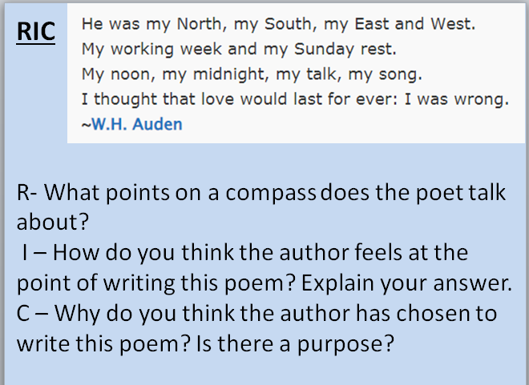

Guided Reading - Predict what might happen next from details stated and implied.
- Based on paragraph 2, do you predict that the graffiti wall will be installed? Explain your answer in detail.
- Based on paragraph 3, do you predict that the graffiti wall will be installed? Explain your answer in detail.
- Based on the final paragraph, do you predict the graffiti wall will be installed?
- State whether you think each sentence is fact or opinion.
An illegal drawing in a public place is called graffiti.
Graffiti is messy and unwanted.
The artists signature is called a tag.
Graffiti encourages criminal behaviour.
- Give 2 reasons why the council cannot remove graffiti.
- Give one reason why some people see graffiti as vandalism.
- Why might the skate park be a good location for the graffiti wall? Give 2 reasons.

Challenge / extension
Write down 2 positives of MacDonalds.
Write down 2 negatives to Macdonalds.
Now write 2 short paragraphs, one for the positives and one for the negatives about a Macdonalds being built in snaith. Try to make it sound like the argument text you have just read. Steal some of the phrases:
Some people think, some people feel, it is thought that

