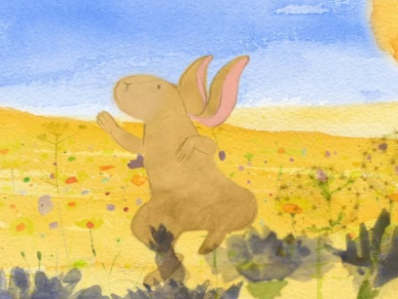 | 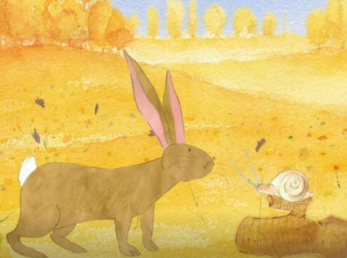 | 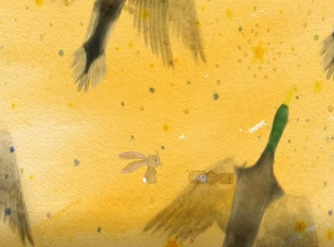 | 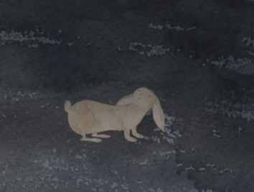
_____________________  _____________________  _____________________  _____________________  _____________________  _____________________ | _____________________  _____________________  _____________________  _____________________  _____________________  _____________________ | _____________________  _____________________  _____________________  _____________________  _____________________  _____________________ | _____________________  _____________________  _____________________  _____________________  _____________________  _____________________
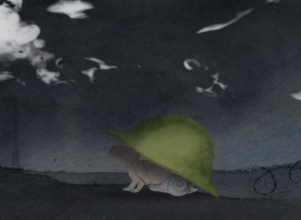 | 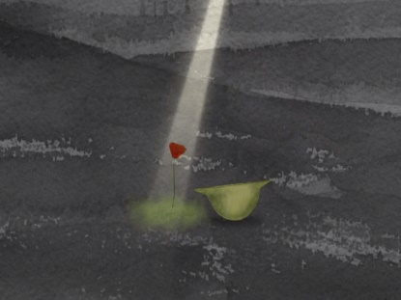 | 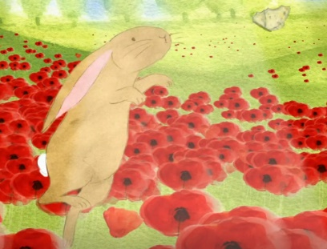 | 
                                              

